**ACKNOWLEDGEMENT**

I would like to express my gratitude to Anupam Singh (HOD of BCA) who gave me the golden opportunity to do this wonderful Project report on ‘MILK MANAGEMENT SYSTEM'.

I am also grateful to my friends and who directly or indirectly involved with the project for their consecutive help and continuous suggestion on matter of the project.

I came to know about so many new things I am thankful to them. I am deeply inherited who devoted their precious time in giving me the information about the various aspects and gave support and guidance at every point of time.

We extend our sincere and heartfelt thanks to our esteemed guide to faculty, for providing us with the right guidance and advice at the crucial junctures and for showing us the right way.

We also take this opportunity to express a deep sense of gratitude to ARCADE BUSINESS COLLEGE.

Next, we thank our respectable parents for educating us with aspect from both arts and science, for their unconditional support and encouragement to pursue out interests, even when interests went out of boundary.

We cannot forget our Teams & Lab teacher in the faculty of Computer Science & Engineering for the academic interactions and Ideas.

**Last but not least, we would like to convey our gratitude to the Anupam Singh & Md. Khurshid Allam in our Faculty for the good of during the class period of our course Coordinator and All our course faculty members.**

**DECLARATION**

We hereby declare that the project entitled “MOON DAIRY” Milk Management System which is being submitted as project in BCA 3rd Year to Arcade Business College, Patna is an authentic record of our genuine work done under the guidance and motivation of Anupam Singh (HOD of BCA Department) Arcade Business College, Patna.

**Under the Guidance of: Team Member:**

**Anupam Singh** Prashant Kumar

(HOD Of BCA Department) Mritunjay Kumar

& Keshav Kumar

**All Faculty** Manish Kumar

**Table of content**

Introduction/Objectives ……………………………………………………………………………………….4

System Analysis ……………………………………………………………………………………………………6

Preliminary Investigation………………………………………………………………………………………8

Feasibility Study………………………………………………………………………………………………….11

Project Planning……………………………………………….....................................................13

Project Scheduling (Gantt Chart)…………………………………………………………………………17

Software requirement specifications …………………………………………………………………18

Introduction to Visual basic 6.0 ………………………………………………............................19

Introduction to oracle 10g …………………………………………………………………………………24

System Security measures ……………………………………………......................................26

Software Engineering Paradigm applied – Water Fall Model……………………………..28

Data models ( DFD)……………………………………………………………………………………………30

Entity Relationship Model…………………………………………….......................................31

System Design……………………………………………………………………………………………………32

Modularisation details………………………………………………….......................................34

Data integrity and constraints……………………………………………………………………………44

Database design………………………………………………………………………………………………..50

Interface Design……………………………………………………….……………………………………….70

Reports…………………………………………………………………..............................................90

Complete Project Coding………………………………………………......................................98

Testing……………………………………………………………………………………………………………..359

Future scope and further enhancement of the Project…………………....................362

Database/data security…………………………………………………....................................363

Cost Estimation of the Project along with Cost Estimation Model……………………365

Bibliography……………………………………………………………..........................................366

**INTRODUCTION**

The Milk collection centre collects milk from the farmer and bringing them under one umbrella for getting remunerative price for the milk produced in the village. The collection centre is also focused on supporting its member farmer in their farming activity with the needed inputs, technical and advisory services and in the processing and marketing of their surplus milk. It is also selling milk and its product to the local villages from the collection centre.

The collection centre was setup through a camping and with the support of Dairy Department. The board is democratically elected and running in profit The board is democratically elected and running in profit. The centre is collecting milks per day and after collecting the local needs during the morning and evening hours send the milk to the dairy through dairy transport. Sometimes the milk becomes sour due to the hot climate or delay in transport to reach at the cooling centre. This is a huge drain to the collection centre. If the milk becomes sour then rate of the milk becomes half.

The Dairy also provides some milk products like Ghee, Paneer, some animal feed supplements and some seeds for farmers which is beneficial for animals and increase the milk production. Dairy also provides VET. Doctor for checking the health of animal.

**Working Behaviors**

Collection Centre collects milk from farmer and calculates the FAT of the milk. According to the FAT price of milk is calculated. After collecting milk, some local customer buy milk from the centre and rest of the milk is sent to main centre. In every ten days company calculate the amount of the milk according to FAT and deposit the money in the bank account of the collection centre. Collection centre also calculate the amount of farmer according to the FAT in ten days. If the farmer purchases some medicine or some product through the collection centre then at the time of calculation, collection centre reduces the amount the product purchased by the farmer and rest of the amount is given to the farmer.

**SYSTEM ANALYSIS**

System Analysis is a process of collecting and interpreting facts, identifying the problems, and decomposition of a system into its components.

System analysis is conducted for the purpose of studying a system or its parts in order to identify its objectives. It is a problem-solving technique that improves the system and ensures that all the components of the system work efficiently to accomplish their purpose.

**Characteristics: -**

* It is the study of the existing system to identify the problem areas
* It is a process of understanding the system requirements and its environment.
* It involves gathering and understanding the user’s requirements.
* It involves analyzing the system in terms of its current and future needs.

**Advantages: -**

* It helps to identify the problems and their causes.
* It helps to understand the functional and non-functional requirements of the system.
* It helps to develop better solutions
* It helps identify the areas of improvement.

**Limitation: -**

* It can be time-consuming.
* It can be costly.
* It can be difficult to get accurate information.

**PRELIMINARY INVESTIGATION**

In this process, our team visit the Milk collection Centre and studies their system. They investigate the need for possible software automation in the given system. By the end of Preliminary Investigation, the team furnishes a document that holds the different specific recommendations for the candidate system. It also the personnel assignments, costs, project schedule, and target dates. Main Tasks of the preliminary investigation phase are:

1. Our team Investigate the present system and identify the functions to be performed.
2. Identify the includes objectives of the new system. In general, an information system benefits a business by increasing efficiency, improving effectiveness, or providing a competitive advantage.
3. Identify problems and suggest a few solutions.
4. Identify constraints, i.e., the limitations placed on the project, usually relating to time, money and resources.
5. Evaluate feasibility - whether the proposed system promises sufficient benefit to invest the additional resources necessary to establish the user requirements in greater detail.

**Benefit to organization**

The organization will obviously be able to again benefits such as savings in operating cost, reduction in paperwork, better utilization of human resources and more presentable image increasing goodwill. The other benefits are improved service and faster and better access to up-to-date information.

**The initial cost**

The initial cost of setting up the system will include the cost of hardware (service/clients, network adapter and related hardware), software (server os, add-on software, and utilities) & labour (setup & maintenance). The same has to bear by the organization.

**Running cost**

Besides the initial cost the long-term cost will include the running cost for the system including the AMC, book charges, cost for human resources, cost for update/renewal of various related software.

**Need for training**

The users along with the administrator need to be trained at the time of implementation of the system for smooth running of the system. The client will provide the training site.

**Depending upon this definition**

we analysed the present Milk collection management system, during the analysis process; we had to through the entire manual system that was being followed in the organization for past few years.

We talked management people who were managing the financial issues of the Centre, Person who were keeping the records in lots of registers and the reporting manager regarding their existing system, their requirements and their expectations from the new proposed system. Then, we did the system study of the entire system based on their requirements and the additional features they wanted to incorporate in this system.

The manual system was very complex to be managed and searching or updating the information was also very difficult.

There was a lengthy procedure for calculating the farmer’s milk collection, Centre’s milk collection, and then making their payment and bills.

The other problem with the manual system was of report generation. The reports to be generated on a daily/10-Days/monthly basis required lot of paper work and calculations etc. thus, reporting manager had to manually calculate all the consultation fees of every player at the end of every day/10-days/month. Even a small calculation mistake was leading to reanalysis and recreation of whole work.

**FEASIBILITY STUDY**

A feasibility study is a detailed analysis that considers all the critical aspects of a proposed project in order to determine the likelihood of it succeeding.

Although feasibility studies can help project managers determine the risk and return of pursuing a plan of action, several steps should be considered before moving forward.

A feasibility study is an assessment of the practicality of a proposed plan or project. A feasibility study analyzes the viability of a project to determine whether the project or venture is likely to succeed. The study is also designed to identify potential issues and problems that could arise while pursuing the project.

**Types of feasibility study in project management**

1. **Technical Feasibility: -** Technical Feasibility study of a project analyzes and evaluates its present resources, including equipment, programming, and necessary innovation. This technical feasibility analysis provides information about whether the technologies and resources needed to build the project are available. Additionally, a feasibility study examines the engineering team's expertise, the viability of using open systems, the ease of maintaining and upgrading the technology of choice, and other factors.
2. **Operational Feasibility: -** Operational Feasibility study examines how well a product will satisfy needs and how simply it will be used and maintained after implementation. Along with this, additional operational responsibilities include evaluating the product's usefulness and the suitability of an application development teams offered to fix.
3. **Economical Feasibility: -** The economic market feasibility study examines the project's expense and value. This implies that a thorough analysis is done to determine the program's development costs, including the cost of the design process and operating costs. After that, it is determined if the venture will be profitable.
4. **Time Feasibility: -** A Time feasibility study's primary focus is the project proposal's schedules and due dates. This assessment involves how long it will take team members to finish the project, which significantly affects the company as the program's intended outcome may not be achieved if it cannot be completed on time.
5. **Legal Feasibility: -** The project is examined from a legal standpoint in examining Legal Feasibility. It evaluates project implementation legal obstacles such as privacy laws or social networking regulations, business certificates, licenses, trademarks, etc. Ultimately, it can be argued that a legal feasibility study is an investigation to determine whether a project proposal complies with the law and ethical guidelines.

**PROJECT PLANNING**

* Project planning is a mechanism to communicate what tasks need to get done and which organizational resources will be allocated to complete those tasks in what timeframe. A project schedule is a document collecting all the work needed to deliver the project on time.
* A project is made up of many tasks, and each task is given a start and end (or due date), so it can be completed on time. Likewise, people have different schedules, and their availability and vacation or leave dates need to be documented in order to successfully plan those tasks.
* System planning is the method used for collection data for the proposed system. When a system is planed it requires information and facts which are needed in developing that system. System planning is basically fact findings using processes like research, interviews, meetings, questionnaires, and other techniques to collect information about the system requirement and desired preferences.
* A good system analyst can obtained information by observing the interviewer and making questionnaires with them. The primary purpose of the system planning is to obtain quantitative and qualitative data for the development of the system. For the development of the new system a convenient time, duration and place for the developing of the project is selected beforehand as this will allow the developer to schedule work accordingly.
* Milk collection management system has been developed keeping in view all basic needs of the farmer and the Centre. It fulfills all the basic requirement of the Centre. The functioning of the implemented system is very accurate and less time consuming.

Creating a project charter containing user expectations and analyst deliverables is recommended, since unrealistic management deadlines, adding unneeded personnel to a project that is trying to meet an unrealistic deadline, and not permitting developer teams to seek expert help outside their immediate group, were cited by programmers as reasons projects had failed. Project failures can usually be avoided by examining the motivations for

requested projects, as well as your team’s motives for recommending or avoiding a particular project.

The systems analyst has three main steps to follow for putting together an effective systems proposal:

1. Effectively organizing the proposal content,
2. writing the proposal in an appropriate business style, and
3. orally presenting an informative systems proposal.

**For a successful software project, the following steps can be followed:**

* Identifying project’s aims and objectives.
* Understanding requirements and specification.
* Methods of analysis, design and implementation.
* Testing techniques
* Documentation

**Requirement Analysis**

The most suitable and appropriate software development methodology we found for our software development is waterfall software development model, which gave us a clear view about our software and helped us to achieve our goal.

Small and medium size software’s are usually divided into six stages that are interrelated with each other in a top-down approach named as waterfall. The input of one specific stage is the output of previous stage which initializes the next stage. At every step or stage of the model some additional information is also added up into the input of that stage and generating the results. But that additional information is restricted in scope and previous stages are directly traceable from that stage. The first stage of the waterfall model is planning stage in which the most critical task is to clearly mention the high-level requirements or goals of the software. It helps to make feasibility and risks associated with the project and also provides the basic project structure. The next stage is the requirement definition stage that takes goals as input from the planning stage and then these goals are defined into a set of one or more requirements. Major functionalities, initial data entities and the operational data areas are defined under this stage.

The input of design stage is the output of the requirement stage which is an approved requirements documentation. In this stage the design elements are defined with the help of interviews, prototypes and workshops conducted. These design elements consist of functional hierarchy, business process diagrams, pseudo code and entity relationship diagram. These design elements provide detail description about the software and each element is related to a specific requirement. The development stage is initialized by the previous design stage. At this stage the code for the design elements of software is written and it provides the functional software components. Integration and test stage is provided the output of the development stage. At this stage the different software functioning components developed in the previous stage are integrated with each other to provide full fledge software project which is providing all the high-level requirements. This software is also passed through different test cases to check the validity, correctness, completeness and hence enables us to achieve our goals regarding our project. Finally, the installation and acceptance stage arrive. The software is loaded to the server at site of customers and tested with different test cases once again to check the correct working. If all this shows adequate results satisfying the customer then the software is handed over to the customer formally.

**Reasoning to Choose Waterfall Model**

As in this model all the phases are in a sequence and are dependent with one another, therefore a phase cannot be started until the previous phase is completed and fully documented. This approach is most appropriate for our project, because all the requirements and goals of our project are very clear. Secondly, it is easy to do work in components and waterfall model is providing this approach. After the completion of all the phases individually, they are integrated together. This model is very economical and risk free due to its sequential approach.

**PROJECT SCHEDULING**

**Gantt Chart**

**ANALYSIS**

**DESIGN**

**INPUT**

**PROCESS**

**OUTPUT**

**COADING**

**TEASTING**

**JAN FEB MARCH**

**H/W AND S/W REQUIREMENTS**

**HARDWARE SPECIFICATION**

• Main Processor: Pentium Dual Core or above

• RAM: 2 GB

• Display Type: SVGA

• Hard Disk: 125 GB

• Keyboard: Any Keyboard

• Mouse: Any Mouse

• Printer: Any printer

**SOFTWARE SPECIFICATION**

• Operating System: Windows 7 or latter

• Front End: VB 6.0

• Back End: Oracle 10 g

**INTRODUCTION TO VB 6.0**

Visual Basic, derived from the Basic language, is an object-based and event driven programming language from Microsoft. This language is relatively easy to learn. It enables you to create GUI (Graphical user interface) applications easily using the Rapid Application Development (RAD) technique. The one most interesting feature of this language is that it comes with a designer called Integrated Development Environment (IDE). The easy-to-use tools of the IDE enable you to easily create buttons, textbox, and other controls for your desktop application. Visual Basic 6.0 is a very powerful programming language. It enables GUI application development, provides access to databases and enables the creation of ActiveX controls. In addition, Visual Basic 6 is Event-driven because we need to write code in order to perform some tasks in response to certain events. The events usually comprises but not limited to the user's inputs. Some of the events are load, click, double click, drag and drop, pressing the keys and more. We will learn more about events in later lessons. Therefore, a VB6 Program is made up of many subprograms, each has its own program code, and each can be executed independently and at the same time each can be linked together in one way or another.

**The Integrated Development Environment**

The main workspace appears where you will develop your application with the tools in IDE (Integrated Development Environment). It is very important to know the names of all the elements of this development environment. The tools available here makes it very easy for you to develop an application. The VB6 11 IDE provides you many tools in one place. You can add a control on the form of your choice, set a property of an object from the Properties Window on the right-hand side, set the form layout and many more things that you can use alongside your coding. You can even fill the Tool box with lots of additional controls.

**The Menu Bar**

The Menu Bar contains all the menus such as File, Edit, View, Tools and so on

**The Tool Bar**

The Tool Bar contains all the tools such as Open, Save, Copy, Cut, Start and so on.

**An Overview of VB6 Controls**

Before getting into the actual programming work, you need to have an overview of the VB controls. In this lesson, a very short description of each of the controls has been given.

**Label:** The label control is used to display text. It is also used to label other controls. The end user cannot edit the label text. Text Box: The Text Box control contains characters. End-users can edit the characters contained in the Text Box.

**Command Button:** The Command Button control is simply a button that we see in our daily-use software. When the end-user clicks the Command Button, the program behaves according to the code assigned in the Common Button.

**Option Button:** This control enables the end-user to select one among several options. Only one option button among others in a group can be on at the same time. You can name an option using the Caption property.

**Check Box:** The Check Box control is used to make a yes/no or true-false selection. You can check more than one Check Box at the same time that let you make multiple choices. You can label this control using the Caption property.

**V scroll Bar & H scroll Bar:** V scroll Bar and H scroll Bar controls let you create Vertical scroll bar and Horizontal scroll bar respectively.

**Frame:** The Frame control is used as a container of other controls. This is also used to group different controls especially in Option Button controls when you wish to select more than one option. The Caption property associated with it is useful to label the frame.

**List Box & Combo Box**: The List Box control contains a number of items. The user can select one or more items from the list. The combo Box control has the feature of List Box and Text Box. This control does not support multiple selections.

**Timer:** The Timer control is not visible on the form when you run the program. It is used to execute lines of code repeatedly at specific intervals.

**The Data Control**: The Data control is used for database programming

**Common Properties in VB6**

In this lesson, you will learn about the common properties used in VB6.

**Back Color and Fore Color:** The Back Color property sets the background color of an object while the Fore Color property changes the foreground color used to display text. You can set these properties either from Properties Window or you may wish to set in run-time.

**Example:** When you click on command1 button, the code in the Click event procedure is executed. Private Sub c m d Change color Click () Label1.BackColor = v b Red, Label1.ForeColor = v b Blue End Sub.

**Font:** You can set the font property from the Properties Window. See the below example to set property in run time.

**Example:** Private Sub c m d Change Font _Click() Text1.FontSize = 16 Text1.FontBold = True Text1.FontItalic = True Text1.Font = "Tahoma" End Sub

**Caption**: It sets the text displayed in the object's title bar or on the object. Example: Private Sub c m d Set Title_ Click() Form1.Caption = "New Program" Label1.Caption = "Hello" Frame1.Caption = "New frame" End Sub 'Caption' property of form sets the form's title text. The text to be displayed on label is set.

**Text:** It sets the text in a Text Box. Example: Text1.Text = "New program" Here the text string is assigned to Text1.Text.

**The Left, Top, Width and Height properties**

1. The Left Property sets the distance between the internal left edge of an object and the left edge of its container.

2. The Top Property sets the distance between the internal top edge of an object and the top edge of its container.

3. The Width Property sets the width of an object.

4. The Height Property sets the height of an object.

Example:

Private Sub c m d Change _Click ()

Form1.Left = 12000

Form1.Top = 7000

Form1.Height = 10000

Form1.Width = 12000 End Sub

**Tab Index and Tab Stop**

The Tab Stop property indicates whether the user can use the TAB key to give the focus to an object. You can give focus to the objects pressing the TAB key in the daily use software applications. The Tab Index property sets the tab order of an object.

**ORACLE 10g**

**ORACLE:** Oracle database is a relational database management system (RDBMS) from Oracle Corporation. This article will explain a complete overview of the Oracle database, features, history, and editions. Before discussing the oracle, we will first need to know about the database.

It is one of the oldest database management companies in the world. It has always focused on enterprise needs and kept up with the newest technological developments. As a result, its products are constantly updated with new features. For example, the most recent Oracle database, 19C, is also available on Oracle Cloud. Oracle allows users to select from various database editions to meet their specific demands with a cost-effective solution.

**DATABASE:** A database refers to the organized collection of structured data stored electronically in a device. It allows us to access, manage, and find relevant information frequently. The flat file structure was extensively used to store data before the database system was invented. The relational database approach becomes popular in comparison to the flat file model because it eliminates redundant data.

**EDITIONS OF ORACLE DATABASE :** Oracle database is compatible with a wide range of platforms such as Windows, UNIX, Linux, and macOS. It supports several operating systems like IBM AIX, HP-UX, Linux, Microsoft 15 Windows Server, Solaris, SunOS, macOS, etc. In the late 1990s, Oracle began supporting open platforms like GNU/Linux.

**The following is a list of Oracle database editions in order of priority:**

**o Enterprise Edition**: It is the most robust and secure edition. It offers all features, including superior performance and security.

**o Standard Edition:** It provides the base functionality for users that do not require Enterprise Edition's robust package.

**o Express Edition (XE):** It is the lightweight, free and limited Windows, and Linux edition.

**o Oracle Lite:** It is designed for mobile devices.

**o Personal Edition:** It's comparable to the Enterprise Edition but without the Oracle Real Application Clusters feature.

**o ORACLE 10 G:** Oracle Database 10g is the first database designed for enterprise grid computing, the most flexible and cost effective way to manage information and applications. Enterprise grid computing creates large pools of industry-standard, modular storage and servers.

**SYSTEM SECURITY MEASURES**

Maintain Proper Password hygiene: - Having your password compromised is one of the easiest ways for cybercriminals to steal information. This makes it essential for you and your team to practice good habits when it comes to creating, storing, and sharing passwords and access. Password hygiene starts with secure password creation. Have policies in place to guarantee everyone in your team knows how to create strong passwords. And as much as possible, reduce the use of shared passwords.

To complement this, consider working with a password manager. This helps ensure that while your passwords are strong, you won’t accidentally lock yourselves out from them. Finally, turn on two-factor authentication. This setting requires an additional step for users before they can login to an account. Verification is done through a separate email address or a mobile phone

Manage and backup your data: - Data management can be tedious. If you’re handling massive amounts of information, it might be worth considering using a data hosting provider. Data hosting providers help you keep your data organized, available, and most importantly, secure. They provide layers of protection with around-the-clock support. They also comply with stringent standards, so you can be sure you’re not violating any of the regulations mentioned in the previous section.

Secure Your Devices: - While this is primarily the responsibility of our team, it is still good to do your part in being vigilant when it comes to our devices. As data breach technologies become more sophisticated do what they can to combat this by constantly improving their products and services through software patches.

Ensuring that your devices use the latest software, operating systems, and anti-virus technologies helps you maximize the protection they provide. Turn on notifications for system updates to help you keep tabs on their latest developments. If your IT team misses it, follow up and secure your team’s devices as much as possible.

Educate our Teams, client and customer: - Our project’s data can be compromised by any member of our team or client. That said, it’s crucial to make sure that each and every one of your colleagues is educated about the importance of security. Raise awareness of the most common cybercrimes, such as malware, ransomware, information phishing, scams, etc. Check the news to stay vigilant of the new ways hackers are trying to steal data. Remind everyone in our organization to double-check the PMCOMs they use, email addresses they interact with, links they receive, and requests they address.

**WATER FALL MODEL**

The Waterfall Model was the first Process Model to be introduced. It is also referred to as a **linear-sequential life cycle model**. It is very simple to understand and use. In a waterfall model, each phase must be completed before the next phase can begin and there is no overlapping in the phases.

The Waterfall model is the earliest SDLC approach that was used for software development.

The waterfall Model illustrates the software development process in a linear sequential flow. This means that any phase in the development process begins only if the previous phase is complete. In this waterfall model, the phases do not overlap.

**The sequential phases in Waterfall model are**

* **Requirement Gathering and analysis -** All possible requirements of the system to be developed are captured in this phase and documented in a requirement specification document.
* **System Design -**The requirement specifications from first phase are studied in this phase and the system design is prepared. This system design helps in specifying hardware and system requirements and helps in defining the overall system architecture.
* **Implementation-** With inputs from the system design, the system is first developed in small programs called units, which are integrated in the next phase. Each unit is developed and tested for its functionality, which is referred to as Unit Testing.
* **Integration and Testing-** All the units developed in the implementation phase are integrated into a system after testing of each unit. Post integration the entire system is tested for any faults and failures.
* **Deployment of system** - Once the functional and non-functional testing is done; the product is deployed in the customer environment or released into the market.
* **Maintenance -** There are some issues which come up in the client environment. To fix those issues, patches are released. Also to enhance the product some better versions are released. Maintenance is done to deliver these changes in the customer environment.

All these phases are cascaded to each other in which progress is seen as flowing steadily downwards (like a waterfall) through the phases. The next phase is started only after the defined set of goals are achieved for previous phase and it is signed off, so the name "Waterfall Model". In this model, phases do not overlap.

DFD

ERD

**SYSTEM DESIGN**

System design is the process of defining elements of a system like modules, architecture, components and their interfaces and data for a system based on the specified requirements. It is the process of defining, developing, and designing systems which satisfies the specific needs and requirements of a business or organization.

A systemic approach is required for a well-running system. Bottom-Up or Top-Down approach is required to consider all related variables of the system. A designer uses the modelling languages to express the information and knowledge in a structure of system that is defined by a consistent set of rules and definitions. The designs can be defined in graphical or textual modelling languages.

**System design takes the following inputs –**

* Statement of work
* Requirement determination plan
* Current situation analysis
* Proposed system requirements including a conceptual data model, modified DFDs, and Metadata (data about data)

**System design gives the following outputs –**

* Infrastructure and organizational changes for the proposed system
* A data schema, often a relational schema
* Metadata to define the tables/files and columns/data-items
* Actual or pseudocode for each module in the program
* A prototype for the proposed system

**Types of System Design**

1. **Logical Design: -** Logical design pertains to an abstract representation of the data flow, inputs, and outputs of the system. It describes the inputs (sources), outputs (destinations), databases (data stores), procedures (data flows) all in a format that meets the user requirements.
2. **Physical Design: -** Physical design relates to the actual input and output processes of the system. It focuses on how data is entered into a system, verified, processed, and displayed as output.

It consists of the following steps: -

* Specifying the input/output media, designing the database, and specifying backup procedures
* Planning system implementation
* Devising a test and implementation plan, and specifying any new hardware and software.
* Updating costs, benefits, conversion dates, and system constraints.

1. **Architectural Design: -** It is also known as high level design that focuses on the design of system architecture. It describes the structure and behavior of the system. It defines the structure and relationship between various modules of system development process.

**MODULE DISCRIPTION**

1. Admin Module

This module contains all the information related to admin department such as login, creating new user, forgot password etc.

This module contain following tables:-

**Table : Login**

Fields : (user_id, user_nm, phone_no, password)

**Table : Collection_center**

Fields : (Cen_id, Cen_name, Cen_addr, Phone_no, Reg_no, Reg_date)

**Table : Product_entry**

Fields : (Pr_id, Pr_nm, Weight, Rate)

**Table : Farmer_entry**

Fields : (Fid, Fnm, Phone_no, Address)

There are some sub functions we used in this module such as:-

Login

In login page admin or any staff who work in this organization can access this software by their user id and password.

Collection Centre

This page can only be access by admin of the organization.

Through this page details of our centre can be entered or update.

Product Entry

Through this page we can enter the new product details or update the existed product details.

Farmer Entry

Through this page we can enter the new farmer details which join with our centre or update the existed farmer details.

Forgot Password

This function can be used by admin or any staff who lost their password. By this function they can easily forgot their password with the help of with their user id and phone number.

1. Dairy Module

In this module we contain information related to Our supplier Dairy, and also manage the work related to dairy such as selling milk to dairy etc.

This module contain following tables:-

**Table : Dairy_entry**

Fields : (Dairy_id, Dairy_nm,Phone_no,lic_no,Address)

**Table : Dairy_pr**

Fields : (serial_no, Pr_id,weight,Rate)

**Table : Morning_Dairysale**

Fields : **(**Bill_no,Bill_date,Dairy_id,Centre_id,Pr_id,Qty,Fat,Rate,Total_amt)

**Table : Evening_Dairysale**

Fields : **(**Bill_no,Bill_date,Dairy_id,Centre_id,Pr_id,Qty,Fat,Rate,Total_amt)

There are some sub functions that we use in this module:-

Dairy Entry

This page can only be access by admin of the organization.

Through this page details of Our supplier dairy can be entered or update.

Dairy_pr

Through this page we can enter the new product details or update the existed product details which is supllied by dairy.

Dairy Sale

Through this page we can store the details of daily morning and evening sale of milk which we sold to the dairy.

1. Collection Module

Collection of milk is one of the major part of this organization. As this organization is product based so we can say that products are the back bone of this organization.

Various functions such as entry the details of new product, updation in product record, deletion, searching, managing stock can be done through the help of this module.

This module contain following tables:-

**Table : Fatlist**

Fields : (Fat, Rate)

**Table : Morning_coll**

Fields : (Time,curr_date, F_id, Qty, Fat, Rate, Amount)

**Table : Evening_coll**

Fields : (Time,curr_date, F_id, Qty, Fat, Rate, Amount)

Sub functions provided in this module are:-

Fat List

In this function insertion Fat details can be done such as generating Fat percent per liter, and rate of per fat. In this we can also update the rate of fat.

For this add new, save ,update and clear command are also given.

Milk Collection

This is the most important function in this module as many other module depends on this function such as dairy sale , dairy payment and farmer payment.

In this function we store the records of milk sold by each farmer daily both in morning and evening.

1. Order Module

The order module is a management system which allows the users to store and manage advance Product ordered information for efficient and effective management. It is a broadly recognized, widely-implemented strategy for managing and nurturing a company's interactions with customers, clients and sales prospects.

This module contain following tables:-

**Table : Purchaseorder_details**

Fields :(Order_no, Centre_id, order_date, Delivery_date, dairy_id,

tot_amt, advance,dues)

**Table : Purchaseorder_pr**

Fields : (order_no,pr_id,qty,rate,amount)

**Table : saleorder_details**

Fields :(Order_no, Cust_id, order_date, Delivery_date, tot_amt, Paid,dues)

**Table : Purchaseorder_pr**

Fields : (order_no,pr_id,qty,rate,amount)

Order module is used for performing following function:-

Purchase Order

In this function we can place the product order to the dairy when stock is low or empty.

Sales Order

In this function we can take the product order from the customer.

1. Transaction Module

This module deals all the function related to billing of product like sell bill or purchase bill. In this module we can generate sell bill for customers. Manage products which are returned by any customer. Store purchase bill given by distributor.

This module also deals with dues of customer.

Through this module we can also see total profit gained in a day or in a month by seeing total sales of product.

This module contain following tables:-

**Table : Purchasebill_details**

Fields : (Bill_no, Bill_date,order_no,Dairy_id Tot_amt, Discount,Paid, Dues )

**Table : Purchasebill_pr**

Fields : (bill_no, Pr_id, Qty, Rate, Amount)

**Table : Salebill_details**

Fields : **(**Bill_no, Bill_date,order_no,cust_id Tot_amt, Discount,Paid, Dues)

**Table : Salebill_pr**

Fields :( bill_no, Pr_id, Qty, Rate, Amount)

**Table : Purchase_Return**

Fields : (Return_no, Return_date,Centre_id, Bill_no Reason, bill_amt, Paid)

**Table : Sales_Return**

Fields : (Return_no, Return_date,Cust_id, Bill_no Reason,bill_amt,Paid,Dues)

**Table : Stock**

Fields : (Pr_id,pr_name,MFD,Exp,balance)

The main functions of this module are:-

Sell bill

In this option we create a bill for customers which contain a unique bill number. Our bill includes information like product purchased by customer, total quantity of product, price of each product, total amount, discount if given, net payable amount, paid and dues left.

Purchase bill

In this option we insert all bill details of product which we purchase from company which contain a. Our bill contains information like unique bill number product purchased by us, total quantity of product, price of each product, total payable amount, paid amount and dues left.

Return

This option is invoked when any customer return some products due to some reason. This function contain customer id, product id, quantity of product returned unique return note number and reason for which product is returned.

Stock

Stock is one of the major function in this module, as this function is responsible for storage of each product in the organization. Through this function we can see the maximum storage space in the organization, total available products in the storage, quantity of each product.

There is also a minimum limit set for each product. If any product goes down the minimum limit then order is placed for purchasing of that product.

1. Payment Module

This module contain all the records related to payment. In this module we create pay slip for farmer and store the details. In this module we also store the payment slip of collection centre which is provided by dairy.

This module contains following tables :-

**Table : Farmer_payment**

Fields : (Start_Date, End_Date, Farmer_id, Morning_Qty, Evening_Qty, Total_qty, Total_amt, Previous_dues, Paid, Dues_left )

**Table : Dairy_payment**

Fields : (bill_no, Start_Date, End_Date,Dairy_id, Morning_Qty, Evening_Qty, Total_qty, Total_amt, Previous_dues, Payment, Dues_left)

In this module following function can be implemented:-

Farmer Payment

In this function we can calculate total amount which centre have to pay to the farmer after 10 days collection of milk.

Dairy Payment

In this function we can calculate total amount which centre have to receive from the dairy after 10 days delivering of milk.

1. Dues Module

This module is used for storing the details of customer who which not paid their bill completely. This function record total dues amount of customer. If any customer pay their bill then their dues amount is deducted from total dues amount.

Through this module we can also see the amount of debt that we have to pay the company.

This module contain following tables:-

**Table : Centre_dues**

Fields : (Centre_id,Total_dues)

**Table : Dairy_dues**

Fields : (Dairy_id,Dues)

**Table : Customer_dues**

Fields : (Cust_id,Cust_name,Dues)

1. Report Module

An essential part of business is the ability to create reports. This module looks at how to structure a report, from the executive summary through to conclusions and recommendations. A report doesn't just rely on the quality of its contents and how it’s structured, but also the style in which it is created.

At the end of day, month, or year we only see our final report of selling and purchasing. Through this module we can easily see our net profit, net loss, net purchasing or selling of products.

The major functions of this module are:-

Search

Through this function we can search each and every report. We have to select beginning date and end date or starting month and end month with type of report we want to fetch, such as sell, purchase, customer etc.

Purchase report

In this report we can see our monthly or annually purchase report. This can be

done by searching, for this we have to select method such as search ‘by date’ , search ‘by month’ and then choose start date or month from DTpicker and end date or month from DTpicker and then search. We will get report according to our desired format.

Sales report

In this report we can see our daily, monthly or annually sales report. This can be done by searching, for this we have to select method such as search ‘by date’, search ‘by month’ and then choose start date or month from DTpicker and end date or month from DTpicker and then search. We will get report according to our desired format.

Customer report

In this report we can see our daily, monthly customer visiting our store. This can be done by searching, for this we have to select method such as search ‘by date’, search ‘by month’ and then choose start date or month from DTpicker and end date or month from DTpicker and then search. We will get report according to our desired format.

Payment report

In this report we can see our all types of payment report such as dairy payment report and farmer payment report according to range of date .

Data Integrity Constraints

Integrity constraints are used to ensure accuracy and consistency of data

in a relational database. Data integrity is handled in a relational database

through the concept of referential integrity. Many types of integrity

constraints play a role in referential integrity (RI).

**Primary Key Constraints**

Primary key is the term used to identify one or more columns in a table

that make a row of data unique. Although the primary key typically

consists of one column in a table, more than one column can comprise

the primary key. For example, either the employee's Social Security

number or an assigned employee identification number is the logical

primary key for an employee table. The objective is for every record to

have a unique primary key or value for the employee's identification

number. Because there is probably no need to have more than one record

for each employee in an employee table, the employee identification

number makes a logical primary key. The primary key is assigned at

table creation.

The following example identifies the F_ID column as the PRIMARY

KEY for the Farmer_entry table:

create table Farmer_Entry

(

F_ID varchar2(6) constraints Farmer_entrypk primary key,

F_name varchar2(20) not null,

Father_name Varchar2(20) not null ,

ph_no number(10) not null,

Aadhar number(12) unique not null,

address varchar2(50) not null,

pr_id varchar(20) constraint farmer_entry_fk_productentry references product_entry

);

This method of defining a primary key is accomplished during table

creation. The primary key in this case is an implied constraint. You can

also specify a primary key explicitly as a constraint when setting up a

table, as follows:

(

F_ID varchar2(6) ,

F_name varchar2(20) not null,

Father_name Varchar2(20) not null ,

ph_no number(10) not null,

Aadhar number(12) unique not null,

address varchar2(50) not null,

pr_id varchar(20) constraint farmer_entry_fk_productentry references product_entry,

constraints Farmer_entrypk primary key(f_id)

);

The primary key constraint in this example is defined after the column

comma list in the CREATE TABLEstatement.

A primary key that consists of more than one column can be defined by

either of the following methods:

create table product_entry

(

pr_id varchar2(20) not null,

vend_id varchar2(20) not null,

pr_name varchar2(20) not null,

mrp number(9,2) not null,

primary key (pr_id, vend_id)

);

**Unique Constraints**

A unique column constraint in a table is similar to a primary key in that

the value in that column for every row of data in the table must have a

unique value. Although a primary key constraint is placed on one

column, you can place a unique constraint on another column even

though it is not actually for use as the primary key.

Study the following example:

create table customer_entry

(

cust_id varchar2(6) constraint cust_entrypk primary key,

name varchar2(20) not null,

gender varchar2(8) not null,

address varchar2(50) not null,

ph_no number(10) unique not null

);

The primary key in this example is EMP_ID, meaning that the employee

identification number is the column that is used to ensure that every

record in the table is unique. The primary key is a column that is

normally referenced in queries, particularly to join tables. The

column EMP_PHONE has been designated as a UNIQUE value,

meaning that no two employees can have the same telephone number.

There is not a lot of difference between the two, except that the primary

key is used to provide an order to data in a table and, in the same

respect, join related tables.

**Foreign Key Constraints**

A foreign key is a column in a child table that references a primary key

in the parent table. A foreign key constraint is the main mechanism used

to enforce referential integrity between tables in a relational database. A

column defined as a foreign key is used to reference a column defined as

a primary key in another table.

Study the creation of the foreign key in the following example:

create table salebill_details

(

bill_no number(9) constraint salebillpk primary key,

bill_date date not null,

order_no number(6) constraint salebill_fk_porderdetails references saleorder_details(order_no),

cust_id varchar2(15) constraint salebill_fk_customerentry references customer_entry(cust_id),

tot_amt number(9,2) not null,

discount number(9,2) not null,

bill_amt number(9,2) not null,

paid number(9,2) not null,

dues number(9,2) not null

);

The options available with the ALTER TABLE command differ among

different implementations of SQL, particularly when dealing with

constraints. In addition, the actual use and definitions of constraints also

vary, but the concept of referential integrity should be the same with all

relational databases.

**Not Null Constraints**

Previous examples use the keywords NULL and NOT NULL listed on

the same line as each column and after the data type. NOT NULL is a

constraint that you can place on a table's column. This constraint

disallows the entrance of NULL values into a column; in other words,

data is required in a NOT NULLcolumn for each row of data in the

table. NULL is generally the default for a column if NOT NULL is not

specified, allowing NULL values in a column.

**TABLE DISCRIPTION**

1. **Table: Login**

|  |  |  |  |  |
| --- | --- | --- | --- | --- |
| **Field Name** | **Data Type** | **Size** | **Constraint** | **Description** |
| User_id | Varchar2 | 20 | Primary key | User id of admin/Staff |
| Name | Varchar2 | 20 | Not null | User name of admin/Staff |
| Password | Varchar2 | 20 | Not null | Password |
| Ph_no | Number | 10 | Unique not null | Contact number |

**2. Table : Collection_Centre**

|  |  |  |  |  |
| --- | --- | --- | --- | --- |
| **Field Name** | **Data Type** | **Size** | **Constraint** | **Description** |
| Centre_id | Number | 20 | Primary key | Collection center id |
| Reg_date | Date |  | Not null | Date of registration |
| Centre_name | Varchar2 | 20 | Not null | Center name |
| Phone_no | Number | 10 | Unique not null | Contact number |
| Address | Varchar2 | 30 | Not null | Collection center address |

**3.Table : Dairy_Entry**

|  |  |  |  |  |
| --- | --- | --- | --- | --- |
| **Field Name** | **Data Type** | **Size** | **Constraint** | **Description** |
| Dairy_id | Varchar2 | 20 | Primary key | Dairy id |
| Dairy_nm | Varchar2 | 20 | Not null | Dairy name |
| Phone_no | Number | 10 | Unique  not null | Contact number of dairy |
| Lic_no | Varchar2 | 20 | Unique  not null | Licence number of dairy |
| Address | Varchar2 | 50 | Not null | Address of dairy |

**4.Table : Farmer_Entry**

|  |  |  |  |  |
| --- | --- | --- | --- | --- |
| **Field Name** | **Data Type** | **Size** | **Constraint** | **Description** |
| F_id | Varchar2 | 6 | Primary key | Farmer’s id |
| F_name | Varchar2 | 15 | Not null | Farmer name |
| Father name | Varchar2 | 15 | Not null | Farmer name |
| Phone_no | Number | 10 | Unique  not null | Phone number |
| Aadhar | Number | 12 | Unique  not null | Aadhar number |
| Address | Varchar2 | 50 | Not null | Address |
| Pr_id | Varchar2 | 20 | Foreign key | Product id |

**5.Table : Product_Entry**

|  |  |  |  |  |
| --- | --- | --- | --- | --- |
| **Field Name** | **Data Type** | **Size** | **Constraint** | **Description** |
| Pr_id | Varchar2 | 20 | Primary key | Product id |
| Pr_name | Varchar2 | 20 | Not null | Product name |
| Weight | Number | (9,2) | Not null | Weight of product |
| Unit | Varchar2 | 10 | Not null | Measurement unit of product |
| Price | Number | (9,2) | Not null | Cost price of product |

**6.Table : Stock**

|  |  |  |  |  |
| --- | --- | --- | --- | --- |
| **Field Name** | **Data Type** | **Size** | **Constraint** | **Description** |
| Pr_id | Varchar2 | 20 | Foreign key | Product id |
| Pr_name | Varchar2 | 20 | Not null | Name of product |
| MFD | Date |  | Not null | Manufacturing date |
| Exp | Date |  | Not null | Expiry Date |
| Balance | Number | 9 | Default 0 | Left quantity of product |
| Amount | Number | 9 | Default 0 | Amount of product |

**7.Table : Customer_Entry**

|  |  |  |  |  |
| --- | --- | --- | --- | --- |
| **Field Name** | **Data Type** | **Size** | **Constraint** | **Description** |
| Cust_id | Varchar2 | 6 | Primary key | Customer id |
| Name | Varchar2 | 20 | Not null | Customer name |
| Gender | Varchar2 | 8 | Not null | Gender of customer |
| Address | Varchar2 | 20 | Not null | Address of customer |
| Ph_no | Number | 10 | Unique  not null | Phone number |

**8.Table : Purchaseorder_Details**

|  |  |  |  |  |
| --- | --- | --- | --- | --- |
| **Field Name** | **Data Type** | **Size** | **Constraint** | **Description** |
| order_no | number | 5 | Primary key | Purchase order no |
| Centre_id | Number | 20 | Foreign key | Collection center id |
| Order_Date | Date |  | Not null | Date of order |
| Delivery_Date | Date |  | Not null | Expected Date of delivery |
| Dairy_id | Varchar2 | 20 | Foreign key | Dairy id |
| Tot_amt | Number | (9,2) | Not null | Total bill of order products |
| Advance | Number | (9,2) | Not null | Advance paid |
| Dues | Number | (9,2) | Default 0 | Dues left |

**9.Table : Purchaseorder_Pr**

|  |  |  |  |  |
| --- | --- | --- | --- | --- |
| **Field Name** | **Data Type** | **Size** | **Constraint** | **Description** |
| order_no | Varchar2 | 5 | Foreign key | Purchase order no |
| Pr_id | Varchar2 | 20 | Foreign key | Product id |
| Qty | Number | 5 | Not null | Quantity of product |
| Rate | Number | (9,2) | Not null | Rate of ordered products |
| Amount | Number | (9,2) | Not null | Total amount of product |

**10.Table : Purchasebill_Details**

|  |  |  |  |  |
| --- | --- | --- | --- | --- |
| **Field Name** | **Data Type** | **Size** | **Constraint** | **Description** |
| Bill_no | Number | 6 | Primary key | Purchase bill number |
| order_no | Varchar2 | 5 | Foreign key | Purchase order  no |
| purc_date | Date |  | Not null | Date |
| Dairy_id | Varchar2 | 20 | Foreign key | Dairy id |
| Net_amt | Number | (9,2) | Not null | Net bill of products |
| Discount | Number | (6,2) | Not null | Discount given in bill |
| Pay_amt | Number | (9,2) | Not null | Payable amount |
| Paid | Number | (9,2) | Not null | Paid amount |
| Dues | Number | (9,2) | Not null | Dues left |

**11.Table : Purchasebill_Pr**

|  |  |  |  |  |
| --- | --- | --- | --- | --- |
| **Field Name** | **Data Type** | **Size** | **Constraint** | **Description** |
| Bill_no | Number | 6 | Primary key | Purchase bill number |
| order_no | Varchar2 | 5 | Foreign key | Purchase order no |
| Pr_id | Varchar2 | 20 | Foreign key | Product id |
| Qty | Number | 4 | Not null | Quantity of product |
| MFD | Date |  | Not null | Manufacturing date |
| Exp | Date |  | Not null | Expiry Date |
| Rate | Number | (9,2) | Not null | Rate of products |
| Amount | Number | (9,2) | Not null | Total amount of product |

**12.Table : Saleorder_Details**

|  |  |  |  |  |
| --- | --- | --- | --- | --- |
| **Field Name** | **Data Type** | **Size** | **Constraint** | **Description** |
| order_no | number | 6 | Primary key | Sale order no |
| Order_Date | Date |  | Not null | Date of order |
| Delivery_Date | Date |  | Not null | Expected Date of delivery |
| Cust_id | Varchar2 | 20 | Foreign key | Customer id |
| Tot_amt | Number | (9,2) | Not null | Total bill of order products |
| Paid | Number | (9,2) | Not null | Advance paid |
| Dues | Number | (9,2) | Not null | Dues left |

**13.Table : Saleorder_Pr**

|  |  |  |  |  |
| --- | --- | --- | --- | --- |
| **Field Name** | **Data Type** | **Size** | **Constraint** | **Description** |
| order_no | Varchar2 | 6 | Foreign key | sale order no |
| Pr_id | Varchar2 | 20 | Foreign key | Product id |
| Qty | Number | 4 | Not null | Quantity of product |
| Rate | Number | (9,2) | Not null | Rate of order products |
| Amount | Number | (9,2) | Not null | Amount of order products |

**14.Table : Salebill_Details**

|  |  |  |  |  |
| --- | --- | --- | --- | --- |
| **Field Name** | **Data Type** | **Size** | **Constraint** | **Description** |
| Bill_no | Number | 6 | Primary key | Sale bill number |
| Bill_date | Date |  | Not null | Date |
| order_no | Varchar2 | 5 | Foreign key | Sale order  no |
| Cust_id | Varchar2 | 20 | Foreign key | Customer id |
| Tot_amt | Number | (9,2) | Not null | Net bill of products |
| Discount | Number | (9,2) | Not null | Discount given in bill |
| Bill_amt | Number | (9,2) | Not null | Payable amount |
| Paid | Number | (9,2) | Not null | Paid amount |
| Dues | Number | (9,2) | Not null | Dues left |

**15.Table : Salebill_Pr**

|  |  |  |  |  |
| --- | --- | --- | --- | --- |
| **Field Name** | **Data Type** | **Size** | **Constraint** | **Description** |
| Bill_no | Number | 6 | Primary key | Sale bill number |
| Pr_id | Varchar2 | 20 | Foreign key | Product id |
| Qty | Number | 4 | Not null | Quantity of product |
| Rate | Number | (9,2) | Not null | Rate of products |
| Amount | Number | (9,2) | Not null | Amount of products |

**16.Table : Purchase_Return**

|  |  |  |  |  |
| --- | --- | --- | --- | --- |
| **Field Name** | **Data Type** | **Size** | **Constraint** | **Description** |
| Return_no | Varchar2 | 6 | Primary key | Return number |
| Return_Date | Date |  | Not null | Date |
| Centre_id | Number | 20 | Foreign key | Collection center id |
| Bill_no | Varchar2 | 6 | Foreign key | Bill number |
| Reason | Varchar2 | 50 | Not null | Reason of returning |
| Bill_amt | Number | (9,2) | Not null | Returning amount |
| Paid | Number | (9,2) | Not null | Paid amount |
| Dues | Number | (9,2) | Not null | Dues left |

**17.Table : Purchasereturn_Pr**

|  |  |  |  |  |
| --- | --- | --- | --- | --- |
| **Field Name** | **Data Type** | **Size** | **Constraint** | **Description** |
| Return_no | Number | 6 | Primary key | Purchase return number |
| Pr_id | Varchar2 | 20 | Foreign key | Product id |
| Qty | Number | 4 | Not null | Quantity of product |
| Rate | Number | (9,2) | Not null | Rate of products |
| Total | Number | (9,2) | Not null | Amount of products |

**18.Table : Sales_Return**

|  |  |  |  |  |
| --- | --- | --- | --- | --- |
| **Field Name** | **Data Type** | **Size** | **Constraint** | **Description** |
| Return_no | Varchar2 | 6 | Primary key | Return number |
| Return_Date | Date |  | Not null | Date |
| Cust_id | Varchar2 | 20 | Foreign key | Customer id |
| Bill_no | Varchar2 | 6 | Foreign key | Bill number |
| Reason | Varchar2 | 50 | Not null | Reason of returning |
| Net_amt | Number | (9,2) | Not null | Returning amount |
| Paid | Number | (9,2) | Not null | Paid amount |
| Dues | Number | (9,2) | Not null | Dues left |

**19.Table : Salesreturn_Pr**

|  |  |  |  |  |
| --- | --- | --- | --- | --- |
| **Field Name** | **Data Type** | **Size** | **Constraint** | **Description** |
| Return_no | Number | 6 | Primary key | Sales return number |
| Pr_id | Varchar2 | 20 | Foreign key | Product id |
| Qty | Number | 4 | Not null | Quantity of product |
| Rate | Number | (9,2) | Not null | Rate of products |
| Total | Number | (9,2) | Not null | Amount of products |

**20.Table : Fatlist**

|  |  |  |  |  |
| --- | --- | --- | --- | --- |
| **Field Name** | **Data Type** | **Size** | **Constraint** | **Description** |
| Fat | Number | (9,2) | Not null | Fat % |
| Rate | Number | (9,2) | Not null | Rate of fat |

**21.Table : Morning_Coll**

|  |  |  |  |  |
| --- | --- | --- | --- | --- |
| **Field Name** | **Data Type** | **Size** | **Constraint** | **Description** |
| Time | Varchar2 | 20 | Not null | Collection time |
| Curr_Date | Date |  | Not null | Date of collection |
| F_id | Varchar2 | 20 | Foreign key | Farmer id |
| Qty | Number | (9,2) | Not null | Total milk collection |
| Fat | Number | (9,2) | Not null | Net fat in milk |
| Rate | Number | (9,2) | Not null | Rate per fat |
| Amount | Number | (9,2) | Not null | Total amount |

**22.Table : Evening_Coll**

|  |  |  |  |  |
| --- | --- | --- | --- | --- |
| **Field Name** | **Data Type** | **Size** | **Constraint** | **Description** |
| Time | Varchar2 | 20 | Not null | Collection time |
| Curr_Date | Date |  | Not null | Date of collection |
| F_id | Varchar2 | 20 | Foreign key | Farmer id |
| Qty | Number | (9,2) | Not null | Total milk collection |
| Net_Fat | Number | (9,2) | Not null | Net fat in milk |
| Rate | Number | (9,2) | Not null | Rate per fat |
| Amount | Number | (9,2) | Not null | Total amount |

**23.Table : Dairy_Pr**

|  |  |  |  |  |
| --- | --- | --- | --- | --- |
| **Field Name** | **Data Type** | **Size** | **Constraint** | **Description** |
| Serial_no | Number | 6 | Primary key | Serial number |
| Dairy_id | Varchar2 | 20 | Foreign key | Dairy id |
| Pr_id | Varchar2 | 20 | Foreign key | Product id |
| Rate | Number | (9,2) | Not null | Rate of products |

**24.Table : Morning_Dairysale**

|  |  |  |  |  |
| --- | --- | --- | --- | --- |
| **Field Name** | **Data Type** | **Size** | **Constraint** | **Description** |
| Bill_no | Number | 6 | Primary key | Dairysale bill number |
| Bill_Date | Date |  | Not null | Date of Dairysale |
| Centre_id | Number | 20 | Foreign key | Collection center id |
| Dairy_id | Varchar2 | 20 | Foreign key | Dairy id |
| Pr_id | Varchar2 | 20 | Foreign key | Product id |
| Qty | Number | (9,2) | Not null | Total milk collection |
| Unit | Varchar2 | 10 | Not null | Measuring Unit |
| Fat | Number | (9,2) | Not null | Net fat in milk |
| Rate | Number | (9,2) | Not null | Rate per fat |
| Total_amt | Number | (9,2) | Not null | Total amount |

**25.Table : Evening_Dairysale**

|  |  |  |  |  |
| --- | --- | --- | --- | --- |
| **Field Name** | **Data Type** | **Size** | **Constraint** | **Description** |
| Bill_no | Number | 6 | Primary key | Dairysale bill number |
| Bill_Date | Date |  | Not null | Date of Dairysale |
| Centre_id | Number | 20 | Foreign key | Collection center id |
| D_id | Varchar2 | 20 | Foreign key | Dairy id |
| Pr_id | Varchar2 | 20 | Foreign key | Product id |
| Qty | Number | (9,2) | Not null | Total milk collection |
| Unit | Varchar2 | 10 | Not null | Measuring Unit |
| Fat | Number | (9,2) | Not null | Net fat in milk |
| Rate | Number | (9,2) | Not null | Rate per fat |
| Total_amt | Number | (9,2) | Not null | Total amount |

**26.Table : Dairy_Payment**

|  |  |  |  |  |
| --- | --- | --- | --- | --- |
| **Field Name** | **Data Type** | **Size** | **Constraint** | **Description** |
| Bill_no | Number | 9 | Primary key | Dairy Payment bill number |
| Start_Date | Date |  | Not null | Start Date of Dairysale |
| End_Date | Date |  | Not null | End Date of Dairysale |
| Dairy_id | Varchar2 | 20 | Foreign key | Dairy id |
| Morning_Qty | Number | (9,2) | Not null | Total morning milk collection |
| Evening_Qty | Number | (9,2) | Not null | Total evening milk collection |
| Total_qty | Number | (6,2) | Not null | Total quantity |
| Total_amt | Number | (9,2) | Not null | Total amount |
| Total_dues | Number | (9,2) | Not null | Total dues |
| Payment | Number | (9,2) | Not null | Total payment |
| Dues_left | Number | (9,2) | Not null | Total dues left |

**27.Table : Farmerbank_details**

|  |  |  |  |  |
| --- | --- | --- | --- | --- |
| **Field Name** | **Data Type** | **Size** | **Constraint** | **Description** |
| F_id | Varchar2 | 6 | Foreign key | Farmer id |
| Bank_name | Varchar2 | 20 | Not null | Farmer bank name |
| Acc_Holdername | Varchar2 | 20 | Not null | Account holder name |
| Acc_No | Number | 16 | Not null | Account Number |
| IFSC | Varchar2 | 10 | Not null | IFSC code |
| Branch_Name | Varchar2 | 20 | Not null | Bank branch name |

**28.Table : Farmer_Payment**

|  |  |  |  |  |
| --- | --- | --- | --- | --- |
| **Field Name** | **Data Type** | **Size** | **Constraint** | **Description** |
| Start_Date | Date |  | Not null | Start Date of farmer collection |
| End_Date | Date |  | Not null | End Date of farmer colletion |
| Farmer_id | Varchar2 | 6 | Foreign key | Farmer id |
| Morning_Qty | Number | (9,2) | Not null | Total morning milk collection |
| Evening_Qty | Number | (9,2) | Not null | Total evening milk collection |
| Total_qty | Number | (6,2) | Not null | Total quantity |
| Total_amt | Number | (9,2) | Not null | Total amount |
| Previous_dues | Number | (9,2) | Not null | Previous dues |
| Paid | Number | (9,2) | Not null | Total payment |
| Dues_left | Number | (9,2) | Not null | Total dues left |

**29.Table : Customer_dues**

|  |  |  |  |  |
| --- | --- | --- | --- | --- |
| **Field Name** | **Data Type** | **Size** | **Constraint** | **Description** |
| Cust_id | Varchar2 | 6 | Foreign key | Customer id |
| Cust_Name | Varchar2 | 20 | Not Null | Bill number |
| Dues | Number | (9,2) | Not null | Dues Left |

**30.Table : Centre_dues**

|  |  |  |  |  |
| --- | --- | --- | --- | --- |
| **Field Name** | **Data Type** | **Size** | **Constraint** | **Description** |
| Centre_id | number | 20 | Foreign key | Center id |
| Total_Dues | Number | (9,2) | Default 0 | Dues Left |

**31.Table : Farmer_dues**

|  |  |  |  |  |
| --- | --- | --- | --- | --- |
| **Field Name** | **Data Type** | **Size** | **Constraint** | **Description** |
| F_id | Varchar2 | 6 | Foreign key | Farmer id |
| Dues | Number | (9,2) | Default 0 | Dues Left |

**32.Table : Dairy_dues**

|  |  |  |  |  |
| --- | --- | --- | --- | --- |
| **Field Name** | **Data Type** | **Size** | **Constraint** | **Description** |
| Dairy_id | Varchar2 | 20 | Foreign key | Dairy id |
| Dues | Number | (9,2) | Default 0 | Dues Left |
|  |  |  |  |  |

**INTERFACE DESIGN**

**HOME**

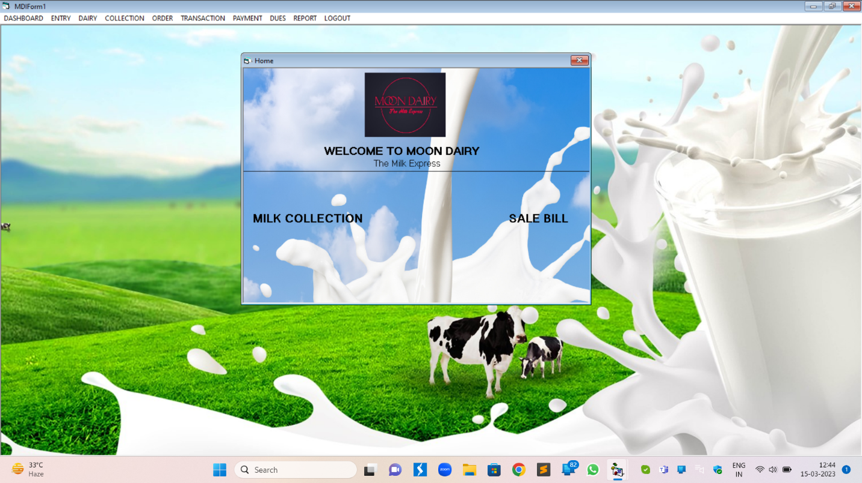

**FARMER ENTRY**

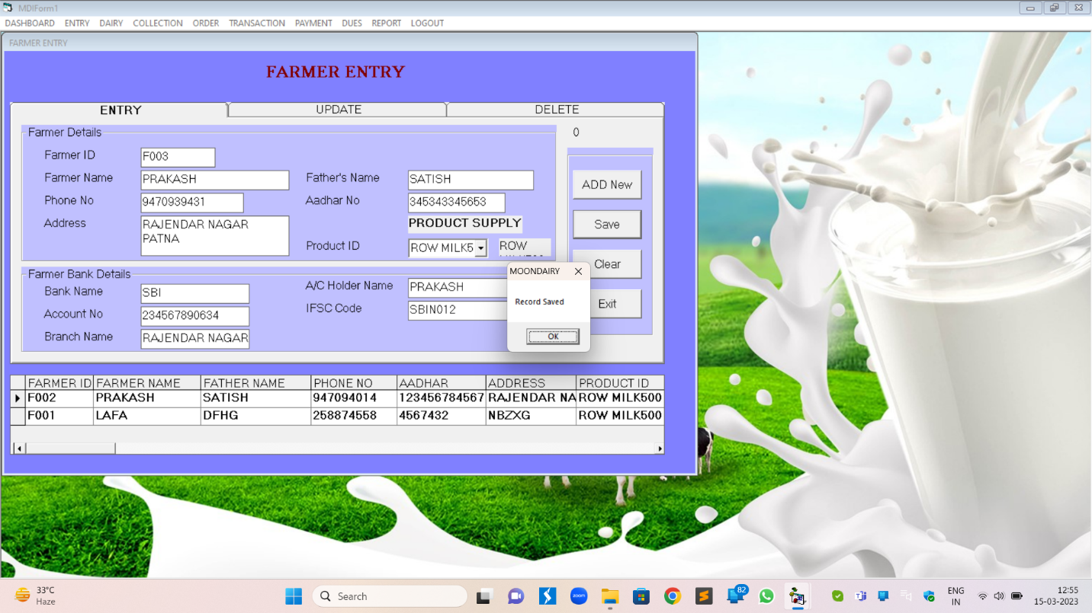

**CUSTOMER ENTRY**

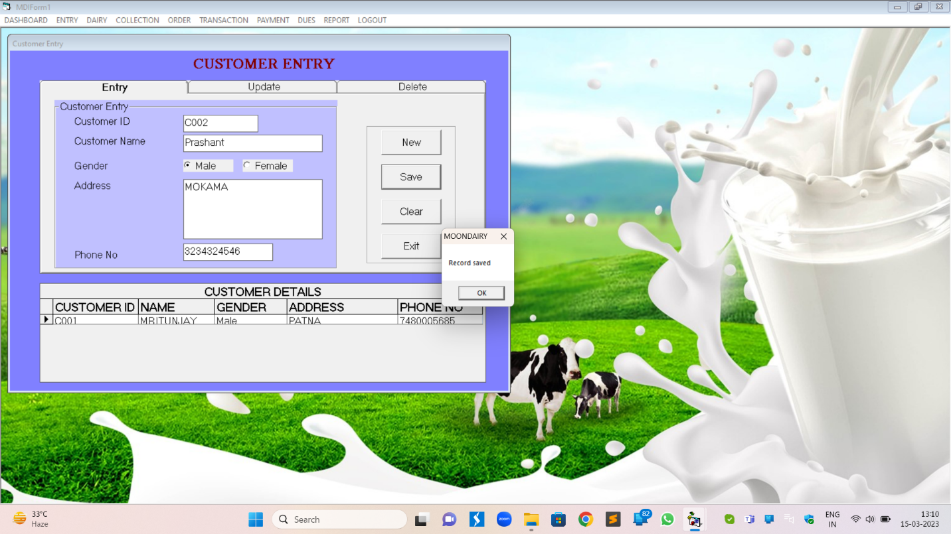

PRODUCT ENTRY

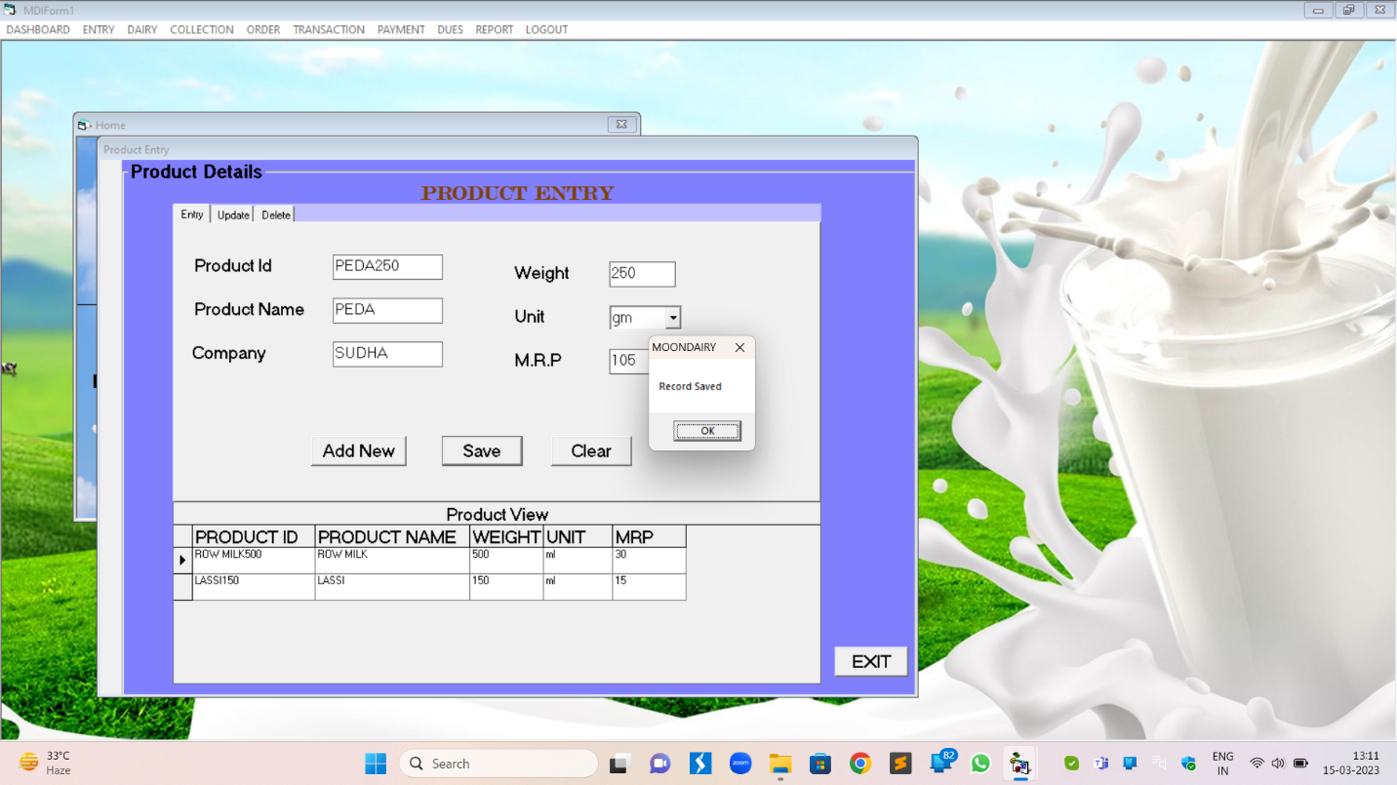

COLLECTION CENTRE

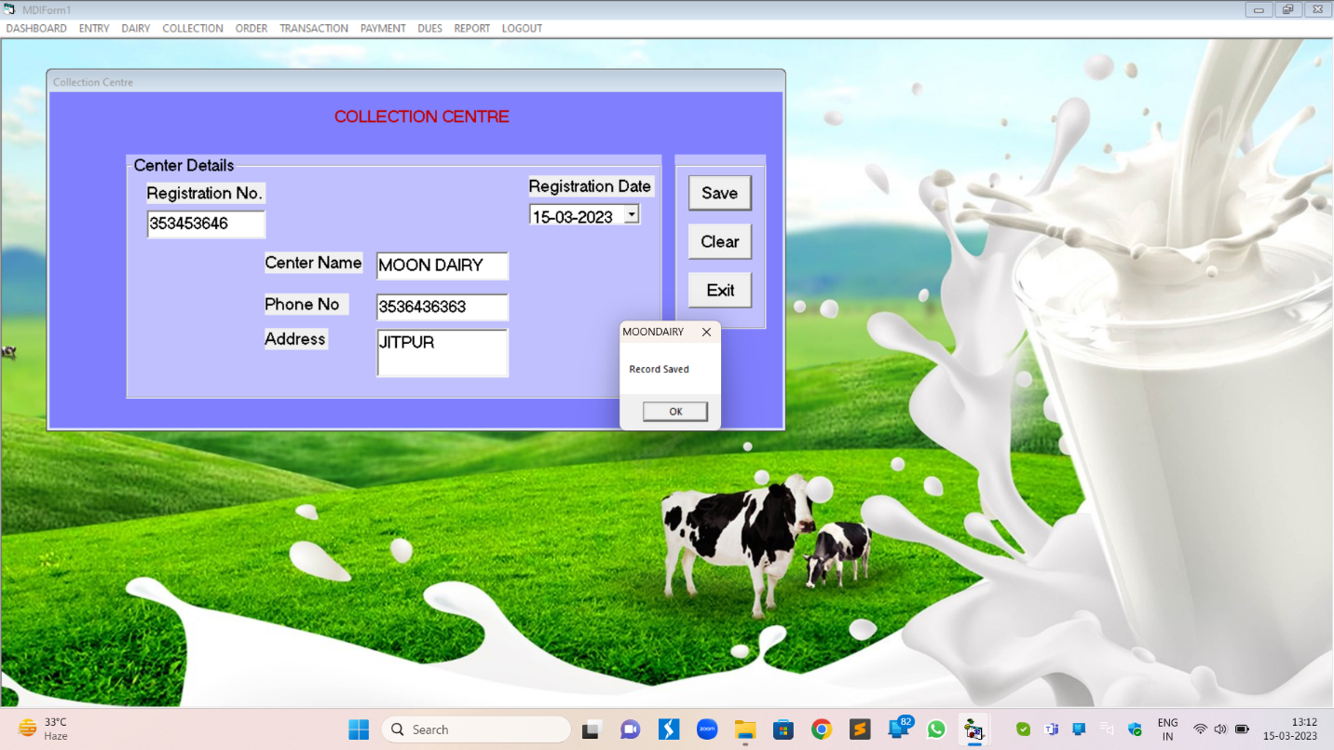

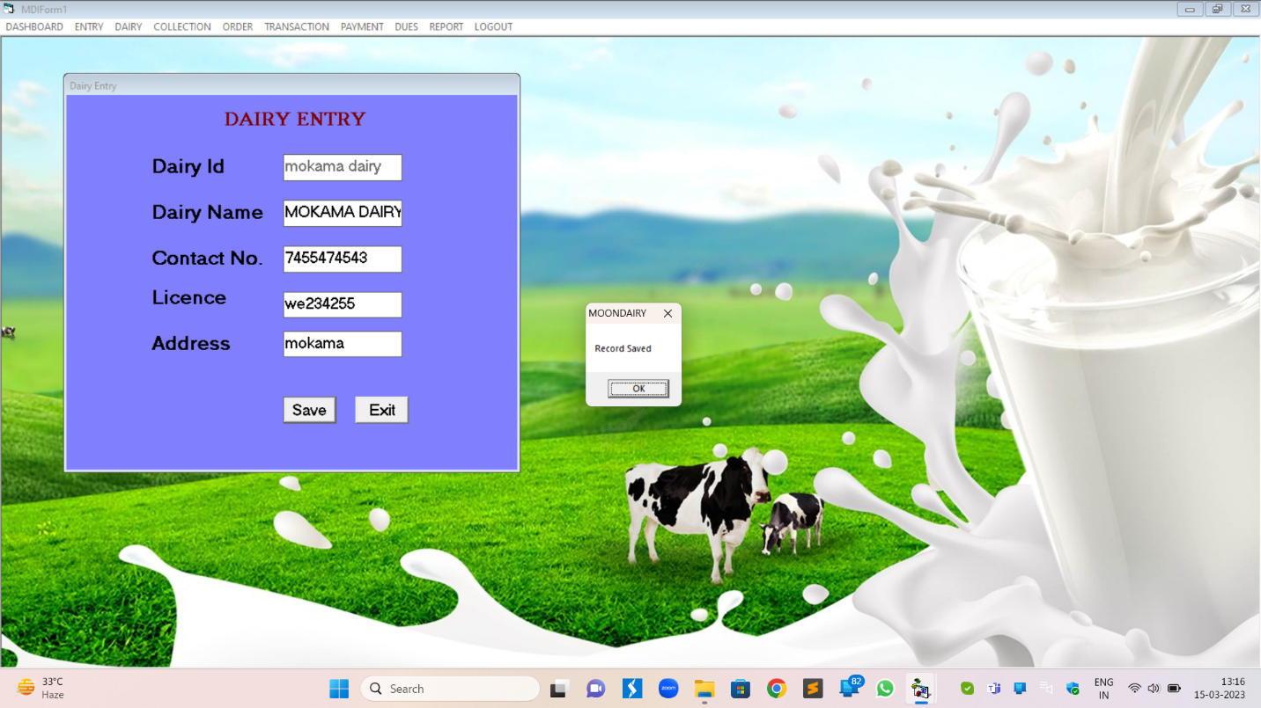 **DAIRY ENTRY**

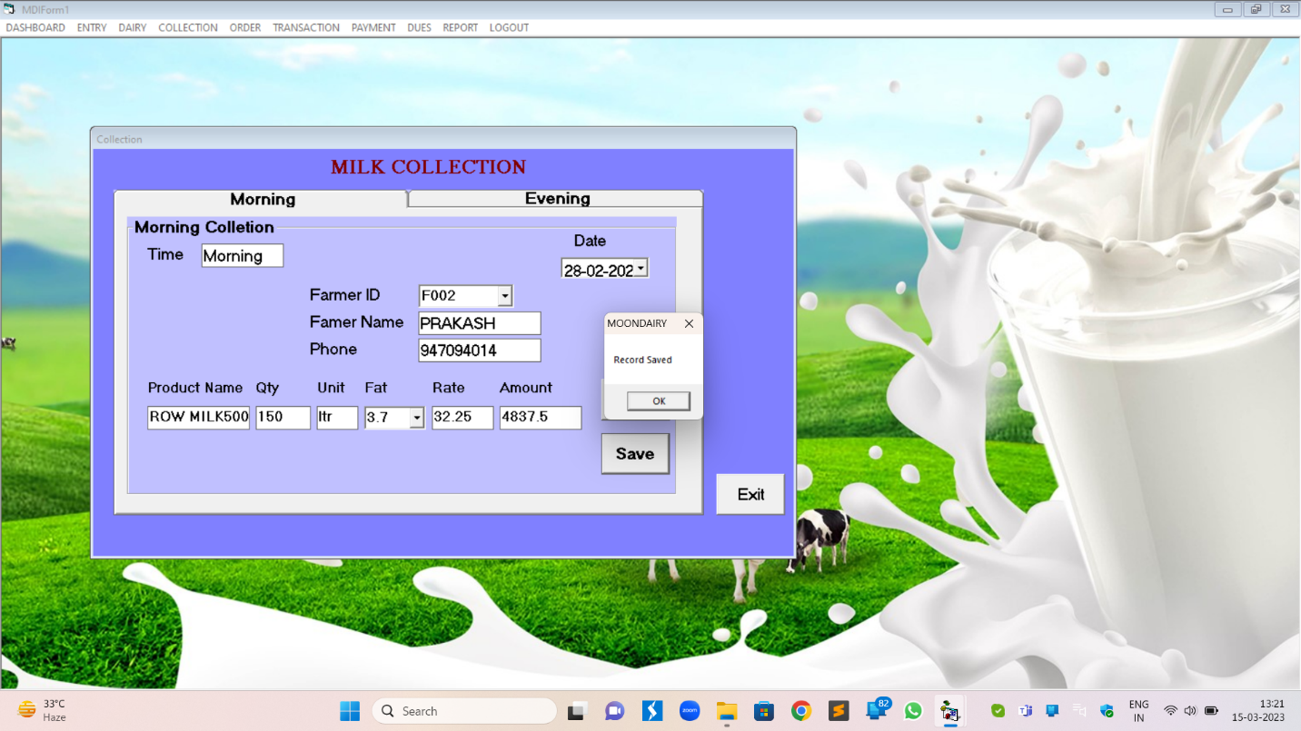

MILK COLLECTION

FAT LIST

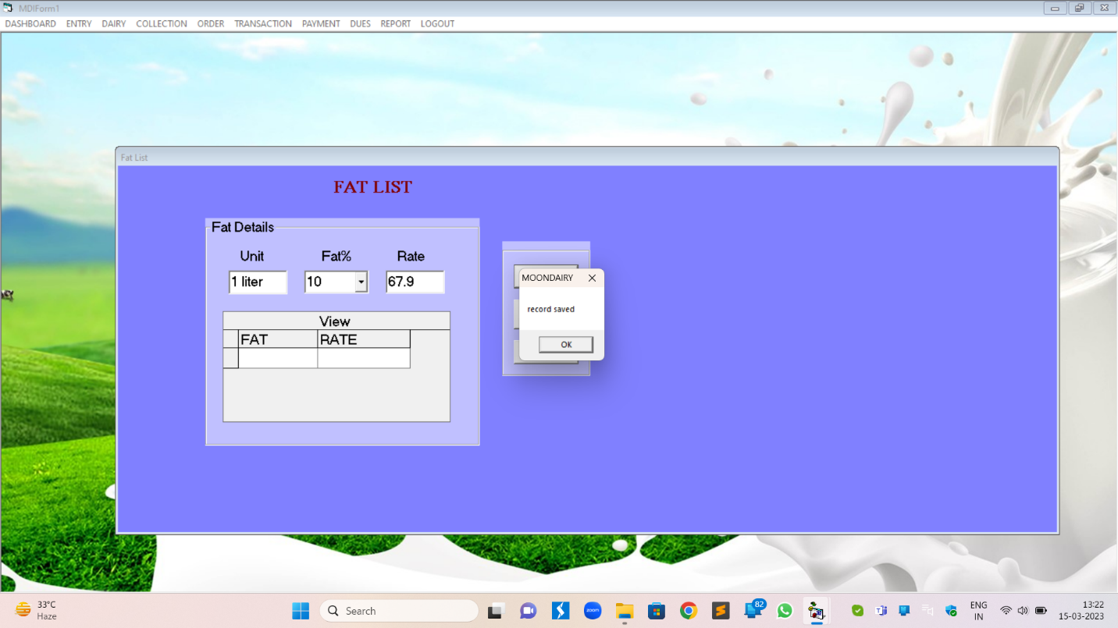

MILK COLLECTION VIEW

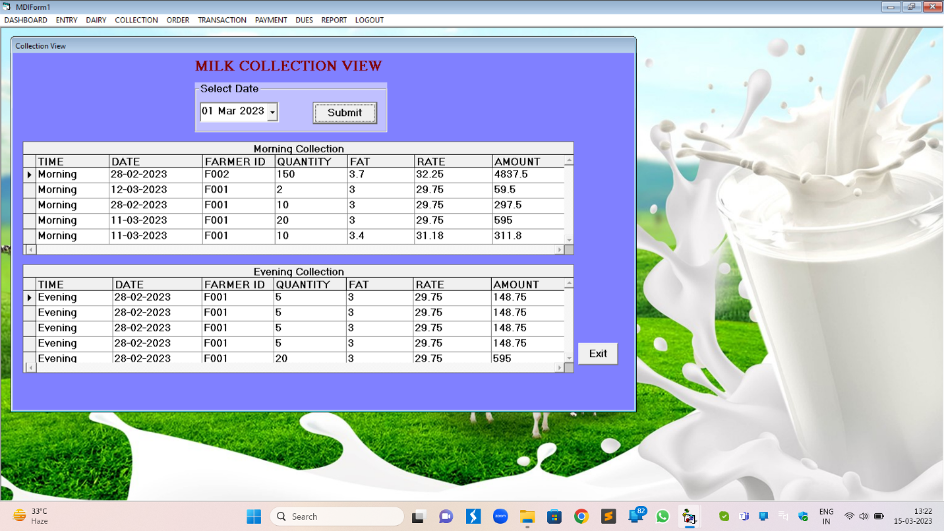

DAIRY SALE

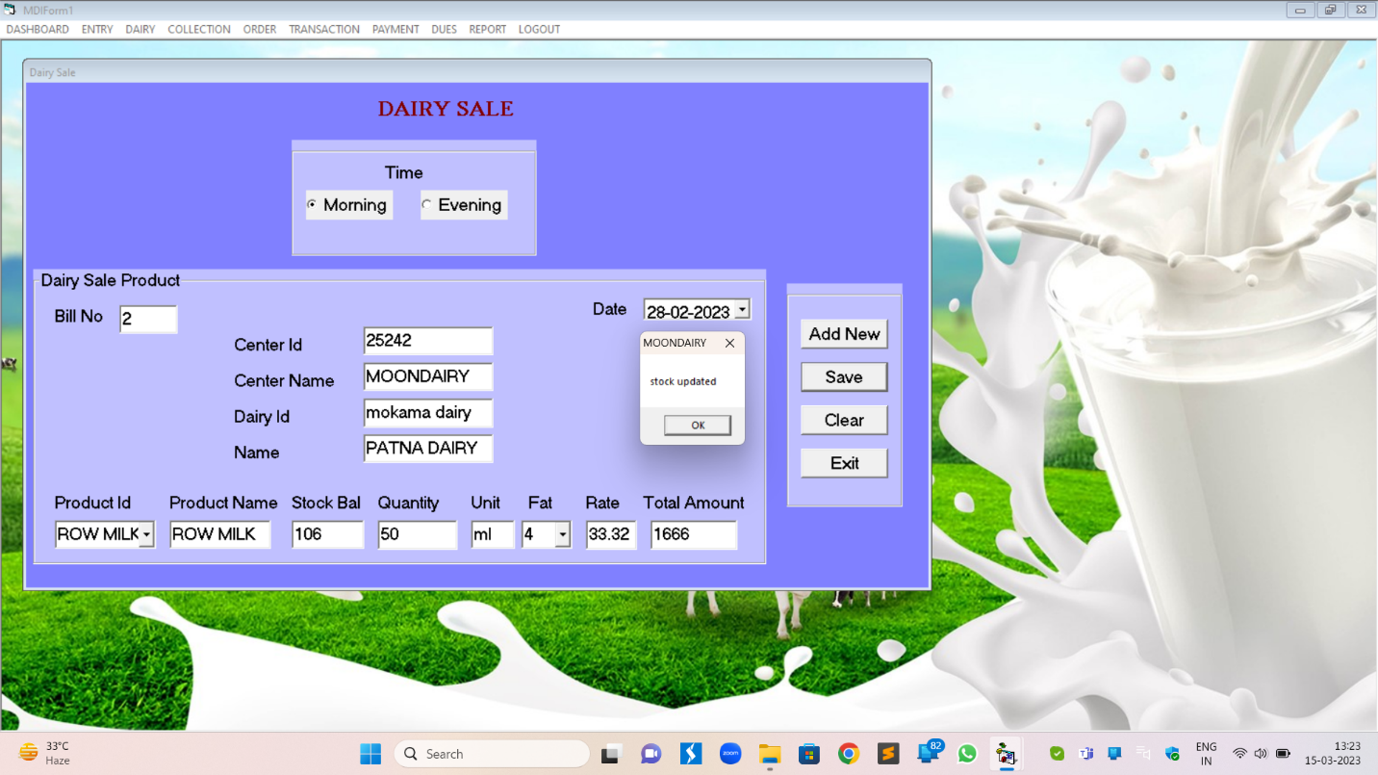

PURCHASE ORDER

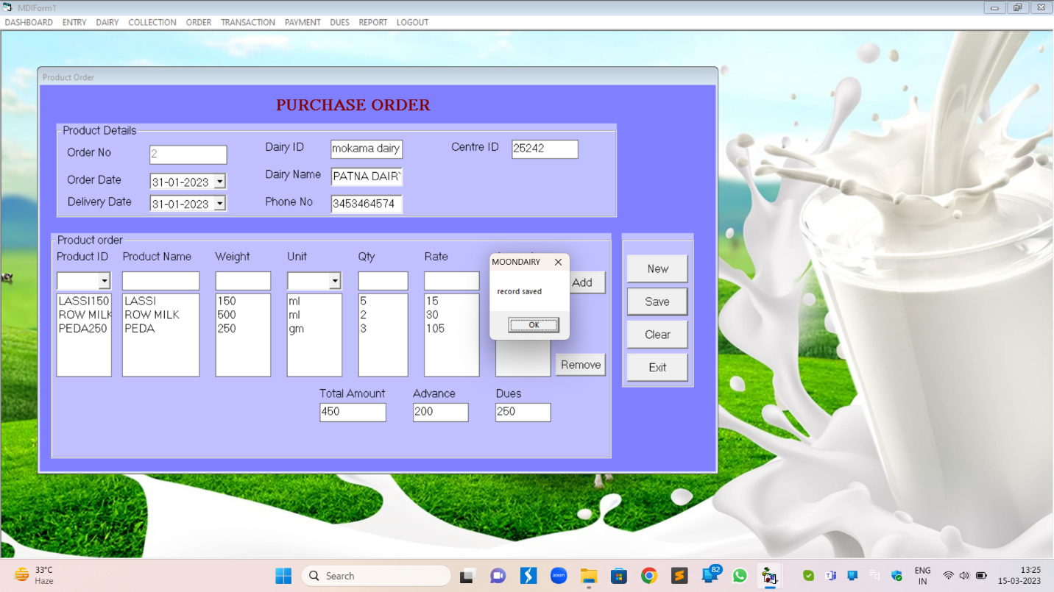

CUSTOMER ORDER

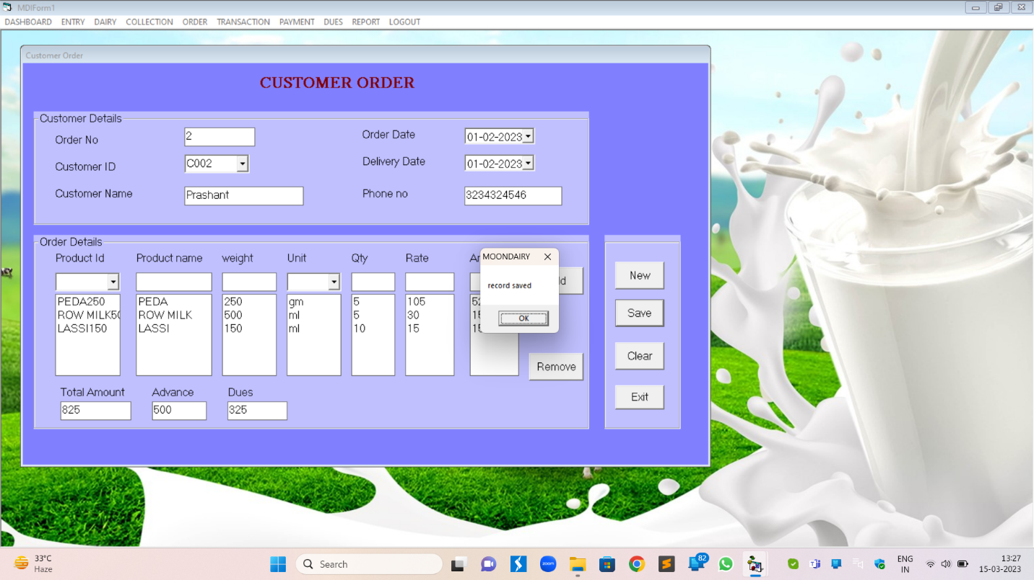

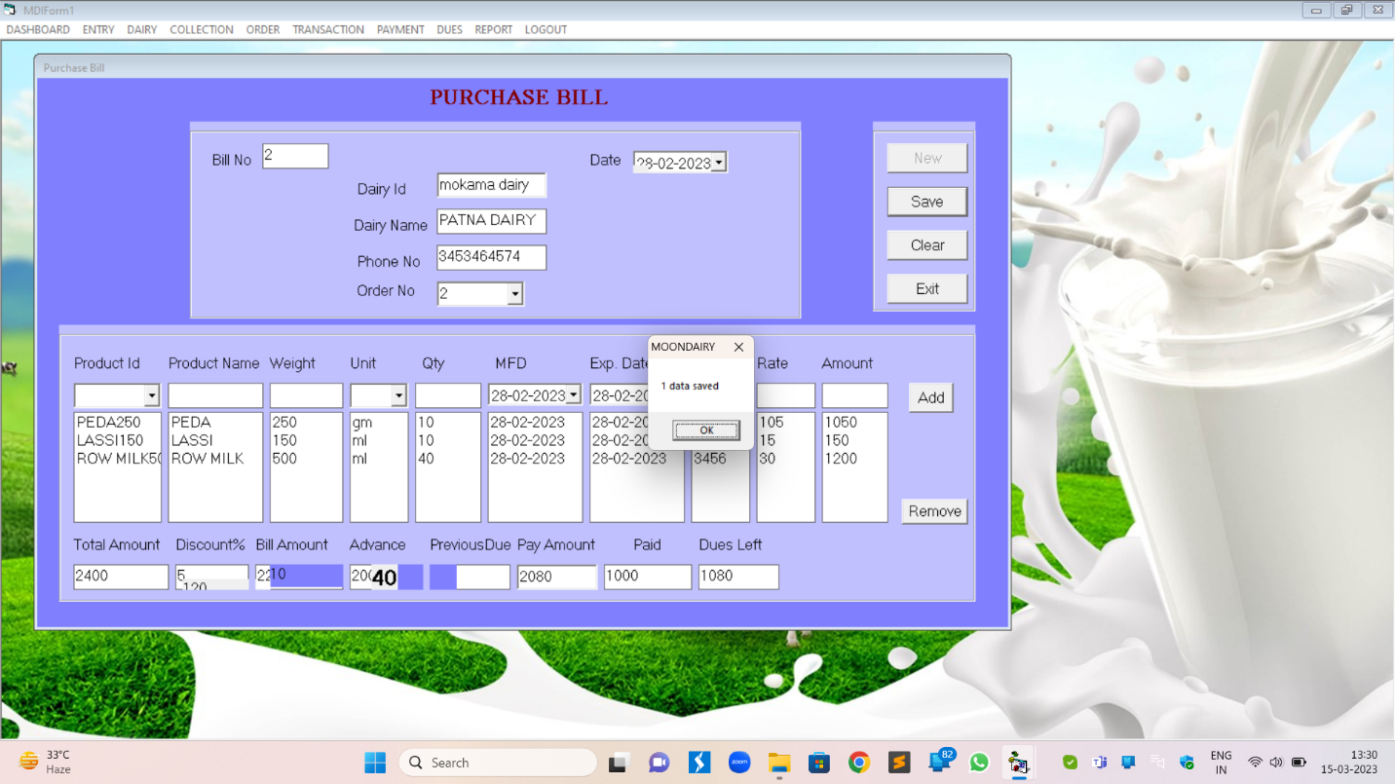PURCHASE BILL

PURCHASE VIEW

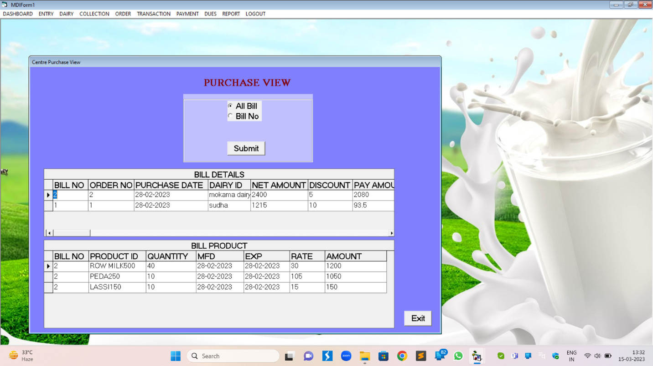

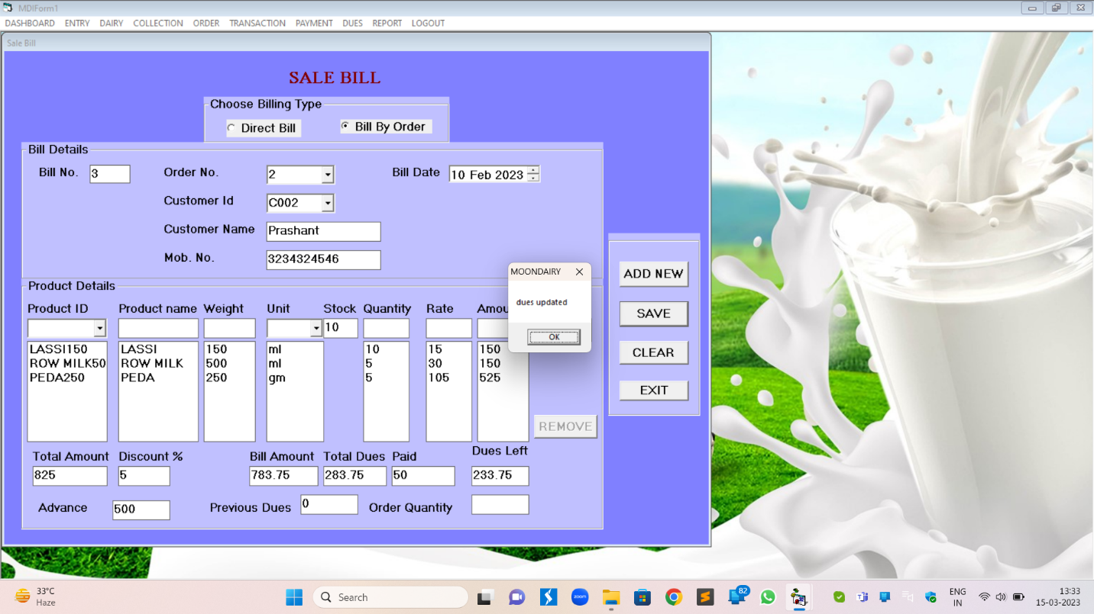SALE BILL

CUSTOMER ORDER

PURCHASE BILL



SALES RETURN VIEW

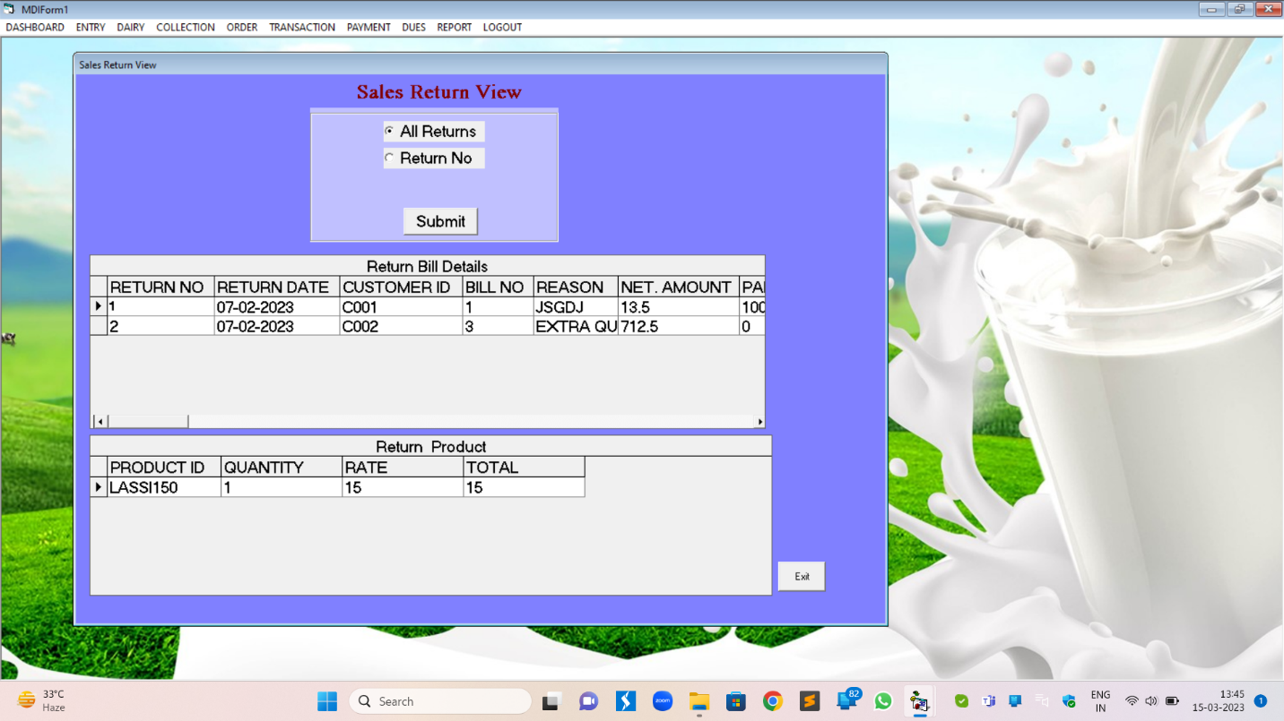

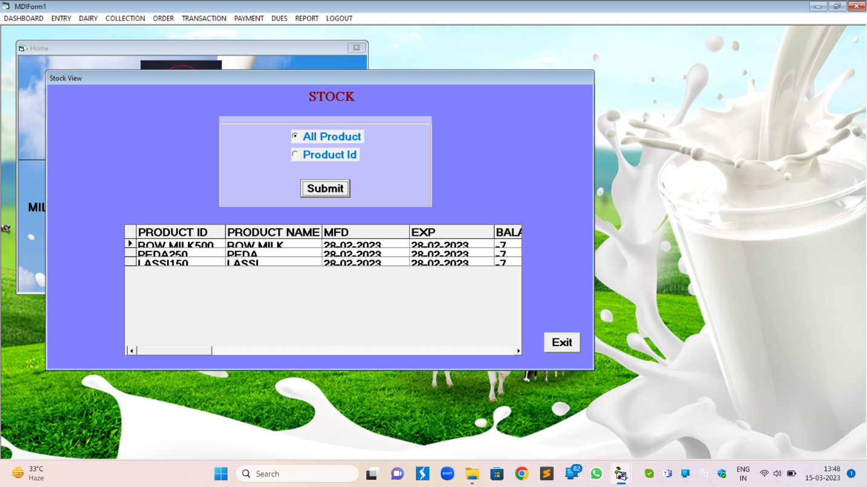STOCK

CENTRE DUES

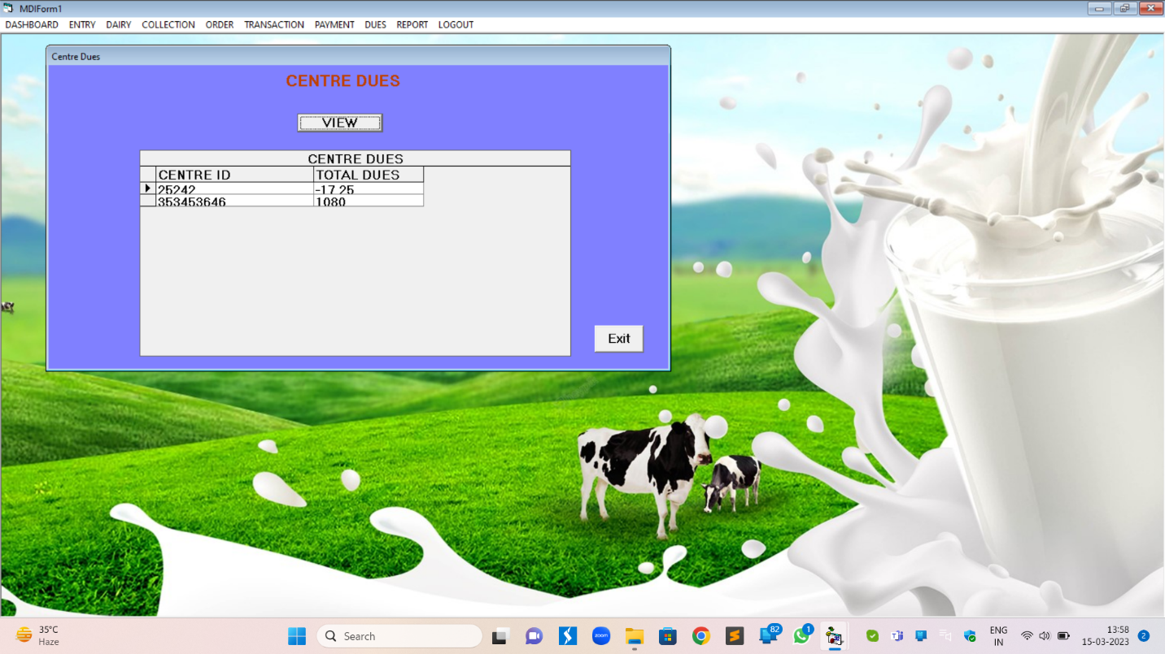

PRODUCT REPORT

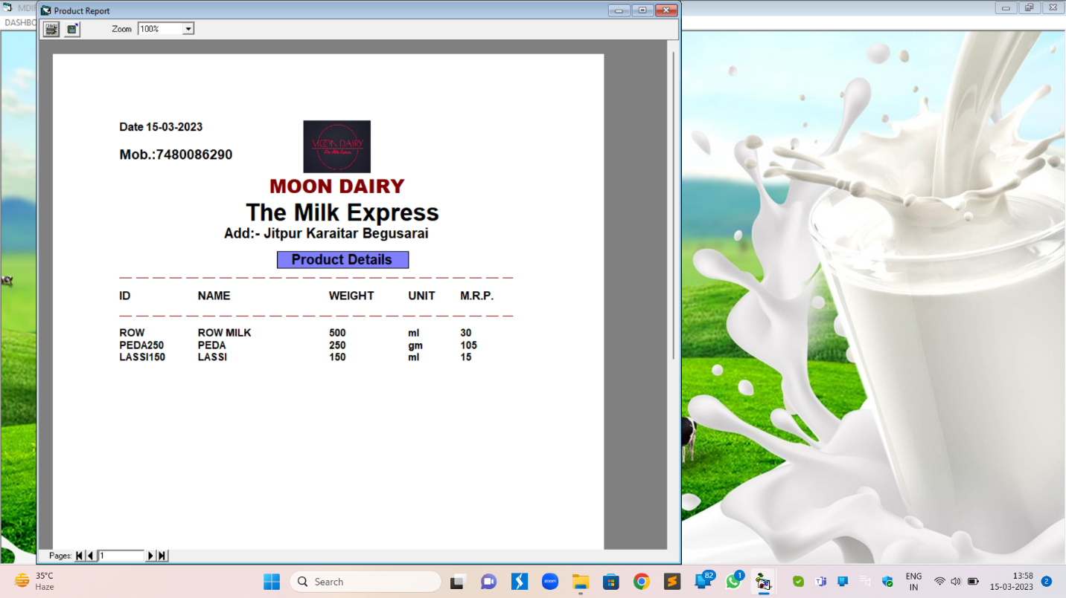

CUSTOMER REPORT

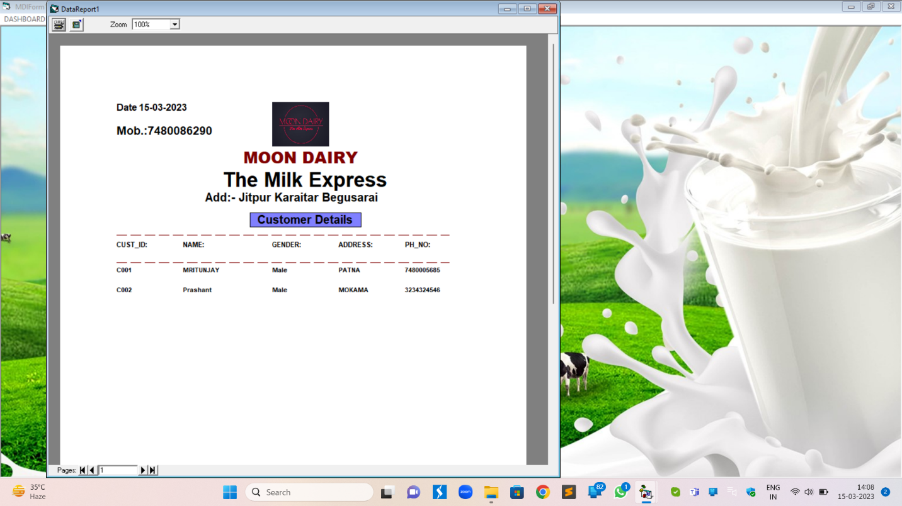

FARMER REPORT

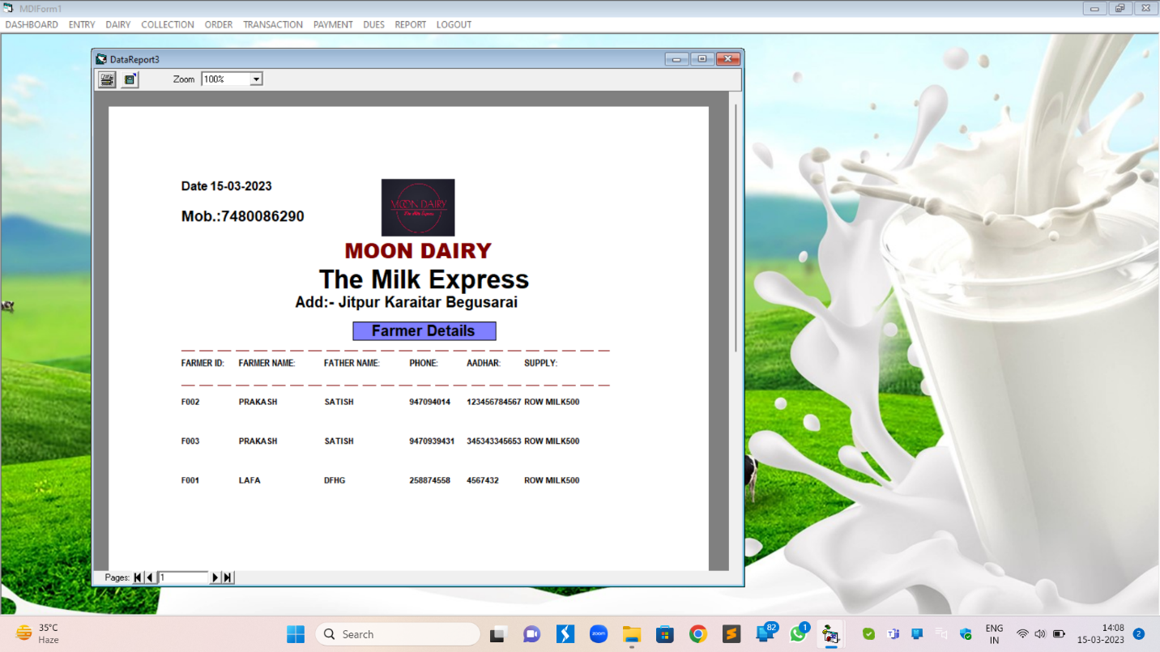

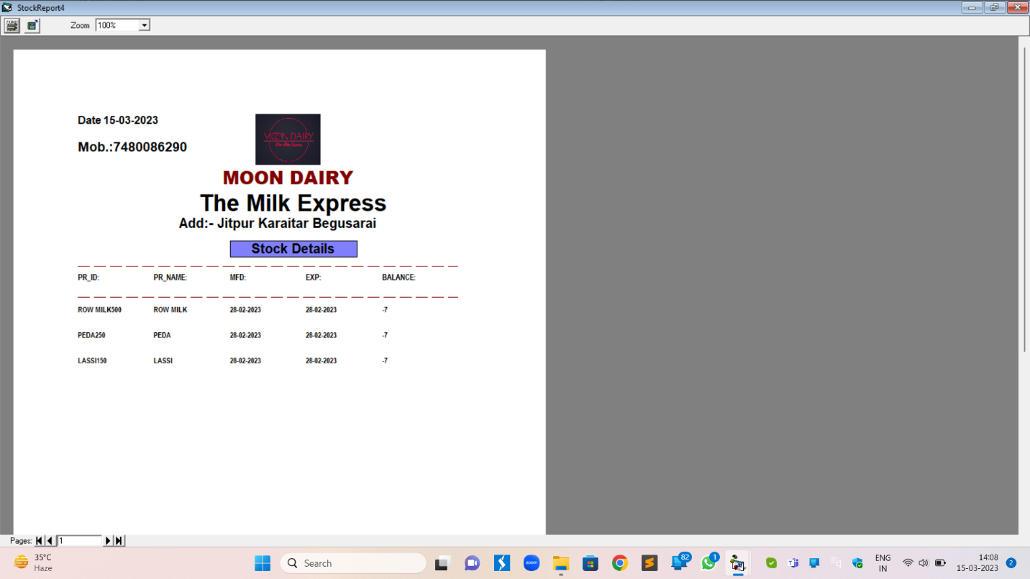STOCK REPORT

SPLASH SCREEN

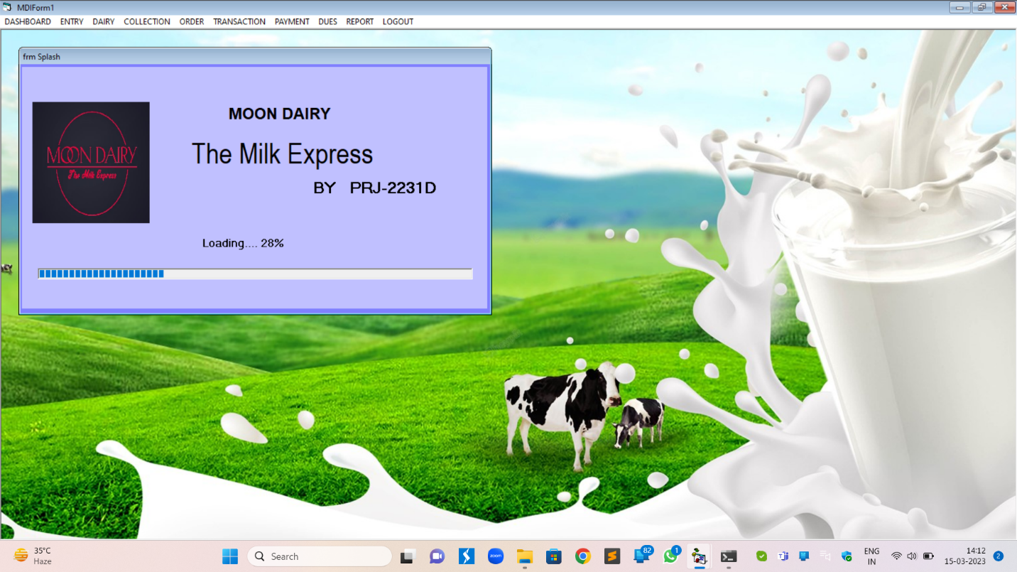

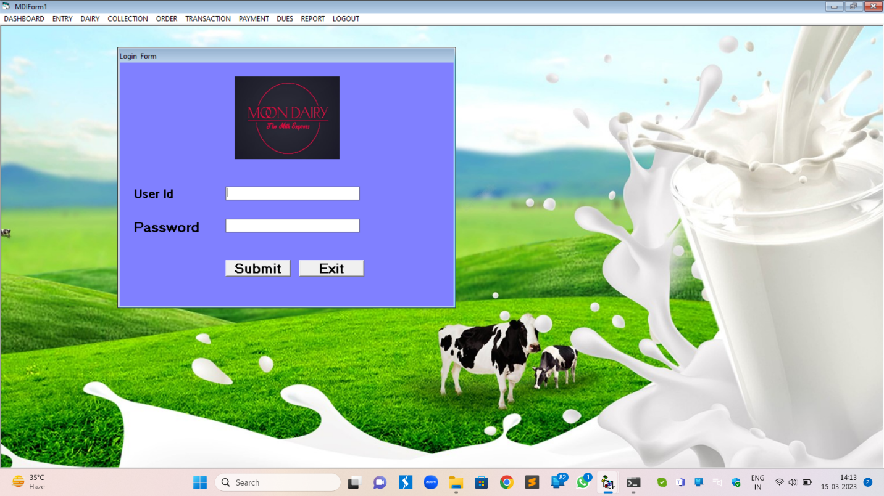LOGIN

MDI FORM



HOME

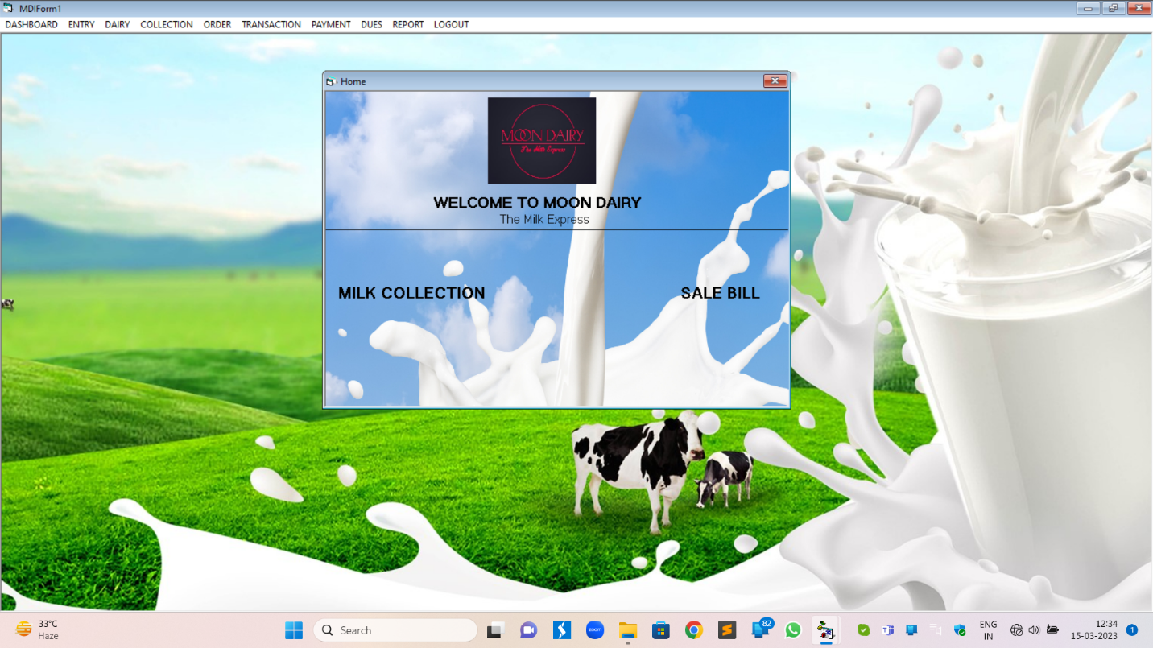

**CUSTOMER DUES**

Option Explicit

Private Sub Command1_Click()

Adodc1.RecordSource = "select * from CENTRE_DUES "

Adodc1.Refresh

End Sub

Private Sub Command2_Click()

Unload Me

home.Show

End Sub

**CENTRE PURCHASE VIEW**

Private Sub Command1_Click()

If Option1.Value = True Then

Adodc1.RecordSource = "select * from purchasebill_details " 'where bill_no=" + Text1.Text + ""

Adodc1.Refresh

'Command2.Visible = True

End If

If Option2.Value = True Then

If Text1.Text = "" Then

MsgBox "Enter Bill No"

Text1.SetFocus

Else

Adodc1.RecordSource = "select * from purchasebill_details where bill_no=" + Text1.Text + ""

Adodc1.Refresh

Command2.Visible = True

End If

End If

End Sub

Private Sub Command2_Click()

DataGrid2.Visible = True

If Option2.Value = True Then

Adodc2.RecordSource = "select * from purchasebill_pr where bill_no=" + Text1.Text + ""

Adodc2.Refresh

End If

If Option1.Value = True Then

Adodc2.RecordSource = "select * from purchasebill_pr " 'where bill_no=" + Text1.Text + ""

Adodc2.Refresh

End If

End Sub

Private Sub Command3_Click()

Unload Me

home.Show

End Sub

Private Sub DataGrid1_Click()

DataGrid2.Visible = True

Adodc2.RecordSource = "select * from purchasebill_pr where bill_no=" + DataGrid1.Text + ""

Adodc2.Refresh

End Sub

Private Sub Form_Load()

DataGrid2.Visible = False

Command2.Visible = False

Text1.Visible = False

End Sub

Private Sub Option1_Click()

Text1.Text = ""

DataGrid2.Visible = False

Text1.Visible = False

Command2.Visible = False

Adodc1.RecordSource = "select * from purchasebill_details where 1>2"

Adodc1.Refresh

End Sub

Private Sub Option2_Click()

Text1.Text = ""

DataGrid2.Visible = False

Text1.Visible = True

Command2.Visible = False

Adodc1.RecordSource = "select * from purchasebill_details where 1>2"

Adodc1.Refresh

End Sub

'Private Sub Text2_LostFocus()

'Text2.Text = StrConv(Text2.Text, vbProperCase)

'End Sub

**COLLECTION CENTRE**

Private Sub Exit_Click()

Unload Me

home.Show

End Sub

Private Sub save_Click()

'If Text1.Text = "" Or Text2.Text = "" Or Text3.Text = "" Or richtexbox1.Text = "" Then

'MsgBox " All Fields Required"

'Else

sql = "insert into collection_centre values(" + Text1.Text + ",'" + Format(DTPicker1.Value, "dd mmm yyyy") + "','" + Text2.Text + "'," + Text3.Text + ",'" + RichTextBox1.Text + "')"

Set r = c.Execute(sql)

sql = "INSERT INTO CENTRE_DUES VALUES('" + Text1.Text + "'," + Label6.Caption + ")"

Set r = c.Execute(sql)

MsgBox "Record Saved"

Text1.Text = ""

Text1.Text = ""

Text1.Text = ""

RichTextBox1.Text = ""

'End If

'save.Enabled = False

End Sub

Private Sub clear_Click()

Text1.Text = ""

Text1.Text = ""

Text1.Text = ""

RichTextBox1.Text = ""

End Sub

Private Sub Form_Load()

conn

End Sub

Private Sub RichTextBox1_KeyPress(KeyAscii As Integer)

If KeyAscii = 13 Then

RichTextBox1.Text = UCase(RichTextBox1.Text)

End If

End Sub

Private Sub RichTextBox1_LostFocus()

RichTextBox1.Text = UCase(RichTextBox1.Text)

End Sub

Private Sub Text1_KeyPress(KeyAscii As Integer)

If (KeyAscii > 47 And KeyAscii < 58) Or (KeyAscii = 13) Or KeyAscii = 8 Then

KeyAscii = KeyAscii

Else

KeyAscii = 0

MsgBox (" enter numeric value only")

End If

If KeyAscii = 13 Then

DTPicker1.SetFocus

End If

End Sub

Private Sub Text2_KeyPress(KeyAscii As Integer)

If KeyAscii = 13 Then

Text2.Text = UCase(Text2.Text)

Text3.SetFocus

End If

End Sub

Private Sub Text2_LostFocus()

Text2.Text = UCase(Text2.Text)

End Sub

Private Sub text3_keypress(KeyAscii As Integer)

Text3.MaxLength = 10

If (KeyAscii > 47 And KeyAscii < 58) Or (KeyAscii = 13) Or KeyAscii = 8 Then

KeyAscii = KeyAscii

Else

KeyAscii = 0

MsgBox (" enter numeric value only")

End If

If KeyAscii = 13 Then

RichTextBox1.SetFocus

End If

End Sub

**CUSTOMER DUES**

Option Explicit

Private Sub Command1_Click()

conn

Adodc1.RecordSource = "select * from customer_dues"

Adodc1.Refresh

End Sub

Private Sub Command2_Click()

conn

Adodc1.RecordSource = "select * from customer_dues where cust_id='" + Combo1.Text + "'"

Adodc1.Refresh

End Sub

Private Sub Command3_Click()

Unload Me

home.Show

End Sub

Private Sub Option1_Click()

Combo1.Visible = False

Command2.Visible = False

Command1.Visible = True

Combo1.clear

End Sub

Private Sub Option2_Click()

conn

sql = "select cust_id from customer_dues"

Set r = c.Execute(sql)

Do While Not r.EOF

Combo1.AddItem r.Fields(0)

r.MoveNext

Loop

Command2.Visible = True

Command1.Visible = False

Combo1.Visible = True

End Sub

**CUSTOMER ENTRY**

Private Sub Command1_Click()

a = "C00"

sql = "select count(cust_id) from customer_entry"

Set r = c.Execute(sql)

Text1.Text = a & r.Fields(0) + 1

Text1.Enabled = True

Text2.Enabled = True

Option1.Enabled = True

Option2.Enabled = True

RichTextBox1.Enabled = True

Text4.Enabled = True

End Sub

Private Sub Command2_Click()

sql = "insert into customer_entry values ('" + Text1.Text + "','" + Text2.Text + "','" + Label24.Caption + "','" + RichTextBox1.Text + "'," + Text4.Text + ")"

Set r = c.Execute(sql)

'SQL = "insert into customer_dues values ('" + Text1.Text + "','" + Text2.Text + "'," + Label5.Caption + "," + Label7.Caption + "," + Label12.Caption + "," + lablel14.Caption + ")"

'Set R = C.Execute(SQL)

sql = "insert into customer_dues values ('" + Text1.Text + "','" + Text2.Text + "'," + Label5.Caption + ")"

Set r = c.Execute(sql)

MsgBox "Record saved"

Adodc1.Refresh

Text2.Text = ""

Label24.Caption = ""

RichTextBox1.Text = ""

Text4.Text = ""

Option1.Value = False

Option2.Value = False

End Sub

Private Sub Command3_Click()

Text2.Text = ""

RichTextBox1.Text = ""

Text4.Text = ""

End Sub

Private Sub Command4_Click()

Unload Me

home.Show

End Sub

Private Sub Command5_Click()

sql = "select * from Customer_entry where cust_id='" + Text11.Text + "'"

Set r = c.Execute(sql)

Text6.Text = r.Fields(0)

Text7.Text = r.Fields(1)

RichTextBox2.Text = r.Fields(3)

Text8.Text = r.Fields(4)

Text6.Enabled = True

Text7.Enabled = True

'Option3.Enabled = true

'Option4.Enabled = true

RichTextBox2.Enabled = True

Text8.Enabled = True

End Sub

Private Sub Command6_Click()

sql = "update cust_entry set name='" + Text7.Text + "',gender='" + Text3.Text + "',address='" + RichTextBox2.Text + "',ph_no=" + Text8.Text + "where cust_id='" + Text6.Text + "'"

Set r = c.Execute(sql)

MsgBox "Record Updated"

Adodc1.Refresh

Text6.Locked = True

End Sub

Private Sub Command7_Click()

sql = "select * from customer_entry WHERE cust_id='" + Text17.Text + "'"

Set r = c.Execute(sql)

Text12.Text = r.Fields(0)

Text13.Text = r.Fields(1)

RichTextBox3.Text = r.Fields(3)

Text16.Text = r.Fields(4)

End Sub

Private Sub Command8_Click()

sql = "DELETE FROM CUSTomer_ENTRY WHERE CUST_ID='" + Text17.Text + "'"

Set r = c.Execute(sql)

MsgBox "RECORD DELETED"

Adodc1.Refresh

Text12.Text = ""

Text13.Text = ""

RichTextBox3.Text = ""

Text16.Text = ""

End Sub

Private Sub Form_Load()

conn

Adodc1.Refresh

Text1.Enabled = False

Text2.Enabled = False

Option1.Enabled = False

Option2.Enabled = False

RichTextBox1.Enabled = False

Text4.Enabled = False

Text6.Enabled = False

Text7.Enabled = False

'Option3.Enabled = False

'Option4.Enabled = False

RichTextBox2.Enabled = False

Text8.Enabled = False

Text12.Enabled = False

Text13.Enabled = False

RichTextBox3.Enabled = False

Text16.Enabled = False

End Sub

Private Sub Option1_Click()

If Option1.Value = True Then

Label24.Caption = Option1.Caption

Option2.Value = False

End If

End Sub

Private Sub Option2_Click()

If Option2.Value = True Then

Label24.Caption = Option2.Caption

Option1.Value = False

End If

End Sub

Private Sub RichTextBox1_KeyPress(KeyAscii As Integer)

If KeyAscii = 13 Then

Text4.SetFocus

End If

End Sub

Private Sub RichTextBox1_LostFocus()

RichTextBox1.Text = UCase(RichTextBox1.Text)

End Sub

Private Sub Text11_LostFocus()

Text11.Text = UCase(Text11.Text)

End Sub

Private Sub Text17_LostFocus()

Text17.Text = UCase(Text17.Text)

End Sub

Private Sub Text2_KeyPress(KeyAscii As Integer)

If (KeyAscii > 96 And KeyAscii < 123) Or (KeyAscii > 64 And KeyAscii < 91) Or (KeyAscii = 32) Or (KeyAscii = 13) Or (KeyAscii = 8) Then

KeyAscii = KeyAscii

Else

KeyAscii = 0

MsgBox "ENTER ALPHABET"

End If

End Sub

Private Sub text4_keypress(KeyAscii As Integer)

Text4.MaxLength = 10

If (KeyAscii > 47 And KeyAscii < 58) Or (KeyAscii = 13) Or (KeyAscii = 8) Then

KeyAscii = KeyAscii

Else

KeyAscii = 0

MsgBox "ENTER NUMBER ONLY"

End If

If KeyAscii = 13 Then

Command2.SetFocus

End If

End Sub

**CUSTOMER ORDER**

Dim X As Single, Y As Single, z As Single

Dim k As Single

Private Sub Combo1_Click()

sql = "select pr_name from product_entry where pr_id='" + Combo1.Text + "'"

Set r = c.Execute(sql)

Text5.Text = r.Fields(0)

sql = "select weight from product_entry where pr_id='" + Combo1.Text + "'"

Set r = c.Execute(sql)

Text6.Text = r.Fields(0)

sql = "select unit from product_entry where pr_id='" + Combo1.Text + "'"

Set r = c.Execute(sql)

Combo2.Text = r.Fields(0)

sql = "select MRP from product_entry where pr_id='" + Combo1.Text + "'"

Set r = c.Execute(sql)

Text8.Text = r.Fields(0)

'Combo1.Enabled = True

'Text4.Enabled = True

Text5.Enabled = True

Combo2.Enabled = True

Text6.Enabled = True

Text7.Enabled = True

Text8.Enabled = True

Text9.Enabled = True

'Text10.Enabled = True

'Text11.Enabled = True

'Text12.Enabled = True

'Text13.Enabled = True

'Text14.Enabled = True

Text5.Locked = True

Text6.Locked = True

Combo2.Locked = True

Text8.Locked = True

Text9.Locked = True

Text7.SetFocus

End Sub

Private Sub Combo1_KeyPress(KeyAscii As Integer)

If KeyAscii = 13 Then

Text7.SetFocus

End If

End Sub

Private Sub Combo2_KeyPress(KeyAscii As Integer)

If KeyAscii = 13 Then

Text7.SetFocus

End If

End Sub

Private Sub Combo3_Click()

sql = "select name from customer_entry where cust_id='" + Combo3.Text + "'"

Set r = c.Execute(sql)

Text3.Text = r.Fields(0)

sql = "select ph_no from customer_entry where cust_id='" + Combo3.Text + "'"

Set r = c.Execute(sql)

Text4.Text = r.Fields(0)

Text3.Enabled = True

Text4.Enabled = True

Combo1.Enabled = True

Text3.Locked = True

Text4.Locked = True

Combo1.SetFocus

End Sub

Private Sub Combo3_KeyPress(KeyAscii As Integer)

If KeyAscii = 13 Then

Combo1.SetFocus

End If

End Sub

Private Sub Command1_Click()

sql = "select count(order_no) from SALEORDER_details "

Set r = c.Execute(sql)

Text1.Text = r.Fields(0) + 1

sql = "select cust_id from customer_entry"

Set r = c.Execute(sql)

Do While Not r.EOF

Combo3.AddItem r.Fields(0)

r.MoveNext

Loop

sql = "select pr_id from product_entry"

Set r = c.Execute(sql)

Do While Not r.EOF

Combo1.AddItem r.Fields(0)

r.MoveNext

Loop

DTPicker1.Enabled = True

DTPicker2.Enabled = True

Command2.Enabled = True

Command3.Enabled = True

Command4.Enabled = True

Command5.Enabled = True

Command6.Enabled = True

Text1.Enabled = True

Combo3.Enabled = True

'Text3.Enabled = True

'Combo1.Enabled = True

'Text4.Enabled = True

'Text5.Enabled = True

'Combo2.Enabled = True

'Text6.Enabled = True

'Text7.Enabled = True

'Text8.Enabled = True

'Text9.Enabled = True

'Text10.Enabled = True

'Text11.Enabled = True

'Text12.Enabled = True

'Text13.Enabled = True

'Text14.Enabled = True

Combo3.Text = ""

Text3.Text = ""

Combo1.Text = ""

Text4.Text = ""

Text5.Text = ""

Combo2.Text = ""

Text6.Text = ""

Text7.Text = ""

Text8.Text = ""

Text9.Text = ""

Text10.Text = ""

'Text11.Text = ""

Text12.Text = ""

Text13.Text = ""

'Text14.Text = ""

Combo3.SetFocus

End Sub

Private Sub Command2_Click()

conn

If Text12.Text = "" Then

MsgBox "Enter All Fields"

Else

sql = "insert into SALEORDER_details values(" + Text1.Text + ",'" + Format(DTPicker1.Value, "dd mmm yyyy") + "','" + Format(DTPicker2.Value, "dd mmm yyyy") + "','" + Combo3.Text + "'," + Text10.Text + "," + Text12.Text + "," + Text13.Text + ")"

Set r = c.Execute(sql)

For k = 0 To List1.ListCount - 1

sql = "insert into saleorder_pr values(" + Text1.Text + ",'" + List1.List(k) + "','" + List5.List(k) + "','" + List6.List(k) + "','" + List7.List(k) + "')"

Set r = c.Execute(sql)

Next

MsgBox "record saved"

Text1.Text = ""

Combo3.Text = ""

Text3.Text = ""

Text4.Text = ""

Combo1.Text = ""

Text5.Text = ""

Text6.Text = ""

Combo2.Text = ""

Text7.Text = ""

Text8.Text = ""

Text9.Text = ""

Text10.Text = ""

'Text11.Text = ""

Text12.Text = ""

Text13.Text = ""

'Text14.Text = ""

List1.clear

List2.clear

List3.clear

List4.clear

List5.clear

List6.clear

List7.clear

Command1.SetFocus

End If

End Sub

Private Sub Command3_Click()

Text1.Text = ""

Combo3.Text = ""

Text3.Text = ""

Text4.Text = ""

Combo1.Text = ""

Text5.Text = ""

Text6.Text = ""

Combo2.Text = ""

Text7.Text = ""

Text8.Text = ""

Text9.Text = ""

Text10.Text = ""

Text11.Text = ""

Text12.Text = ""

Text13.Text = ""

Text14.Text = ""

List1.clear

List2.clear

List3.clear

List4.clear

List5.clear

List6.clear

List7.clear

Command1.SetFocus

End Sub

Private Sub Command4_Click()

Unload Me

home.Show

End Sub

Private Sub Command5_Click()

If Combo1.Text = "" Or Text7.Text = "" Then

MsgBox " Enter All Fields"

Else

List1.AddItem Combo1.Text

List2.AddItem Text5.Text

List3.AddItem Text6.Text

List4.AddItem Combo2.Text

List5.AddItem Text7.Text

List6.AddItem Text8.Text

List7.AddItem Text9.Text

For i = 0 To List7.ListCount Step 1

total = total + Val(List7.List(i))

Text10.Text = total

Next

Text10.Enabled = True

'Text11.Enabled = True

Text12.Enabled = True

Text13.Enabled = True

'Text14.Enabled = True

Text10.Locked = True

Text13.Locked = True

'Text14.Locked = True

Combo1.Text = ""

Text5.Text = ""

Text6.Text = ""

Combo2.Text = ""

Text7.Text = ""

Text8.Text = ""

Text9.Text = ""

End If

End Sub

Private Sub Command6_Click()

List1.RemoveItem ListIndex

List2.RemoveItem ListIndex

List3.RemoveItem ListIndex

List4.RemoveItem ListIndex

List5.RemoveItem ListIndex

List6.RemoveItem ListIndex

List7.RemoveItem ListIndex

For i = 0 To List7.ListCount Step 1

total = total + Val(List7.List(i))

Text10.Text = total

Next

End Sub

Private Sub Form_Load()

conn

'Combo1.AddItem "ghee"

Combo2.AddItem "kg"

Combo2.AddItem "lit"

Combo2.AddItem "gm"

Combo2.AddItem "ml"

Command2.Enabled = False

Command3.Enabled = False

Command4.Enabled = False

Command5.Enabled = False

Command6.Enabled = False

Text1.Enabled = False

Combo3.Enabled = False

Text3.Enabled = False

Combo1.Enabled = False

Text4.Enabled = False

Text5.Enabled = False

Combo2.Enabled = False

Text6.Enabled = False

Text7.Enabled = False

Text8.Enabled = False

Text9.Enabled = False

Text10.Enabled = False

'Text11.Enabled = False

Text12.Enabled = False

Text13.Enabled = False

'Text14.Enabled = False

End Sub

'Private Sub Text10_KeyPress(KeyAscii As Integer)

'If (KeyAscii > 47 And KeyAscii < 58) Or (KeyAscii = 13) Or (KeyAscii = 8) Then

'KeyAscii = KeyAscii

'Else

'KeyAscii = 0

'MsgBox "ENTER NUMBER ONLY"

'End If

'End Sub

'Private Sub Text11_KeyPress(KeyAscii As Integer)

'If (KeyAscii > 47 And KeyAscii < 58) Or (KeyAscii = 13) Or (KeyAscii = 8) Then

'KeyAscii = KeyAscii

'Else

'KeyAscii = 0

'MsgBox "ENTER NUMBER ONLY"

'End If

'If KeyAscii = 13 Then

'Text12.SetFocus

'End If

'End Sub

'Private Sub Text11_LostFocus()

'Text14.Text = Val(Text10.Text) - Val(Text10.Text) * Val(Text11.Text) / 100

'End Sub

Private Sub Text12_KeyPress(KeyAscii As Integer)

If (KeyAscii > 47 And KeyAscii < 58) Or (KeyAscii = 13) Or (KeyAscii = 8) Then

KeyAscii = KeyAscii

Else

KeyAscii = 0

MsgBox "ENTER NUMBER ONLY"

End If

If KeyAscii = 13 Then

Text13.Text = Val(Text10.Text) - Val(Text12.Text)

Command2.SetFocus

End If

End Sub

Private Sub Text12_LostFocus()

Text13.Text = Val(Text10.Text) - Val(Text12.Text)

End Sub

'Private Sub Text13_KeyPress(KeyAscii As Integer)

'If (KeyAscii > 47 And KeyAscii < 58) Or (KeyAscii = 13) Or (KeyAscii = 8) Then

'KeyAscii = KeyAscii

'Else

'KeyAscii = 0

'MsgBox "ENTER NUMBER ONLY"

'End If

'End Sub

'Private Sub Text14_KeyPress(KeyAscii As Integer)

'If (KeyAscii > 47 And KeyAscii < 58) Or (KeyAscii = 13) Or (KeyAscii = 8) Then

'KeyAscii = KeyAscii

'Else

'KeyAscii = 0

'MsgBox "ENTER NUMBER ONLY"

'End If

'End Sub

Private Sub Text2_KeyPress(KeyAscii As Integer)

If KeyAscii = 13 Then

Text3.SetFocus

End If

End Sub

Private Sub text3_keypress(KeyAscii As Integer)

If (KeyAscii > 96 And KeyAscii < 123) Or (KeyAscii > 64 And KeyAscii < 91) Or (KeyAscii = 32) Or (KeyAscii = 13) Or (KeyAscii = 8) Then

KeyAscii = KeyAscii

Else

KeyAscii = 0

MsgBox "ENTER ALPHABET"

End If

If KeyAscii = 13 Then

Text4.SetFocus

End If

End Sub

Private Sub Text4_LostFocus()

If Len(Text4.Text) <> 10 Then

MsgBox "Enter 10 Digit"

Text4.SetFocus

End If

End Sub

Private Sub Text5_KeyPress(KeyAscii As Integer)

If KeyAscii = 13 Then

Text6.SetFocus

End If

End Sub

Private Sub Text6_KeyPress(KeyAscii As Integer)

If (KeyAscii > 47 And KeyAscii < 58) Or (KeyAscii = 13) Or (KeyAscii = 8) Then

KeyAscii = KeyAscii

Else

KeyAscii = 0

MsgBox "ENTER NUMBER ONLY"

End If

If KeyAscii = 13 Then

Combo2.SetFocus

End If

End Sub

Private Sub Text7_KeyPress(KeyAscii As Integer)

If (KeyAscii > 47 And KeyAscii < 58) Or (KeyAscii = 13) Or (KeyAscii = 8) Then

KeyAscii = KeyAscii

Else

KeyAscii = 0

MsgBox "ENTER NUMBER ONLY"

End If

If KeyAscii = 13 Then

Command5.SetFocus

End If

End Sub

Private Sub Text7_LostFocus()

X = Val(Text7.Text)

Y = Val(Text8.Text)

z = X * Y

Text9.Text = z

End Sub

Private Sub Text8_KeyPress(KeyAscii As Integer)

If (KeyAscii > 47 And KeyAscii < 58) Or (KeyAscii = 13) Or (KeyAscii = 8) Then

KeyAscii = KeyAscii

Else

KeyAscii = 0

MsgBox "ENTER NUMBER ONLY"

End If

If KeyAscii = 13 Then

Command5.SetFocus

End If

End Sub

Private Sub Text8_LostFocus()

X = Val(Text7.Text)

Y = Val(Text8.Text)

z = X * Y

Text9.Text = z

End Sub

Private Sub Text9_KeyPress(KeyAscii As Integer)

If (KeyAscii > 47 And KeyAscii < 58) Or (KeyAscii = 13) Or (KeyAscii = 8) Then

KeyAscii = KeyAscii

Else

KeyAscii = 0

MsgBox "ENTER NUMBER ONLY"

End If

End Sub

**DAIRY ENTRY**

Private Sub Image1_Click()

End Sub

Private Sub save_Click()

If Text1.Text = "" Or Text2.Text = "" Or Text3.Text = "" Or Text4.Text = "" Or Text5.Text = "" Then

MsgBox "All Fields Required"

Command2.SetFocus

Else

conn

sql = "insert into Dairy_Entry values('" + Text1.Text + "','" + Text2.Text + "'," + Text3.Text + ",'" + Text4.Text + "','" + Text5.Text + "')"

Set r = c.Execute(sql)

sql = "insert into Dairy_dues values('" + Text1.Text + "'," + Label6.Caption + ")"

Set r = c.Execute(sql)

MsgBox "Record Saved"

End If

Text1.Text = ""

Text2.Text = ""

Text3.Text = ""

Text4.Text = ""

Text5.Text = ""

End Sub

Private Sub Exit_Click()

Unload Me

home.Show

End Sub

Private Sub Form_Load()

Text1.Enabled = False

save.Enabled = False

End Sub

Private Sub Text1_KeyPress(KeyAscii As Integer)

If KeyAscii = 13 Then

Text2.SetFocus

End If

End Sub

Private Sub Text2_KeyPress(KeyAscii As Integer)

If (KeyAscii > 96 And KeyAscii < 123) Or (KeyAscii > 64 And KeyAscii < 91) Or (KeyAscii = 32) Or (KeyAscii = 13) Or (KeyAscii = 8) Then

KeyAscii = KeyAscii

Else

KeyAscii = 0

MsgBox ("Enter Character Only")

End If

If KeyAscii = 13 Then

Text2.Text = UCase(Text2.Text)

Text3.SetFocus

End If

End Sub

Private Sub text3_keypress(KeyAscii As Integer)

Text3.MaxLength = 10

If (KeyAscii > 47 And KeyAscii < 58) Or (KeyAscii = 13) Or (KeyAscii = 8) Then

KeyAscii = KeyAscii

Else

KeyAscii = 0

MsgBox ("Enter Number Only")

End If

If KeyAscii = 13 Then

Text4.SetFocus

End If

End Sub

Private Sub Text2_LostFocus()

Text1.Text = LCase(Text2.Text)

End Sub

Private Sub Text3_LostFocus()

If Len(Text3.Text) <> 10 Then

MsgBox "Enter 10 Digit"

Text5.SetFocus

End If

End Sub

Private Sub Text4_Click()

If KeyAscii = 13 Then

Text5.SetFocus

End If

End Sub

Private Sub text4_keypress(KeyAscii As Integer)

If KeyAscii = 13 Then

Text5.SetFocus

End If

End Sub

Private Sub Text5_KeyPress(KeyAscii As Integer)

save.Enabled = True

If KeyAscii = 13 Then

save.SetFocus

End If

End Sub

**DAIRY PAYMENT**

Private Sub Exit_Click()

Unload Me

home.Show

End Sub

Private Sub Submit_Click()

sql = "select bill_date,qty,fat,total_amt from morning_dairysale where bill_date between '" + Format(DTPicker1.Value, "dd mmm yyyy") + "' and '" + Format(DTPicker2.Value, "dd mmm yyyy") + "'" ' and f_id='" + Combo1.Text + "'"

Set r = c.Execute(sql)

Do While Not r.EOF

List1.AddItem r.Fields(0)

List2.AddItem r.Fields(1)

List3.AddItem r.Fields(2)

List4.AddItem r.Fields(3)

r.MoveNext

Loop

sql = "select bill_date,qty,fat,total_amt from evening_dairysale where bill_date between '" + Format(DTPicker1.Value, "dd mmm yyyy") + "' and '" + Format(DTPicker2.Value, "dd mmm yyyy") + "'" 'and f_id='" + Combo1.Text + "'"

Set r = c.Execute(sql)

Do While Not r.EOF

List5.AddItem r.Fields(0)

List6.AddItem r.Fields(1)

List7.AddItem r.Fields(2)

List8.AddItem r.Fields(3)

r.MoveNext

Loop

For i = 0 To List2.ListCount Step 1

total = total + Val(List2.List(i))

Text1.Text = total

Next

For i = 0 To List4.ListCount Step 1

Sum = Sum + Val(List4.List(i))

Text2.Text = Sum

Next

For i = 0 To List6.ListCount Step 1

Add = Add + Val(List6.List(i))

Text3.Text = Add

Next

For i = 0 To List8.ListCount Step 1

Addition = Addition + Val(List8.List(i))

Text4.Text = Addition

Next

sql = "select dues from dairy_dues"

Set r = c.Execute(sql)

Text7.Text = r.Fields(0)

Text5.Text = Val(Text1.Text) + Val(Text3.Text)

Text6.Text = Val(Text2.Text) + Val(Text4.Text)

Text8.Text = Val(Text6.Text) + Val(Text7.Text)

Text9.Locked = False

save.Enabled = True

clear.Enabled = True

End Sub

Private Sub save_Click()

If Text6.Text = "" Or Text9.Text = "" Or Text11.Text = "" Then

MsgBox " Enter All Fields"

Else

sql = "insert into dairy_payment values(" + Text13.Text + ",'" + Format(DTPicker1.Value, "dd mmm yyyy") + "','" + Format(DTPicker2.Value, "dd mmm yyyy") + "','" + Text11.Text + "'," + Text1.Text + "," + Text3.Text + "," + Text5.Text + "," + Text6.Text + "," + Text8.Text + "," + Text9.Text + "," + Text10.Text + ")"

Set r = c.Execute(sql)

MsgBox "record saved"

sql = " update dairy_dues set dues=" + Text10.Text + " where dairy_id='" + Text11.Text + "'"

Set r = c.Execute(sql)

MsgBox "dues Updated"

Text1.Text = ""

Text2.Text = ""

Text3.Text = ""

Text4.Text = ""

Text5.Text = ""

Text6.Text = ""

Text7.Text = ""

Text8.Text = ""

Text9.Text = ""

Text10.Text = ""

Text11.Text = ""

Text12.Text = ""

Text13.Text = ""

List1.clear

List2.clear

List3.clear

List4.clear

List5.clear

List6.clear

List7.clear

List8.clear

DTPicker1.Enabled = False

DTPicker2.Enabled = False

submit.Enabled = False

save.Enabled = False

clear.Enabled = False

End If

End Sub

Private Sub clear_Click()

Text1.Text = ""

Text2.Text = ""

Text3.Text = ""

Text4.Text = ""

Text5.Text = ""

Text6.Text = ""

Text7.Text = ""

Text8.Text = ""

Text9.Text = ""

Text10.Text = ""

Text11.Text = ""

Text12.Text = ""

Text13.Text = ""

List1.clear

List2.clear

List3.clear

List4.clear

List5.clear

List6.clear

List7.clear

List8.clear

End Sub

Private Sub new_Click()

sql = "select count(bill_no) from dairy_payment"

Set r = c.Execute(sql)

Text13.Text = r.Fields(0) + 1

sql = "select dairy_id from dairy_entry"

Set r = c.Execute(sql)

Text11.Text = r.Fields(0)

sql = "select dairy_nm from dairy_entry"

Set r = c.Execute(sql)

Text12.Text = r.Fields(0)

DTPicker1.Enabled = True

DTPicker2.Enabled = True

submit.Enabled = True

Text13.Locked = True

End Sub

Private Sub Form_Load()

conn

Text1.Locked = True

Text2.Locked = True

Text3.Locked = True

Text4.Locked = True

Text5.Locked = True

Text6.Locked = True

Text7.Locked = True

Text8.Locked = True

Text9.Locked = True

Text10.Locked = True

Text11.Locked = True

Text12.Locked = True

DTPicker1.Enabled = False

DTPicker2.Enabled = False

submit.Enabled = False

save.Enabled = False

clear.Enabled = False

End Sub

Private Sub Text9_KeyPress(KeyAscii As Integer)

If (KeyAscii > 47 And KeyAscii < 58) Or (KeyAscii = 13) Or (KeyAscii = 8) Then

KeyAscii = KeyAscii

Else

KeyAscii = 0

MsgBox ("Enter Number Only")

End If

If KeyAscii = 13 Then

save.SetFocus

End If

End Sub

Private Sub Text9_LostFocus()

Text10.Text = Val(Text8.Text) - Val(Text9.Text)

End Sub

**DAIRY PAYMENT VIEW**

Private Sub Command1_Click()

If Option1.Value = True Then

Adodc1.RecordSource = "select * from dairy_payment "

Adodc1.Refresh

End If

If Option2.Value = True Then

Text1.Visible = True

If Text1.Text = "" Then

MsgBox "Enter Bill No"

Text1.SetFocus

Else

Adodc1.RecordSource = "select * from dairy_payment where bill_no=" + Text1.Text + ""

Adodc1.Refresh

End If

End If

End Sub

Private Sub Command2_Click()

Unload Me

home.Show

End Sub

Private Sub Form_Load()

Text1.Visible = False

End Sub

Private Sub Option1_Click()

Text1.Text = ""

Text1.Visible = False

Adodc1.RecordSource = "select * from dairy_payment where 1>2"

Adodc1.Refresh

End Sub

Private Sub Option2_Click()

Text1.Text = ""

Text1.Visible = True

Adodc1.RecordSource = "select * from dairy_payment where 1>2"

Adodc1.Refresh

End Sub

**DAIRY PRODUCT**

Dim k As Integer

Private Sub Combo1_Click()

Text4.Enabled = True

sql = "select pr_name from Product_Entry where pr_id='" + Combo1.Text + "'"

Set r = c.Execute(sql)

Text3.Text = r.Fields(0)

Text3.Enabled = True

Text3.Locked = True

Text4.SetFocus

End Sub

Private Sub addlist_Click()

removelist.Enabled = True

save.Enabled = True

clear.Enabled = True

List1.AddItem Text1.Text

List2.AddItem Combo1.Text

List3.AddItem Text3.Text

List4.AddItem Text4.Text

If Text1.Text = "" Then

sql = "select count(serial_no) from dairy_pr "

Set r = c.Execute(sql)

Text1.Text = r.Fields(0) + 1

Else

Text1.Text = Text1.Text + 1

End If

Combo1.Text = ""

Text3.Text = ""

Text4.Text = ""

addnew.Enabled = True

addlist.Enabled = False

End Sub

Private Sub removelist_Click()

List1.RemoveItem ListIndex

List2.RemoveItem ListIndex

List3.RemoveItem ListIndex

List4.RemoveItem ListIndex

End Sub

Private Sub addnew_Click()

Text1.Enabled = True

Text2.Enabled = True

Combo1.Enabled = True

Text1.Locked = True

Text2.Locked = True

If Text1.Text = "" Then

sql = "select count(serial_no) from dairy_pr "

Set r = c.Execute(sql)

Text1.Text = r.Fields(0) + 1

Else

Text1.Text = Text1.Text + 1

End If

sql = "select Dairy_Id from Dairy_Entry"

Set r = c.Execute(sql)

Text2.Text = r.Fields(0)

sql = "select Dairy_nm from Dairy_Entry"

Set r = c.Execute(sql)

Text5.Text = r.Fields(0)

Text3.Text = ""

Text4.Text = ""

Combo1.Text = ""

removelist.Enabled = False

End Sub

Private Sub save_Click()

For k = 0 To List1.ListCount - 1

sql = "insert into dairy_pr(serial_no,dairy_id,pr_id,rate) values(" + List1.List(k) + ",'" + Text2.Text + "','" + List2.List(k) + "'," + List4.List(k) + ")"

Set r = c.Execute(sql)

Next

MsgBox "record saved"

Text1.Text = ""

Text2.Text = ""

Combo1.Text = ""

Text3.Text = ""

Text4.Text = ""

Text5.Text = ""

List1.clear

List2.clear

List3.clear

List4.clear

End Sub

Private Sub clear_Click()

Text1.Text = ""

Text2.Text = ""

Combo1.Text = ""

Text3.Text = ""

Text4.Text = ""

List1.clear

List2.clear

List3.clear

List4.clear

End Sub

Private Sub Exit_Click()

Unload Me

home.Show

End Sub

Private Sub Form_Load()

addnew.TabIndex = 0

Text1.Enabled = False

Text2.Enabled = False

Text3.Enabled = False

Text4.Enabled = False

Combo1.Enabled = False

addlist.Enabled = False

removelist.Enabled = False

save.Enabled = False

clear.Enabled = False

conn

sql = "select pr_id from Product_Entry"

Set r = c.Execute(sql)

Do While Not r.EOF

Combo1.AddItem r.Fields(0)

r.MoveNext

Loop

Text1.Locked = True

Text2.TabIndex = 0

End Sub

Private Sub text4_keypress(KeyAscii As Integer)

If KeyAscii = 13 Then

addlist.Enabled = True

addlist.SetFocus

End If

End Sub

Private Sub Text4_LostFocus()

addlist.Enabled = True

addlist.SetFocus

End Sub

Private Sub Text4_Validate(Cancel As Boolean)

If Not IsNumeric(Text4.Text) Then

cancle = True

MsgBox "Enter Numeric Value"

Text4.Text = ""

Text4.SetFocus

Else

cancle = False

End If

End Sub

**DAIRY SALE**

Private Sub Combo1_Click()

sql = "select pr_name from product_entry where pr_id='" + Combo1.Text + "'"

Set r = c.Execute(sql)

Text3.Text = r.Fields(0)

sql = "select balance from stock where pr_id='" + Combo1.Text + "'"

Set r = c.Execute(sql)

Text10.Text = r.Fields(0)

sql = "select unit from product_entry where pr_id='" + Combo1.Text + "'"

Set r = c.Execute(sql)

Text6.Text = r.Fields(0)

Text3.Enabled = True

Text10.Enabled = True

Text11.Enabled = True

'Text4.Enabled = True

'Text5.Enabled = True

Text6.Enabled = True

Combo2.Enabled = True

Text3.Locked = True

Text10.Locked = True

Text6.Locked = True

End Sub

Private Sub Combo2_Click()

sql = "select rate from fatlist where fat=" + Combo2.Text + ""

Set r = c.Execute(sql)

Text5.Text = r.Fields(0)

Text4.Enabled = True

Text5.Enabled = True

Text4.Locked = True

Text5.Locked = True

Text4 = Val(Text5.Text) * Val(Text11.Text)

save.SetFocus

End Sub

Private Sub addnew_Click()

Text1.Enabled = True

Text2.Enabled = True

Text7.Enabled = True

Text8.Enabled = True

Text9.Enabled = True

DTPicker1.Enabled = True

Combo1.Enabled = True

save.Enabled = True

clear.Enabled = True

Text1.Locked = True

Text2.Locked = True

Text7.Locked = True

Text8.Locked = True

Text9.Locked = True

Text2.Locked = True

sql = "select dairy_id from dairy_entry"

Set r = c.Execute(sql)

Text2.Text = r.Fields(0)

sql = "select dairy_nm from dairy_entry"

Set r = c.Execute(sql)

Text9.Text = r.Fields(0)

If Option1.Value = True Then

sql = "select count(bill_no) from morning_dairysale"

Set r = c.Execute(sql)

Text1.Text = r.Fields(0) + 1

Text1.Locked = True

End If

If Option2.Value = True Then

sql = "select count(bill_no) from evening_dairysale"

Set r = c.Execute(sql)

Text1.Text = r.Fields(0) + 1

Text1.Locked = True

End If

sql = "select centre_id from collection_centre"

Set r = c.Execute(sql)

Text7.Text = r.Fields(0)

sql = "select centre_name from collection_centre"

Set r = c.Execute(sql)

Text8.Text = r.Fields(0)

End Sub

Private Sub save_Click()

sql = "update stock set balance=" + Label17.Caption + " where pr_id='" + Combo1.Text + "'"

Set r = c.Execute(sql)

MsgBox "stock updated"

If Option1.Value = True Then

sql = "insert into morning_dairysale values(" + Text1.Text + ",'" + Format(DTPicker1.Value, "dd mmm yyyy") + "', '" + Text7.Text + "','" + Text2.Text + "','" + Combo1.Text + "'," + Text11.Text + ",'" + Text6.Text + "'," + Combo2.Text + "," + Text5.Text + "," + Text4.Text + ")"

Set r = c.Execute(sql)

MsgBox "Morning record saved"

End If

If Option2.Value = True Then

sql = "insert into evening_dairysale values(" + Text1.Text + ",'" + Format(DTPicker1.Value, "dd mmm yyyy") + "', '" + Text7.Text + "','" + Text2.Text + "','" + Combo1.Text + "'," + Text11.Text + ",'" + Text6.Text + "'," + Combo2.Text + "," + Text5.Text + "," + Text4.Text + ")"

Set r = c.Execute(sql)

MsgBox "Evening record saved"

End If

Text1.Text = ""

Text2.Text = ""

Combo1.Text = ""

Text3.Text = ""

Text4.Text = ""

Text5.Text = ""

Text6.Text = ""

Text7.Text = ""

Combo2.Text = ""

Text8.Text = ""

Text9.Text = ""

Text10.Text = ""

Text11.Text = ""

End Sub

Private Sub clear_Click()

Text1.Text = ""

Text2.Text = ""

Combo1.Text = ""

Text3.Text = ""

Text4.Text = ""

Text5.Text = ""

Text6.Text = ""

Text7.Text = ""

Combo2.Text = ""

Text8.Text = ""

Text9.Text = ""

Text10.Text = ""

Text11.Text = ""

End Sub

Private Sub Exit_Click()

Unload Me

home.Show

End Sub

Private Sub Form_Load()

conn

Text1.Enabled = False

Text2.Enabled = False

Text3.Enabled = False

Text4.Enabled = False

Text5.Enabled = False

Text6.Enabled = False

Text7.Enabled = False

Text8.Enabled = False

Text9.Enabled = False

Text10.Enabled = False

Text11.Enabled = False

addnew.Enabled = False

Combo2.Enabled = False

Combo1.Enabled = False

save.Enabled = False

clear.Enabled = False

DTPicker1.Enabled = False

sql = "select pr_id from product_entry"

Set r = c.Execute(sql)

Do While Not r.EOF

Combo1.AddItem r.Fields(0)

r.MoveNext

Loop

sql = "select fat from fatlist"

Set r = c.Execute(sql)

Do While Not r.EOF

Combo2.AddItem r.Fields(0)

r.MoveNext

Loop

End Sub

Private Sub Option1_Click()

Text1.Enabled = False

Text2.Enabled = False

Text3.Enabled = False

Text4.Enabled = False

Text5.Enabled = False

Text6.Enabled = False

Text7.Enabled = False

Text8.Enabled = False

Text9.Enabled = False

Text10.Enabled = False

Text11.Enabled = False

addnew.Enabled = False

Combo2.Enabled = False

Combo1.Enabled = False

save.Enabled = False

clear.Enabled = False

DTPicker1.Enabled = False

Text1.Text = ""

Text2.Text = ""

Combo1.Text = ""

Text3.Text = ""

Text4.Text = ""

Text5.Text = ""

Text6.Text = ""

Text7.Text = ""

Combo2.Text = ""

Text8.Text = ""

Text9.Text = ""

Text10.Text = ""

Text11.Text = ""

addnew.Enabled = True

addnew.SetFocus

End Sub

Private Sub Option2_Click()

Text1.Enabled = False

Text2.Enabled = False

Text3.Enabled = False

Text4.Enabled = False

Text5.Enabled = False

Text6.Enabled = False

Text7.Enabled = False

Text8.Enabled = False

Text9.Enabled = False

Text10.Enabled = False

Text11.Enabled = False

addnew.Enabled = False

Combo2.Enabled = False

Combo1.Enabled = False

save.Enabled = False

clear.Enabled = False

DTPicker1.Enabled = False

Text1.Text = ""

Text2.Text = ""

Combo1.Text = ""

Text3.Text = ""

Text4.Text = ""

Text5.Text = ""

Text6.Text = ""

Text7.Text = ""

Combo2.Text = ""

Text8.Text = ""

Text9.Text = ""

Text10.Text = ""

Text11.Text = ""

addnew.Enabled = True

addnew.SetFocus

End Sub

Private Sub Text11_KeyPress(KeyAscii As Integer)

If (KeyAscii > 47 And KeyAscii < 58) Or (KeyAscii = 13) Or (KeyAscii = 8) Then

KeyAscii = KeyAscii

Else

KeyAscii = 0

MsgBox ("Enter Number Only")

End If

If KeyAscii = 13 Then

Combo2.SetFocus

End If

End Sub

Private Sub Text11_LostFocus()

Label17.Caption = Val(Text10.Text) - Val(Text11.Text)

End Sub

**FARMER ENTRY**

Dim a As String

Private Sub Combo1_Click()

Label34.Caption = Combo1.Text

End Sub

Private Sub Combo1_KeyPress(KeyAscii As Integer)

If KeyAscii = 13 Then

Text6.SetFocus

End If

End Sub

Private Sub Command1_Click()

a = "F00"

Text1.Enabled = True

Text2.Enabled = True

Text3.Enabled = True

Text4.Enabled = True

Text5.Enabled = True

Text6.Enabled = True

Text7.Enabled = True

Text9.Enabled = True

Text8.Enabled = True

Text10.Enabled = True

Combo1.Enabled = True

RichTextBox1.Enabled = True

Command2.Enabled = True

Command3.Enabled = True

sql = "select count(f_id) from farmer_Entry"

Set r = c.Execute(sql)

Text1.Text = a & r.Fields(0) + 1

Text1.Locked = True

Text2.SetFocus

sql = "select pr_id from product_entry"

Set r = c.Execute(sql)

Do While Not r.EOF

Combo1.AddItem r.Fields(0) + ""

r.MoveNext

Loop

End Sub

Private Sub Command2_Click()

If Text1.Text = "" Or Text2.Text = "" Or Text3.Text = "" Or Text4.Text = "" Or Text5.Text = "" Or RichTextBox1.Text = "" Or Text6.Text = "" Or Text7.Text = "" Or Text8.Text = "" Or Text9.Text = "" Or Text10.Text = "" Then

MsgBox "All Fields Reqired"

Else

sql = "insert into Farmer_Entry values('" + Text1.Text + "','" + Text2.Text + "','" + Text3.Text + "'," + Text4.Text + "," + Text5.Text + ",'" + RichTextBox1.Text + "','" + Label34.Caption + "')"

Set r = c.Execute(sql)

sql = "insert into Farmerbank_details values('" + Text1.Text + "', '" + Text6.Text + "','" + Text7.Text + "'," + Text8.Text + ",'" + Text9.Text + "','" + Text10.Text + "' )"

Set r = c.Execute(sql)

sql = "insert into farmer_dues values('" + Text1.Text + "','" + Label32.Caption + "')"

Set r = c.Execute(sql)

MsgBox "Record Saved"

Text2.Text = ""

Text3.Text = ""

Text4.Text = ""

Text5.Text = ""

Text6.Text = ""

Text7.Text = ""

Text8.Text = ""

Text9.Text = ""

Text10.Text = ""

Label34.Caption = ""

RichTextBox1.Text = ""

Adodc1.Refresh

End If

End Sub

Private Sub Command3_Click()

Text2.Text = ""

Text3.Text = ""

Text4.Text = ""

Text5.Text = ""

Text6.Text = ""

Text7.Text = ""

Text8.Text = ""

Text9.Text = ""

Text10.Text = ""

End Sub

Private Sub Command4_Click()

Unload Me

home.Show

End Sub

Private Sub Command5_Click()

If Text33.Text = "" Then

MsgBox "Farmer ID Required"

Else

sql = "SELECT * FROM FARMER_ENTRY WHERE F_ID='" + Text33.Text + "'"

Set r = c.Execute(sql)

Text11.Text = r.Fields(0)

Text12.Text = r.Fields(1)

Text13.Text = r.Fields(2)

Text14.Text = r.Fields(3)

Text15.Text = r.Fields(4)

RichTextBox2.Text = r.Fields(5)

Text21.Text = r.Fields(6)

sql = "SELECT * FROM Farmerbank_details WHERE F_ID='" + Text33.Text + "'"

Set r = c.Execute(sql)

Text16.Text = r.Fields(1) & ""

Text17.Text = r.Fields(2) & ""

Text18.Text = r.Fields(3) & ""

Text19.Text = r.Fields(4) & ""

Text20.Text = r.Fields(5) & ""

Text33.Text = ""

Text11.Enabled = True

Text12.Enabled = True

Text13.Enabled = True

Text14.Enabled = True

Text15.Enabled = True

Text16.Enabled = True

Text17.Enabled = True

Text18.Enabled = True

Text19.Enabled = True

Text20.Enabled = True

Text21.Enabled = True

RichTextBox2.Enabled = True

Text11.Locked = True

End If

End Sub

Private Sub Command6_Click()

sql = "update FARMER set f_name='" + Text12.Text + "',father_name='" + Text13.Text + "',ph_no=" + Text14.Text + ",aadhar=" + Text15.Text + ",address='" + RichTextBox2.Text + "',P_ID='" + Text21.Text + "' WHERE F_ID='" + Text11.Text + "'"

Set r = c.Execute(sql)

sql = "update bank_details SET BANK_NAME='" + Text16.Text + "',acc_no=" + Text18.Text + ",Ifsc='" + Text19.Text + "',acc_holder='" + Text17.Text + "',branch_name='" + Text20.Text + "' WHERE F_ID='" + Text11.Text + "'"

Set r = c.Execute(sql)

MsgBox "Record Updated"

Text33.SetFocus

End Sub

Private Sub Command7_Click()

If Text34.Text = "" Then

MsgBox "Farmer ID Required"

Else

sql = "SELECT * FROM FARMER_ENTRY WHERE F_ID='" + Text34.Text + "'"

Set r = c.Execute(sql)

Text22.Text = r.Fields(0)

Text23.Text = r.Fields(1)

Text24.Text = r.Fields(2)

Text25.Text = r.Fields(3)

Text26.Text = r.Fields(4)

RichTextBox3.Text = r.Fields(5)

Text27.Text = r.Fields(6)

sql = "SELECT * FROM Farmerbank_details WHERE F_ID='" + Text34.Text + "'"

Set r = c.Execute(sql)

Text28.Text = r.Fields(1) & ""

Text29.Text = r.Fields(2) & ""

Text30.Text = r.Fields(3) & ""

Text31.Text = r.Fields(4) & ""

Text32.Text = r.Fields(5) & ""

Text22.Enabled = True

Text23.Enabled = True

Text24.Enabled = True

Text25.Enabled = True

Text26.Enabled = True

Text27.Enabled = True

Text28.Enabled = True

Text29.Enabled = True

Text30.Enabled = True

Text31.Enabled = True

Text32.Enabled = True

RichTextBox3.Enabled = True

Text22.Locked = True

Text23.Locked = True

Text24.Locked = True

Text25.Locked = True

Text26.Locked = True

Text27.Locked = True

Text28.Locked = True

Text29.Locked = True

Text30.Locked = True

Text31.Locked = True

Text32.Locked = True

RichTextBox3.Enabled = True

End If

End Sub

Private Sub Form_Load()

conn

Text1.Enabled = False

Text2.Enabled = False

Text3.Enabled = False

Text4.Enabled = False

Text5.Enabled = False

Text6.Enabled = False

Text7.Enabled = False

Text8.Enabled = False

Text9.Enabled = False

Text10.Enabled = False

Text11.Enabled = False

Text12.Enabled = False

Text13.Enabled = False

Text14.Enabled = False

Text15.Enabled = False

Text16.Enabled = False

Text17.Enabled = False

Text18.Enabled = False

Text19.Enabled = False

Text20.Enabled = False

Text21.Enabled = False

Text22.Enabled = False

Text23.Enabled = False

Text24.Enabled = False

Text25.Enabled = False

Text26.Enabled = False

Text27.Enabled = False

Text28.Enabled = False

Text30.Enabled = False

Text29.Enabled = False

Text31.Enabled = False

Text32.Enabled = False

Combo1.Enabled = False

RichTextBox1.Enabled = False

RichTextBox2.Enabled = False

RichTextBox3.Enabled = False

Command2.Enabled = False

Command3.Enabled = False

End Sub

Private Sub RichTextBox1_KeyPress(KeyAscii As Integer)

If KeyAscii = 13 Then

Combo1.SetFocus

End If

End Sub

Private Sub RichTextBox1_LostFocus()

RichTextBox1.Text = UCase(RichTextBox1.Text)

End Sub

Private Sub RichTextBox2_LostFocus()

RichTextBox2.Text = UCase(RichTextBox2.Text)

End Sub

Private Sub Text1_LostFocus()

Text1.Text = UCase(Text1.Text)

End Sub

Private Sub Text10_KeyPress(KeyAscii As Integer)

If (KeyAscii > 96 And KeyAscii < 123) Or (KeyAscii > 64 And KeyAscii < 91) Or (KeyAscii = 32) Or (KeyAscii = 13) Or (KeyAscii = 8) Then

KeyAscii = KeyAscii

Else

KeyAscii = 0

MsgBox "ENTER ALPHABET"

End If

If KeyAscii = 13 Then

Command2.SetFocus

End If

End Sub

Private Sub Text10_LostFocus()

Text10.Text = UCase(Text10.Text)

End Sub

Private Sub Text12_LostFocus()

Text12.Text = UCase(Text12.Text)

End Sub

Private Sub Text13_LostFocus()

Text13.Text = UCase(Text13.Text)

End Sub

Private Sub Text16_LostFocus()

Text16.Text = UCase(Text16.Text)

End Sub

Private Sub Text17_LostFocus()

Text17.Text = UCase(Text17.Text)

End Sub

Private Sub Text19_LostFocus()

Text19.Text = UCase(Text19.Text)

End Sub

Private Sub Text2_KeyPress(KeyAscii As Integer)

If (KeyAscii > 96 And KeyAscii < 123) Or (KeyAscii > 64 And KeyAscii < 91) Or (KeyAscii = 32) Or (KeyAscii = 13) Or (KeyAscii = 8) Then

KeyAscii = KeyAscii

Else

KeyAscii = 0

MsgBox "ENTER ALPHABET"

End If

If KeyAscii = 13 Then

Text3.SetFocus

End If

End Sub

Private Sub Text2_LostFocus()

Text2.Text = UCase(Text2.Text)

End Sub

Private Sub Text20_LostFocus()

Text20.Text = UCase(Text20.Text)

End Sub

Private Sub text3_keypress(KeyAscii As Integer)

If (KeyAscii > 96 And KeyAscii < 123) Or (KeyAscii > 64 And KeyAscii < 91) Or (KeyAscii = 32) Or (KeyAscii = 13) Or (KeyAscii = 8) Then

KeyAscii = KeyAscii

Else

KeyAscii = 0

MsgBox "ENTER ALPHABET"

End If

If KeyAscii = 13 Then

Text4.SetFocus

End If

End Sub

Private Sub Text3_LostFocus()

Text3.Text = UCase(Text3.Text)

End Sub

Private Sub Text33_LostFocus()

Text33.Text = UCase(Text33.Text)

End Sub

Private Sub Text34_LostFocus()

Text34.Text = UCase(Text34.Text)

End Sub

Private Sub text4_keypress(KeyAscii As Integer)

Text4.MaxLength = 10

If (KeyAscii > 47 And KeyAscii < 58) Or (KeyAscii = 13) Or (KeyAscii = 8) Then

KeyAscii = KeyAscii

Else

KeyAscii = 0

MsgBox "ENTER NUMBER ONLY"

End If

If KeyAscii = 13 Then

Text5.SetFocus

End If

End Sub

Private Sub Text5_KeyPress(KeyAscii As Integer)

Text5.MaxLength = 12

If (KeyAscii > 47 And KeyAscii < 58) Or (KeyAscii = 13) Or (KeyAscii = 8) Then

KeyAscii = KeyAscii

Else

KeyAscii = 0

MsgBox "ENTER NUMBER ONLY"

End If

If KeyAscii = 13 Then

RichTextBox1.SetFocus

End If

End Sub

Private Sub Text6_KeyPress(KeyAscii As Integer)

If (KeyAscii > 96 And KeyAscii < 123) Or (KeyAscii > 64 And KeyAscii < 91) Or (KeyAscii = 32) Or (KeyAscii = 13) Or (KeyAscii = 8) Then

KeyAscii = KeyAscii

Else

KeyAscii = 0

MsgBox "ENTER ALPHABET"

End If

If KeyAscii = 13 Then

Text7.SetFocus

End If

End Sub

Private Sub Text6_LostFocus()

Text6.Text = UCase(Text6.Text)

End Sub

Private Sub Text7_KeyPress(KeyAscii As Integer)

If (KeyAscii > 96 And KeyAscii < 123) Or (KeyAscii > 64 And KeyAscii < 91) Or (KeyAscii = 32) Or (KeyAscii = 13) Or (KeyAscii = 8) Then

KeyAscii = KeyAscii

Else

KeyAscii = 0

MsgBox "ENTER ALPHABET"

End If

If KeyAscii = 13 Then

Text8.SetFocus

End If

End Sub

Private Sub Text7_LostFocus()

Text7.Text = UCase(Text7.Text)

End Sub

Private Sub Text8_KeyPress(KeyAscii As Integer)

If (KeyAscii > 47 And KeyAscii < 58) Or (KeyAscii = 13) Or (KeyAscii = 8) Then

KeyAscii = KeyAscii

Else

KeyAscii = 0

MsgBox "ENTER NUMBER ONLY"

End If

If KeyAscii = 13 Then

Text9.SetFocus

End If

End Sub

Private Sub Text9_KeyPress(KeyAscii As Integer)

If KeyAscii = 13 Then

Text10.SetFocus

End If

End Sub

Private Sub Text9_LostFocus()

Text9.Text = UCase(Text9.Text)

End Sub

**FARMER PAYMENT**

Dim total As Single

Private Sub Combo1_Click()

List1.clear

List2.clear

List3.clear

List4.clear

List5.clear

List6.clear

List7.clear

List8.clear

Label23.Caption = Combo1.Text

sql = "select f_name from farmer_entry where f_id='" + Combo1.Text + "'"

Set r = c.Execute(sql)

Text1.Text = r.Fields(0)

sql = "select ph_no from farmer_entry where f_id='" + Combo1.Text + "'"

Set r = c.Execute(sql)

Text2.Text = r.Fields(0)

sql = "select dues from farmer_dues where f_id='" + Combo1.Text + "'"

Set r = c.Execute(sql)

Text9.Text = r.Fields(0)

sql = "select curr_date,qty,fat,amount from morning_coll where curr_date between '" + Format(DTPicker1.Value, "dd mmm yyyy") + "' and '" + Format(DTPicker2.Value, "dd mmm yyyy") + "' and f_id='" + Combo1.Text + "'"

Set r = c.Execute(sql)

Do While Not r.EOF

List1.AddItem r.Fields(0)

List2.AddItem r.Fields(1)

List3.AddItem r.Fields(2)

List4.AddItem r.Fields(3)

r.MoveNext

Loop

sql = "select curr_date,qty,fat,amount from evening_coll where curr_date between '" + Format(DTPicker1.Value, "dd mmm yyyy") + "' and '" + Format(DTPicker2.Value, "dd mmm yyyy") + "' and f_id='" + Combo1.Text + "'"

Set r = c.Execute(sql)

Do While Not r.EOF

List5.AddItem r.Fields(0)

List6.AddItem r.Fields(1)

List7.AddItem r.Fields(2)

List8.AddItem r.Fields(3)

r.MoveNext

Loop

For i = 0 To List6.ListCount Step 1

total = total + Val(List6.List(i))

Text7.Text = total

Next

For i = 0 To List2.ListCount Step 1

Sum = Sum + Val(List2.List(i))

Text5.Text = Sum

Next

For i = 0 To List8.ListCount Step 1

Add = Add + Val(List8.List(i))

Text8.Text = Add

Next

For i = 0 To List4.ListCount Step 1

Addition = Addition + Val(List4.List(i))

Text6.Text = Addition

Next

Text4.Text = Val(Text6.Text) + Val(Text8.Text)

Text3.Text = Val(Text5.Text) + Val(Text7.Text)

Text10.SetFocus

If Text3.Text = "0" Then

MsgBox "No Record found"

End If

Command3.Enabled = True

End Sub

Private Sub Command1_Click()

sql = "select f_id from farmer_entry"

Set r = c.Execute(sql)

Do While Not r.EOF

Combo1.AddItem r.Fields(0)

r.MoveNext

Loop

Text1.Enabled = True

Text2.Enabled = True

Text3.Enabled = True

Text4.Enabled = True

Text5.Enabled = True

Text6.Enabled = True

Text7.Enabled = True

Text8.Enabled = True

Combo1.Enabled = True

Command4.Enabled = True

End Sub

Private Sub Command2_Click()

Unload Me

home.Show

End Sub

Private Sub Command3_Click()

If Label23.Caption = "" Or Text10.Text = "" Then

MsgBox "Farmer Paid And ID required"

Else

sql = "insert into Farmer_payment values('" + Format(DTPicker1.Value, "dd mmm yyyy") + "','" + Format(DTPicker2.Value, "dd mmm yyyy") + "','" + Label23.Caption + "'," + Text5.Text + "," + Text7.Text + "," + Text3.Text + "," + Text4.Text + "," + Text9.Text + "," + Text10.Text + "," + Text11.Text + ")"

Set r = c.Execute(sql)

sql = " update farmer_dues set dues=" + Text11.Text + " where f_id='" + Label23.Caption + "'"

Set r = c.Execute(sql)

MsgBox "Record Saved"

Combo1.SetFocus

Text1.Text = ""

Text2.Text = ""

Text3.Text = ""

Text4.Text = ""

Text5.Text = ""

Text6.Text = ""

Text7.Text = ""

Text8.Text = ""

Text9.Text = ""

Text10.Text = ""

Text11.Text = ""

List1.clear

List2.clear

List3.clear

List4.clear

List5.clear

List6.clear

List7.clear

List8.clear

End If

End Sub

Private Sub Command4_Click()

Text1.Text = ""

Text2.Text = ""

Text3.Text = ""

Text4.Text = ""

Text5.Text = ""

Text6.Text = ""

Text7.Text = ""

Text8.Text = ""

Text9.Text = ""

Text10.Text = ""

Text11.Text = ""

List1.clear

List2.clear

List3.clear

List4.clear

List5.clear

List6.clear

List7.clear

List8.clear

End Sub

Private Sub Form_Load()

conn

'Text9.Text = "0"

Text1.Enabled = False

Text2.Enabled = False

Text3.Enabled = False

Text4.Enabled = False

Text5.Enabled = False

Text6.Enabled = False

Text7.Enabled = False

Text8.Enabled = False

Combo1.Enabled = False

Text1.Locked = True

Text2.Locked = True

Text3.Locked = True

Text4.Locked = True

Text5.Locked = True

Text6.Locked = True

Text7.Locked = True

Text8.Locked = True

Text9.Locked = True

Text11.Locked = True

Command3.Enabled = False

Command4.Enabled = False

End Sub

Private Sub Text10_KeyPress(KeyAscii As Integer)

If (KeyAscii > 47 And KeyAscii < 58) Or (KeyAscii = 13) Or (KeyAscii = 8) Then

KeyAscii = KeyAscii

Else

KeyAscii = 0

MsgBox "ENTER NUMBER ONLY"

End If

If KeyAscii = 13 Then

Command3.SetFocus

End If

End Sub

Private Sub Text10_LostFocus()

Text11.Text = Val(Text4.Text) + Val(Text9.Text) - Val(Text10.Text)

End Sub

**FARMER PAYMENT VIEW**

Private Sub Command1_Click()

Adodc1.RecordSource = "select * from farmer_payment where f_id='" + Combo1.Text + "'"

Adodc1.Refresh

End Sub

Private Sub Command2_Click()

Unload Me

home.Show

End Sub

Private Sub Form_Load()

conn

sql = "select f_id from farmer_entry"

Set r = c.Execute(sql)

Do While Not r.EOF

Combo1.AddItem r.Fields(0)

r.MoveNext

Loop

End Sub

**FAT LIST**

Dim n As Single

Dim i As Single

Private Sub Combo1_Click()

n = Combo1.Text

Select Case n

Case 3

Text2.Text = 29.75

Case 3.1

Text2.Text = 30.11

Case 3.2

Text2.Text = 30.46

Case 3.3

Text2.Text = 30.82

Case 3.4

Text2.Text = 31.18

Case 3.5

Text2.Text = 31.54

Case 3.6

Text2.Text = 31.89

Case 3.7

Text2.Text = 32.25

Case 3.8

Text2.Text = 32.61

Case 3.9

Text2.Text = 32.96

Case 4

Text2.Text = 33.32

Case 4.1

Text2.Text = 33.68

Case 4.2

Text2.Text = 34.03

Case 4.3

Text2.Text = 34.39

Case 4.4

Text2.Text = 34.75

Case 4.5

Text2.Text = 35.6

Case 4.6

Text2.Text = 35.96

Case 4.7

Text2.Text = 36.32

Case 4.8

Text2.Text = 36.68

Case 4.9

Text2.Text = 37.04

Case 5

Text2.Text = 37.41

Case 5.1

Text2.Text = 37.77

Case 5.2

Text2.Text = 38.13

Case 5.3

Text2.Text = 38.49

Case 5.4

Text2.Text = 38.85

Case 5.5

Text2.Text = 40.4

Case 5.6

Text2.Text = 40.77

Case 5.7

Text2.Text = 41.13

Case 5.8

Text2.Text = 41.5

Case 5.9

Text2.Text = 41.86

Case 6

Text2.Text = 40.74

Case 6.1

Text2.Text = 41.42

Case 6.2

Text2.Text = 42.1

Case 6.3

Text2.Text = 42.78

Case 6.4

Text2.Text = 43.46

Case 6.5

Text2.Text = 44.14

Case 6.6

Text2.Text = 44.81

Case 6.7

Text2.Text = 45.49

Case 6.8

Text2.Text = 46.17

Case 6.9

Text2.Text = 46.85

Case 7

Text2.Text = 47.53

Case 7.1

Text2.Text = 48.21

Case 7.2

Text2.Text = 48.89

Case 7.3

Text2.Text = 49.57

Case 7.4

Text2.Text = 50.25

Case 7.5

Text2.Text = 50.93

Case 7.6

Text2.Text = 51.6

Case 7.7

Text2.Text = 52.28

Case 7.8

Text2.Text = 52.96

Case 7.9

Text2.Text = 53.64

Case 8

Text2.Text = 54.32

Case 8.1

Text2.Text = 55

Case 8.2

Text2.Text = 55.68

Case 8.3

Text2.Text = 56.36

Case 8.4

Text2.Text = 57.04

Case 8.5

Text2.Text = 57.72

Case 8.6

Text2.Text = 58.39

Case 8.7

Text2.Text = 59.07

Case 8.8

Text2.Text = 59.75

Case 8.9

Text2.Text = 60.43

Case 9

Text2.Text = 61.11

Case 9.1

Text2.Text = 61.79

Case 9.2

Text2.Text = 62.47

Case 9.3

Text2.Text = 63.15

Case 9.4

Text2.Text = 63.83

Case 9.5

Text2.Text = 64.51

Case 9.6

Text2.Text = 65.18

Case 9.7

Text2.Text = 65.86

Case 9.8

Text2.Text = 66.54

Case 9.9

Text2.Text = 67.22

Case 10

Text2.Text = 67.9

End Select

End Sub

Private Sub save_Click()

sql = "insert into fatlist values(" + Combo1.Text + "," + Text2.Text + ")"

Set r = c.Execute(sql)

MsgBox "record saved"

Adodc1.Refresh

End Sub

Private Sub update_Click()

Text2.Locked = False

sql = " update fatlist set rate=" + Text2.Text + " where fat=" + Combo1.Text + ""

Set r = c.Execute(sql)

MsgBox "record updated"

Adodc1.Refresh

End Sub

Private Sub Command2_MouseMove(Button As Integer, Shift As Integer, X As Single, Y As Single)

Text2.Locked = False

'Combo1.Locked = True

Text1.Locked = True

update.Enabled = False

End Sub

Private Sub Exit_Click()

Unload Me

home.Show

End Sub

Private Sub Form_Load()

conn

For i = 3 To 11 Step 0.1

Combo1.AddItem Round(i, 1)

If i >= 10 Then

Exit For

End If

Next

Text1.Text = "1 liter"

'Text1.Locked = True

Text2.Locked = True

End Sub

Private Sub Text2_Change()

update.Enabled = True

End Sub

**SPLASH FORM**

Option Explicit

Private Sub Frame1_Click()

Unload Me

End Sub

Private Sub Form_KeyPress(KeyAscii As Integer)

Unload Me

End Sub

Private Sub Timer1_Timer()

ProgressBar1.Value = ProgressBar1.Value + 4

Label2.Caption = "Loading.... " & ProgressBar1.Value & "%"

If (ProgressBar1.Value = ProgressBar1.Max) Then

Timer1.Enabled = False

Unload Me

home.Show

End If

End Sub

**HOME**

Option Explicit

Private Sub Image2_Click()

End Sub

Private Sub Label3_Click()

MilkCollection.Show

End Sub

Private Sub Label4_Click()

Salebill.Show

End Sub

**LOGIN**

Dim u As String, p As String

Private Sub CreateUser_Click()

USERENTRY.Show

End Sub

Private Sub Exit_Click()

Unload Me

End

End Sub

Private Sub Forget_Click()

PasswordReset.Show

End Sub

Private Sub Form_Load()

conn

End Sub

Private Sub NewUsers_Click()

End Sub

Private Sub Submit_Click()

If u = Text1.Text And p = Text2.Text Then

Unload Me

frmSplash.Show

Else

MsgBox "wrong user or passw"

End If

End Sub

Private Sub Text1_KeyPress(KeyAscii As Integer)

On Error GoTo err

If KeyAscii = 13 Then

Text1.Text = UCase(Text1.Text)

sql = "select * from login where user_id='" + Text1.Text + "'"

Set r = c.Execute(sql)

u = r.Fields(0)

p = r.Fields(2)

Text2.SetFocus

Exit Sub

err:

MsgBox "NO DATA FOUND"

Text1.Text = ""

Text1.SetFocus

End If

End Sub

Private Sub Text2_GotFocus()

sql = "select * from login where user_id='" + Text1.Text + "'"

Set r = c.Execute(sql)

u = r.Fields(0)

p = r.Fields(2)

End Sub

Private Sub Text2_KeyPress(KeyAscii As Integer)

If KeyAscii = 13 Then

Text2.Text = UCase(Text2.Text)

Submit.SetFocus

End If

End Sub

**MDIFORM**

Option Explicit

Private Sub CENTRE_DUES_Click()

CentreDues.Show

End Sub

Private Sub CENTRE_ENTRY_Click()

CollectionCentre.Show

End Sub

Private Sub CUSTOMER_DUES_Click()

CustomerDues.Show

End Sub

Private Sub CUSTOMER_ENTRY_Click()

CustomerEntry.Show

End Sub

Private Sub CUSTOMER_ORDER_Click()

CustomerOrder.Show

End Sub

Private Sub CUSTOMER_REPORT_Click()

DataReport1.Show

End Sub

Private Sub DAIRY_ENTRY_Click()

DairyEntry.Show

End Sub

Private Sub DAIRY_PAYMENT_Click()

DairyPayment.Show

End Sub

Private Sub DAIRY_PAYMENT_VIEW_Click()

DairyPaymentView.Show

End Sub

Private Sub DAIRY_PRODUCT_Click()

DairyProduct.Show

End Sub

Private Sub DAIRY_SALE_Click()

DairySale.Show

End Sub

Private Sub DASHBOARD_Click()

home.Show

End Sub

Private Sub FARMER_ENTRY_Click()

FarmerEntry.Show

End Sub

Private Sub FARMER_PAYMENT_Click()

FarmerPayment.Show

End Sub

Private Sub FARMER_PAYMENT_VIEW_Click()

FarmerPaymentView.Show

End Sub

Private Sub FARMER_REPORT_Click()

DataReport3.Show

End Sub

Private Sub FAT_LIST_Click()

FatList.Show

End Sub

Private Sub LOGOUT_Click()

End

LoginForm.Show

End Sub

Private Sub MDIForm_Load()

End Sub

Private Sub MILK_COLLECTION_Click()

MilkCollection.Show

End Sub

Private Sub MILK_COLLECTION_VIEW_Click()

MilkCollectionView.Show

End Sub

Private Sub PRODUCT_ENTRY_Click()

Product.Show

End Sub

Private Sub PRODUCT_REPORT_Click()

ProductReport1.Show

End Sub

Private Sub PURCHASE_BILL_Click()

PurchaseBill.Show

End Sub

Private Sub PURCHASE_ORDER_Click()

PurchaseOrder.Show

End Sub

Private Sub PURCHASE_RETURN_Click()

PurchaseReturn.Show

End Sub

Private Sub PURCHASE_RETURN_VIEW_Click()

PurchaseReturnView.Show

End Sub

Private Sub PURCHASE_VIEW_Click()

Centrepurchaseview.Show

End Sub

Private Sub SALE_BILL_Click()

Salebill.Show

End Sub

Private Sub SALE_BILL_VIEW_Click()

SalesView.Show

End Sub

Private Sub SALES_RETURN_Click()

SalesReturn.Show

End Sub

Private Sub SALES_RETURN_VIEW_Click()

SalesReturnView.Show

End Sub

Private Sub STOCK_Click()

StockView.Show

End Sub

Private Sub STOCK_REPORT_Click()

StockReport4.Show

End Sub

**MILK COLLECTION**

Dim p As Integer

Private Sub Combo1_Click()

sql = "select f_name from farmer_entry where f_id='" + Combo1.Text + "'"

Set r = c.Execute(sql)

Text2.Text = r.Fields(0)

sql = "select ph_no from farmer_entry where f_id='" + Combo1.Text + "'"

Set r = c.Execute(sql)

Text3.Text = r.Fields(0)

sql = "select pr_id from farmer_entry where f_id='" + Combo1.Text + "'"

Set r = c.Execute(sql)

Text4.Text = r.Fields(0)

sql = "SELECT BALANCE FROM STOCK WHERE PR_ID='" + Text4.Text + "'"

Set r = c.Execute(sql)

Label23.Caption = r.Fields(0)

Text5.SetFocus

End Sub

Private Sub Combo2_Click()

If Text5.Text = "" Then

MsgBox "enter Quantity"

Else

sql = "select rate from fatlist where fat='" + Combo2.Text + "'"

Set r = c.Execute(sql)

Text6.Text = r.Fields(0)

Text7.Text = Val(Text6.Text * Text5.Text)

End If

Command2.SetFocus

End Sub

Private Sub Combo3_Click()

sql = "select f_name from farmer_entry where f_id='" + Combo3.Text + "'"

Set r = c.Execute(sql)

Text9.Text = r.Fields(0)

sql = "select ph_no from farmer_entry where f_id='" + Combo3.Text + "'"

Set r = c.Execute(sql)

Text10.Text = r.Fields(0)

sql = "select pr_id from farmer_entry where f_id='" + Combo3.Text + "'"

Set r = c.Execute(sql)

Text11.Text = r.Fields(0)

Text12.SetFocus

sql = "SELECT BALANCE FROM STOCK WHERE PR_ID='" + Text11.Text + "'"

Set r = c.Execute(sql)

Label23.Caption = r.Fields(0)

End Sub

Private Sub Combo4_Click()

If Text12.Text = "" Then

MsgBox "enter Quantity"

Else

sql = "select rate from fatlist where fat='" + Combo4.Text + "'"

Set r = c.Execute(sql)

Text13.Text = r.Fields(0)

Text14.Text = Val(Text13.Text * Text12.Text)

Command4.SetFocus

End If

End Sub

Private Sub Command1_Click()

Combo1.clear

'Sql = "select count(serialNo) from morning_coll"

'Set R = C.Execute(Sql)

'Text17.Text = R.Fields(0) + 1

Text1.Text = "Morning"

Text15.Text = "ltr"

sql = "select f_id from farmer_entry"

Set r = c.Execute(sql)

Do While Not r.EOF

Combo1.AddItem r.Fields(0)

r.MoveNext

Loop

sql = "select Fat from fatlist"

Set r = c.Execute(sql)

Do While Not r.EOF

Combo2.AddItem r.Fields(0)

r.MoveNext

Loop

Text1.Enabled = True

Text2.Enabled = True

Text3.Enabled = True

Text4.Enabled = True

Text5.Enabled = True

Text6.Enabled = True

Text7.Enabled = True

Text15.Enabled = True

DTPicker1.Enabled = True

Combo1.Enabled = True

Combo2.Enabled = True

Combo1.SetFocus

Command2.Enabled = True

End Sub

Private Sub Command2_Click()

If Combo1.Text = "" Or Combo2.Text = "" Or Text5.Text = "" Then

MsgBox "All Fields required"

Else

sql = "insert into morning_coll values('" + Text1.Text + "','" + Format(DTPicker1.Value, "dd mmm yyyy") + "','" + Combo1.Text + "'," + Text5.Text + ",'" + Combo2.Text + "'," + Text6.Text + "," + Text7.Text + ")"

Set r = c.Execute(sql)

sql = "UPDATE STOCK SET BALANCE=" + Label24.Caption + " WHERE PR_ID= '" + Text4.Text + "'"

Set r = c.Execute(sql)

MsgBox "Record Saved"

Combo1.Text = ""

Combo2.Text = ""

Text2.Text = ""

Text3.Text = ""

Text4.Text = ""

Text5.Text = ""

Text6.Text = ""

Text7.Text = ""

Combo1.SetFocus

End If

End Sub

Private Sub Command3_Click()

Combo1.clear

'Sql = "select count(serialNo) from evening_coll"

'Set R = C.Execute(Sql)

'Text18.Text = R.Fields(0) + 1

Text8.Text = "Evening"

Text16.Text = "ltr"

sql = "select f_id from farmer_entry"

Set r = c.Execute(sql)

Do While Not r.EOF

Combo3.AddItem r.Fields(0)

r.MoveNext

Loop

sql = "select Fat from fatlist"

Set r = c.Execute(sql)

Do While Not r.EOF

Combo4.AddItem r.Fields(0)

r.MoveNext

Loop

Text8.Enabled = True

Text9.Enabled = True

Text10.Enabled = True

Text11.Enabled = True

Text12.Enabled = True

Text13.Enabled = True

Text14.Enabled = True

Text16.Enabled = True

Combo3.Enabled = True

Combo4.Enabled = True

DTPicker2.Enabled = True

Combo3.SetFocus

Command4.Enabled = True

End Sub

Private Sub Command4_Click()

If Combo3.Text = "" Or Combo4.Text = "" Or Text12.Text = "" Then

MsgBox "All Fields Required"

Else

sql = "insert into evening_coll values('" + Text8.Text + "','" + Format(DTPicker2.Value, "dd mmm yyyy") + "','" + Combo3.Text + "'," + Text12.Text + ",'" + Combo4.Text + "'," + Text13.Text + "," + Text14.Text + ")"

Set r = c.Execute(sql)

sql = "UPDATE STOCK SET BALANCE=" + Label24.Caption + " WHERE PR_ID= '" + Text11.Text + "'"

Set r = c.Execute(sql)

MsgBox "Record Saved"

'p = Combo3.li

'If p > -1 Then

'Combo1.RemoveItem p

'End If

Text9.Text = ""

Text10.Text = ""

Text11.Text = ""

Text12.Text = ""

Text13.Text = ""

Text14.Text = ""

Combo3.Text = ""

Combo4.Text = ""

Combo3.SetFocus

End If

End Sub

Private Sub Command5_Click()

Unload Me

home.Show

End Sub

Private Sub Form_Load()

conn

Text1.Enabled = False

Text2.Enabled = False

Text3.Enabled = False

Text4.Enabled = False

Text5.Enabled = False

Text6.Enabled = False

Text7.Enabled = False

Text8.Enabled = False

Text9.Enabled = False

Text10.Enabled = False

Text11.Enabled = False

Text12.Enabled = False

Text13.Enabled = False

Text14.Enabled = False

Text15.Enabled = False

Text16.Enabled = False

Combo1.Enabled = False

Combo2.Enabled = False

Combo3.Enabled = False

Combo4.Enabled = False

DTPicker1.Enabled = False

DTPicker2.Enabled = False

Text1.Locked = True

Text2.Locked = True

Text3.Locked = True

Text4.Locked = True

Text6.Locked = True

Text7.Locked = True

Text8.Locked = True

Text9.Locked = True

Text10.Locked = True

Text11.Locked = True

Text13.Locked = True

Text14.Locked = True

Text15.Locked = True

Text16.Locked = True

Command2.Enabled = False

Command4.Enabled = False

End Sub

Private Sub Text12_KeyPress(KeyAscii As Integer)

If (KeyAscii > 47 And KeyAscii < 58) Or (KeyAscii = 13) Or (KeyAscii = 8) Then

KeyAscii = KeyAscii

Else

KeyAscii = 0

MsgBox "ENTER NUMBER ONLY"

End If

If KeyAscii = 13 Then

Combo4.SetFocus

End If

End Sub

Private Sub Text12_LostFocus()

Label24.Caption = Val(Label23.Caption) + Val(Text12.Text)

End Sub

Private Sub Text5_KeyPress(KeyAscii As Integer)

If (KeyAscii > 47 And KeyAscii < 58) Or (KeyAscii = 13) Or (KeyAscii = 8) Then

KeyAscii = KeyAscii

Else

KeyAscii = 0

MsgBox "ENTER NUMBER ONLY"

End If

If KeyAscii = 13 Then

Combo2.SetFocus

End If

End Sub

Private Sub Text5_LostFocus()

Label24.Caption = Val(Label23.Caption) + Val(Text5.Text)

End Sub

**MILK COLLECTION VIEW**

Private Sub Command1_Click()

DataGrid1.Enabled = True

DataGrid2.Enabled = True

Adodc1.RecordSource = "select * from morning_coll where Curr_date='" + Format(DTPicker1.Value, "dd mmm yyyy") + "'"

Adodc1.Refresh

Adodc2.RecordSource = "select * from evening_coll where Curr_date='" + Format(DTPicker1.Value, "dd mmm yyyy") + "'"

Adodc2.Refresh

End Sub

Private Sub Command2_Click()

Unload Me

home.Show

End Sub

Private Sub Form_Load()

conn

DataGrid1.Enabled = False

DataGrid2.Enabled = False

End Sub

**PASSWORD RESET**

Option Explicit

Dim a As String, B As String

Dim X As String

Dim Y As String

Private Sub CancelButton_Click()

Unload Me

Form1.Show

End Sub

Private Sub Form_Load()

conn

End Sub

Private Sub OKButton_Click()

If Text1.Text = "" Or Text2.Text = "" Then

MsgBox "ENTER ALL FEILDS"

Text1.SetFocus

Exit Sub

End If

If a = Text1.Text And B = Text2.Text Then

X = InputBox("Enter New Password", "For x sub")

Y = InputBox("Enter Confirm Password", "For y sub")

Else

MsgBox "NOT MATCH"

Text2.SetFocus

Exit Sub

End If

If X = "" Or Y = "" Then

MsgBox "Enter value"

Exit Sub

End If

If X = Y Then

sql = "update login set password='" + UCase(Y) + "' where USER_ID = '" + a + "'"

Set r = c.Execute(sql)

MsgBox "Password Reset Successfully"

Else

MsgBox "New Password & Confirm Password Unmatched"

End If

End Sub

Private Sub Text1_KeyPress(KeyAscii As Integer)

On Error GoTo ccc

If KeyAscii = 13 Then

Text1.Text = UCase(Text1.Text)

sql = "select * from login where USER_ID='" + Text1.Text + "'"

Set r = c.Execute(sql)

a = r.Fields(0)

B = r.Fields(3)

Text2.SetFocus

Exit Sub

ccc:

MsgBox "NO DATA FOUND"

Text1.Text = ""

Text1.SetFocus

End If

End Sub

Private Sub Text2_KeyPress(KeyAscii As Integer)

If KeyAscii = 13 Then

OKButton.SetFocus

End If

End Sub

**PRODUCT**

Dim a As String

Private Sub Combo1_KeyPress(KeyAscii As Integer)

If KeyAscii = 13 Then

Text5.SetFocus

End If

End Sub

Private Sub Command1_Click()

conn

Text1.Enabled = True

Text2.Enabled = True

Text3.Enabled = True

Combo1.Enabled = True

Text4.Enabled = True

Text5.Enabled = True

Command3.Enabled = True

Text1.Locked = True

Text2.SetFocus

End Sub

Private Sub Command10_Click()

Unload Me

home.Show

End Sub

Private Sub Command2_Click()

If Text2.Text = "" Or Text5.Text = "" Then

MsgBox "All Fields Required"

Else

sql = "insert into product_entry values('" + Text1.Text + "','" + Text2.Text + "','" + Text4.Text + "','" + Combo1.Text + "','" + Text5.Text + "')"

Set r = c.Execute(sql)

sql = "INSERT INTO STOCK VALUES('" + Text1.Text + "','" + Text2.Text + "'," + Label11.Caption + "," + Label15.Caption + "," + Label7.Caption + ")"

Set r = c.Execute(sql)

MsgBox "Record Saved"

Adodc1.Refresh

Text1.Text = ""

Text2.Text = ""

Text3.Text = ""

Text4.Text = ""

Combo1.Text = ""

Text5.Text = ""

End If

End Sub

Private Sub Command3_Click()

Text1.Text = ""

Text2.Text = ""

Text3.Text = ""

Text4.Text = ""

Combo1.Text = ""

Text5.Text = ""

End Sub

Private Sub Command4_Click()

On Error GoTo ABC

Text7.Enabled = True

Text8.Enabled = True

'Text9.Enabled = True

Combo2.Enabled = True

Text10.Enabled = True

Text11.Enabled = True

Command5.Enabled = True

Command6.Enabled = True

sql = " select * from product_entry where pr_id='" + Text13.Text + "'"

Set r = c.Execute(sql)

Text7.Text = r.Fields(0)

Text8.Text = r.Fields(1)

'Text9.Text = R.Fields(2)

Text10.Text = r.Fields(2)

Combo2.Text = r.Fields(3)

Text11.Text = r.Fields(4)

Text13.Text = ""

Command4.Enabled = False

Exit Sub

ABC:

MsgBox "NO DATA FOUND"

Text13.Text = ""

Text13.SetFocus

End Sub

Private Sub Command5_Click()

sql = "update product_entry set pr_id='" + Text7.Text + "',pr_name='" + Text8.Text + "',weight=" + Text10.Text + ",unit='" + Combo2.Text + "',MRP=" + Text11.Text + " where pr_id='" + Text7.Text + "'" 'or pr_name='"+ text13.text +"'

Set r = c.Execute(sql)

MsgBox "product updated succesfully"

Adodc1.Refresh

Text7.Text = ""

Text8.Text = ""

Text10.Text = ""

Combo2.Text = ""

Text11.Text = ""

End Sub

Private Sub Command6_Click()

Text7.Text = ""

Text8.Text = ""

'Text9.Text = ""

Text10.Text = ""

Combo2.Text = ""

Text11.Text = ""

Text13.Text = ""

Text7.Enabled = False

Text8.Enabled = False

Combo2.Enabled = False

Text10.Enabled = False

Text11.Enabled = False

Command5.Enabled = False

Command6.Enabled = False

Text13.SetFocus

End Sub

Private Sub Command7_Click()

On Error GoTo ABC

Text14.Enabled = True

Text15.Enabled = True

'Text16.Enabled = True

Text17.Enabled = True

Combo3.Enabled = True

Text18.Enabled = True

Text14.Locked = True

Text15.Locked = True

'Text16.Locked = True

Text17.Locked = True

Combo3.Locked = True

Text18.Locked = True

Command8.Enabled = True

Command9.Enabled = True

sql = " select * from product_entry where pr_id='" + Text20.Text + "'"

Set r = c.Execute(sql)

Text14.Text = r.Fields(0)

Text15.Text = r.Fields(1)

'Text16.Text = R.Fields(2)

Text17.Text = r.Fields(2)

Combo3.Text = r.Fields(3)

Text18.Text = r.Fields(4)

Text20.Text = ""

Command7.Enabled = False

Exit Sub

ABC:

MsgBox "NO DATA FOUND"

Text20.Text = ""

Text20.SetFocus

End Sub

Private Sub Command8_Click()

sql = "delete from product_entry where pr_id='" + Text14.Text + "'"

Set r = c.Execute(sql)

MsgBox "product removed"

Adodc1.Refresh

Text14.Text = ""

Text15.Text = ""

'Text16.Text = ""

Text17.Text = ""

Combo3.Text = ""

Text18.Text = ""

End Sub

Private Sub Command9_Click()

Text14.Text = ""

Text15.Text = ""

Text17.Text = ""

Text18.Text = ""

Combo3.Text = ""

Text14.Enabled = False

Text15.Enabled = False

Combo3.Enabled = False

Text17.Enabled = False

Text18.Enabled = False

Command8.Enabled = False

Text20.SetFocus

End Sub

Private Sub Form_Load()

conn

Combo1.AddItem "gm"

Combo1.AddItem "Kg"

Combo1.AddItem "ml"

Combo1.AddItem "Ltr"

Combo2.AddItem "gm"

Combo2.AddItem "Kg"

Combo2.AddItem "ml"

Combo2.AddItem "Ltr"

Text1.Enabled = False

Text2.Enabled = False

Text3.Enabled = False

Combo1.Enabled = False

Text4.Enabled = False

Text5.Enabled = False

Command2.Enabled = False

Command3.Enabled = False

Text7.Enabled = False

Text8.Enabled = False

'Text9.Enabled = False

Combo2.Enabled = False

Text10.Enabled = False

Text11.Enabled = False

Command5.Enabled = False

Command6.Enabled = False

Text14.Enabled = False

Text15.Enabled = False

'Text16.Enabled = False

Combo3.Enabled = False

Text17.Enabled = False

Text18.Enabled = False

Command8.Enabled = False

Command9.Enabled = False

End Sub

Private Sub Text10_KeyPress(KeyAscii As Integer)

If KeyAscii = 13 Then

Text10.Text = UCase(Text10.Text)

Exit Sub

End If

If (KeyAscii > 47 And KeyAscii < 58) Or (KeyAscii = 13) Or (KeyAscii = 8) Then

KeyAscii = KeyAscii

Else

KeyAscii = 0

MsgBox (" enter numeric value only")

End If

End Sub

Private Sub Text11_KeyPress(KeyAscii As Integer)

If KeyAscii = 13 Then

Text11.Text = UCase(Text11.Text)

Command5.SetFocus

Exit Sub

End If

If (KeyAscii > 47 And KeyAscii < 58) Or (KeyAscii = 13) Or KeyAscii = 8 Then

KeyAscii = KeyAscii

Else

KeyAscii = 0

MsgBox (" enter numeric value only")

End If

End Sub

Private Sub Text13_GotFocus()

Command4.Enabled = True

End Sub

Private Sub Text13_KeyPress(KeyAscii As Integer)

'Command4.Enabled = True

If KeyAscii = 13 Then

Command4.SetFocus

End If

End Sub

Private Sub Text13_LostFocus()

Text13.Text = UCase(Text13.Text)

End Sub

Private Sub Text2_KeyPress(KeyAscii As Integer)

If KeyAscii = 13 Then

Text2.Text = UCase(Text2.Text)

Text3.SetFocus

Exit Sub

End If

If (KeyAscii > 96 And KeyAscii < 123) Or (KeyAscii > 64 And KeyAscii < 91) Or (KeyAscii = 8) Or (KeyAscii = 32) Then

KeyAscii = KeyAscii

Else

KeyAscii = 0

MsgBox (" enter character only")

End If

'End If

End Sub

Private Sub Text20_KeyPress(KeyAscii As Integer)

If KeyAscii = 13 Then

Command7.Enabled = True

Command7.SetFocus

End If

End Sub

Private Sub Text20_LostFocus()

Text20.Text = UCase(Text20.Text)

End Sub

Private Sub text3_keypress(KeyAscii As Integer)

If KeyAscii = 13 Then

Text3.Text = UCase(Text3.Text)

Text4.SetFocus

Exit Sub

End If

If (KeyAscii > 96 And KeyAscii < 123) Or (KeyAscii > 64 And KeyAscii < 91) Or (KeyAscii = 32) Or (KeyAscii = 8) Then

KeyAscii = KeyAscii

Else

KeyAscii = 0

MsgBox (" enter character only")

End If

End Sub

Private Sub text4_keypress(KeyAscii As Integer)

If (KeyAscii > 47 And KeyAscii < 58) Or (KeyAscii = 13) Or (KeyAscii = 8) Then

KeyAscii = KeyAscii

Else

KeyAscii = 0

MsgBox (" enter numeric value only")

End If

If KeyAscii = 13 Then

Combo1.SetFocus

Text1.Text = Text2.Text + Text4.Text

End If

End Sub

Private Sub Text4_Validate(Cancel As Boolean)

If Not IsNumeric(Text4.Text) Then

cancle = True

Combo1.Enabled = False

Text5.Enabled = False

Text4.Text = ""

Text4.SetFocus

MsgBox "enter numberic value"

Else

cancle = False

Combo1.Enabled = True

Text5.Enabled = True

End If

End Sub

Private Sub Text5_Validate(Cancel As Boolean)

If Not IsNumeric(Text5.Text) Then

cancle = True

MsgBox "enter numberic value"

Text5.Text = ""

Text5.SetFocus

Else

cancle = False

End If

End Sub

Private Sub Text5_KeyPress(KeyAscii As Integer)

If (KeyAscii > 47 And KeyAscii < 58) Or (KeyAscii = 13) Or KeyAscii = 8 Then

KeyAscii = KeyAscii

Else

KeyAscii = 0

MsgBox (" enter numeric value only")

End If

If KeyAscii = 13 Then

Command2.Enabled = True

Command2.SetFocus

End If

End Sub

Private Sub Text5_LostFocus()

Command2.Enabled = True

End Sub

Private Sub Text8_KeyPress(KeyAscii As Integer)

If KeyAscii = 13 Then

Text8.Text = UCase(Text8.Text)

Text9.SetFocus

Exit Sub

End If

If (KeyAscii > 96 And KeyAscii < 123) Or (KeyAscii > 64 And KeyAscii < 91) Or (KeyAscii = 8) Or (KeyAscii = 32) Then

KeyAscii = KeyAscii

Else

KeyAscii = 0

MsgBox (" enter character only")

End If

End Sub

Private Sub Text9_KeyPress(KeyAscii As Integer)

If KeyAscii = 13 Then

Text9.Text = UCase(Text9.Text)

Exit Sub

End If

If (KeyAscii > 96 And KeyAscii < 123) Or (KeyAscii > 64 And KeyAscii < 91) Or (KeyAscii = 8) Or (KeyAscii = 32) Then

KeyAscii = KeyAscii

Else

KeyAscii = 0

MsgBox (" enter character only")

End If

End Sub

**PRODUCT BILL**

Dim k As Single, X As Single, Y As Single

Dim p As Integer

Private Sub add_Click()

'Label21.Caption = Combo1.Text

Label22.Caption = Text7.Text

Label18.Caption = Val(Label20.Caption) + Val(Label22.Caption)

If Combo1.Text = "" Or Text7.Text = "" Or Text15.Text = "" Or Text8.Text = "" Then

MsgBox "Enter All Data"

Else

List1.AddItem Combo1.Text

List2.AddItem Text5.Text

List3.AddItem Text6.Text

List4.AddItem Combo2.Text

List5.AddItem Text7.Text

List6.AddItem Text8.Text

List7.AddItem Text9.Text

List8.AddItem Label18.Caption

List10.AddItem DTPicker2.Value

List11.AddItem DTPicker3.Value

List12.AddItem Text15.Text

End If

For i = 0 To List7.ListCount Step 1

total = total + Val(List7.List(i))

Text10.Text = total

Next

p = Combo1.ListIndex

If p > -1 Then

Combo1.RemoveItem p

End If

Combo1.Text = ""

Text5.Text = ""

Combo2.Text = ""

Text6.Text = ""

Text7.Text = ""

Text8.Text = ""

Text9.Text = ""

Text15.Text = ""

remove.Enabled = True

End Sub

Private Sub Combo1_Click()

sql = "select pr_name from product_entry where pr_id='" + Combo1.Text + "'"

Set r = c.Execute(sql)

Text5.Text = r.Fields(0)

sql = "select weight from product_entry where pr_id='" + Combo1.Text + "'"

Set r = c.Execute(sql)

Text6.Text = r.Fields(0)

sql = "select unit from product_entry where pr_id='" + Combo1.Text + "'"

Set r = c.Execute(sql)

Combo2.Text = r.Fields(0)

sql = "select Qty From PurchaseOrder_pr where pr_id='" + Combo1.Text + "'"

Set r = c.Execute(sql)

Text7.Text = r.Fields(0)

sql = "select MRP from product_entry where pr_id='" + Combo1.Text + "'"

Set r = c.Execute(sql)

Text8.Text = r.Fields(0)

Text5.Locked = True

Text6.Locked = True

Combo2.Locked = True

'Text8.Locked = True

Text7.SetFocus

'sql = "select * from STOCK where pr_id='" + Combo1.Text + "'"

'Set r = c.Execute(sql)

'Label21.Caption = r.Fields(0)

'Label20.Caption = r.Fields(4)

End Sub

Private Sub Combo1_KeyPress(KeyAscii As Integer)

If KeyAscii = 13 Then

Text5.SetFocus

End If

End Sub

Private Sub Combo2_KeyPress(KeyAscii As Integer)

If KeyAscii = 13 Then

Text7.SetFocus

End If

End Sub

Private Sub Combo3_Click()

sql = "select pr_id from PURchaseorder_Pr where order_no=" + Combo3.Text + ""

Set r = c.Execute(sql)

Do While Not r.EOF

Combo1.AddItem r.Fields(0)

r.MoveNext

Loop

sql = "select advance from purchaseORDER_details where order_no=" + Combo3.Text + ""

Set r = c.Execute(sql)

Text2.Text = r.Fields(0)

Combo1.Enabled = True

addnew.Enabled = False

'Sql = "select dues from purchaseORDER_details where order_no=" + Combo3.Text + ""

'Set R = C.Execute(Sql)

'Text14.Text = R.Fields(0)

'Sql = "select tot_amt from purchaseORDER_details where order_no=" + Combo3.Text + ""

'Set R = C.Execute(Sql)

'Text10.Text = R.Fields(0)

End Sub

Private Sub remove_Click()

Combo1.AddItem List1.Text

List1.RemoveItem ListIndex

List2.RemoveItem ListIndex

List3.RemoveItem ListIndex

List4.RemoveItem ListIndex

List5.RemoveItem ListIndex

List6.RemoveItem ListIndex

List7.RemoveItem ListIndex

List10.RemoveItem ListIndex

List11.RemoveItem ListIndex

List12.RemoveItem ListIndex

For i = 0 To List7.ListCount Step 1

total = total + Val(List7.List(i))

Text10.Text = total

Next

End Sub

Private Sub addnew_Click()

conn

sql = "select count(Bill_no)from purchasebill_details"

Set r = c.Execute(sql)

Text1.Text = r.Fields(0) + 1

sql = "select dairy_id from dairy_entry"

Set r = c.Execute(sql)

Text18.Text = r.Fields(0)

sql = "select dairy_nm from dairy_entry"

Set r = c.Execute(sql)

Text3.Text = r.Fields(0)

sql = "select phone_no from dairy_entry"

Set r = c.Execute(sql)

Text4.Text = r.Fields(0)

sql = "select centre_id from collection_centre"

Set r = c.Execute(sql)

Label29.Caption = r.Fields(0)

Text14.Text = "0"

Text1.Enabled = True

Text2.Enabled = True

Text3.Enabled = True

Text4.Enabled = True

Text5.Enabled = True

Text6.Enabled = True

Combo2.Enabled = True

Text7.Enabled = True

Text8.Enabled = True

Text9.Enabled = True

Text10.Enabled = True

Text11.Enabled = True

Text12.Enabled = True

Text13.Enabled = True

Text14.Enabled = True

Text15.Enabled = True

Text16.Enabled = True

save.Enabled = True

clear.Enabled = True

Text9.Locked = True

Text10.Locked = True

Text2.Locked = True

Text12.Locked = True

Text14.Locked = True

sql = "select order_no from PurchaseORDER_DETAILS"

Set r = c.Execute(sql)

Do While Not r.EOF

Combo3.AddItem r.Fields(0)

r.MoveNext

Loop

Combo3.SetFocus

Text16.Locked = True

End Sub

Private Sub save_Click()

conn

If Text11.Text = "" Or Text13.Text = "" Then

MsgBox "Enter All Fields"

Else

sql = "insert into purchasebill_details values (" + Text1.Text + "," + Combo3.Text + ",'" + Format(DTPicker1.Value, "dd mmm yyyy") + "','" + Text18.Text + "'," + Text10.Text + "," + Text11.Text + "," + Text17.Text + "," + Text13.Text + "," + Text16.Text + ")"

Set r = c.Execute(sql)

For k = 0 To List1.ListCount - 1

sql = "insert into purchasebill_pr values(" + Text1.Text + ",'" + List1.List(k) + "','" + List5.List(k) + "','" + Format(List10.List(k), "dd mmm yyyy") + "','" + Format(List11.List(k), "dd mmm yyyy") + "','" + List6.List(k) + "','" + List7.List(k) + "')"

Set r = c.Execute(sql)

Next

For k = 0 To List1.ListCount - 1

balance = balance + Val(List5.List(k))

Label18.Caption = balance

sql = "UPDATE stock SET balance =" + List8.List(k) + " WHERE pr_id = '" + List1.List(k) + "'"

'sql = "update stock set BALANCE=" + balance + Label20.Caption + ",AMOUNT=" + Label19.Caption + " WHERE PR_ID='" + Label21.Caption + "'"

Set r = c.Execute(sql)

MsgBox " 1 data saved"

sql = "UPDATE stock SET MFD ='" + Format(List10.List(k), "dd mmm yyyy") + "' WHERE pr_id = '" + List1.List(k) + "'"

Set r = c.Execute(sql)

sql = "UPDATE stock SET EXP ='" + Format(List11.List(k), "dd mmm yyyy") + "' WHERE pr_id = '" + List1.List(k) + "'"

Set r = c.Execute(sql)

Next

sql = "update CENTRE_dues set total_dues=" + Text16.Text + "" ' where centre_id=" + lable29.Caption + ""

Set r = c.Execute(sql)

For i = 0 To List7.ListCount - 1

tot = tot + Val(List7.List(i))

Next

Text9.Text = tot

'sql = "UPDATE STOCK SET BALANCE=" + Label20.Caption + ", AMOUNT=" + Label19.Caption + " WHERE PR_ID='" + Label21.Caption + "'"

'Set r = c.Execute(sql)

MsgBox "Record saved"

Combo3.Text = ""

Text2.Text = ""

Text3.Text = ""

Combo1.Text = ""

Text4.Text = ""

Text5.Text = ""

Combo2.Text = ""

Text6.Text = ""

Text7.Text = ""

Text8.Text = ""

Text9.Text = ""

Text10.Text = ""

Text11.Text = ""

Text12.Text = ""

Text13.Text = ""

Text14.Text = ""

Text16.Text = ""

List1.clear

List2.clear

List3.clear

List4.clear

List5.clear

List6.clear

List7.clear

List10.clear

List11.clear

List12.clear

addnew.Enabled = True

End If

End Sub

Private Sub clear_Click()

Text2.Text = ""

Text3.Text = ""

Text4.Text = ""

Text5.Text = ""

Text6.Text = ""

Text7.Text = ""

Text8.Text = ""

Text9.Text = ""

Text10.Text = ""

Text11.Text = ""

Text13.Text = ""

Text12.Text = ""

Text14.Text = ""

Combo1.Text = ""

Combo2.Text = ""

End Sub

Private Sub Exit_Click()

Unload Me

home.Show

End Sub

Private Sub Form_Load()

conn

List8.Visible = True

Text1.Enabled = False

Text2.Enabled = False

Text3.Enabled = False

Text4.Enabled = False

Combo1.Enabled = False

Text5.Enabled = False

Text6.Enabled = False

Combo2.Enabled = False

Text7.Enabled = False

Text8.Enabled = False

Text9.Enabled = False

Text10.Enabled = False

Text11.Enabled = False

Text12.Enabled = False

Text13.Enabled = False

Text14.Enabled = False

Text15.Enabled = False

Text16.Enabled = False

save.Enabled = False

clear.Enabled = False

remove.Enabled = False

Add.Enabled = False

'List8.Visible = False

End Sub

Private Sub Text11_KeyPress(KeyAscii As Integer)

If (KeyAscii > 47 And KeyAscii < 58) Or (KeyAscii = 13) Or (KeyAscii = 8) Then

KeyAscii = KeyAscii

Else

KeyAscii = 0

MsgBox "ENTER NUMBER ONLY"

End If

If KeyAscii = 13 Then

Text13.SetFocus

End If

End Sub

Private Sub Text11_LostFocus()

Label26.Caption = (Val(Text10.Text) * Val(Text11.Text)) / 100

Text12.Text = Val(Text10.Text) - Val(Label26.Caption)

Text17.Text = Text12.Text - (Text2.Text - Text14.Text)

End Sub

Private Sub Text13_KeyPress(KeyAscii As Integer)

If (KeyAscii > 47 And KeyAscii < 58) Or (KeyAscii = 13) Or (KeyAscii = 8) Then

KeyAscii = KeyAscii

Else

KeyAscii = 0

MsgBox "ENTER NUMBER ONLY"

End If

If KeyAscii = 13 Then

save.SetFocus

End If

End Sub

Private Sub Text13_LostFocus()

Text16.Text = (Val(Text17.Text) - Val(Text13.Text))

Label18.Caption = Val(Label22.Caption) + Val(Label20.Caption)

'Label19.Caption = Val(Label20.Caption) * Val(Label19.Caption)

'Text14.Text = Text12.Text - Text13.Text

End Sub

Private Sub Text2_KeyPress(KeyAscii As Integer)

If KeyAscii = 13 Then

Text3.SetFocus

End If

End Sub

Private Sub Text15_KeyPress(KeyAscii As Integer)

If (KeyAscii > 47 And KeyAscii < 58) Or (KeyAscii = 13) Or (KeyAscii = 8) Then

KeyAscii = KeyAscii

Else

KeyAscii = 0

MsgBox "ENTER NUMBER ONLY"

End If

If KeyAscii = 13 Then

Text8.SetFocus

End If

End Sub

Private Sub text3_keypress(KeyAscii As Integer)

If KeyAscii = 13 Then

Text4.SetFocus

End If

End Sub

Private Sub text4_keypress(KeyAscii As Integer)

Text4.MaxLength = 10

If (KeyAscii > 47 And KeyAscii < 58) Or (KeyAscii = 13) Or (KeyAscii = 8) Then

KeyAscii = KeyAscii

Else

KeyAscii = 0

MsgBox "ENTER NUMBER ONLY"

End If

If KeyAscii = 13 Then

Combo1.SetFocus

End If

End Sub

Private Sub Text5_KeyPress(KeyAscii As Integer)

If KeyAscii = 13 Then

Text6.SetFocus

End If

End Sub

Private Sub Text6_KeyPress(KeyAscii As Integer)

If (KeyAscii > 47 And KeyAscii < 58) Or (KeyAscii = 13) Or (KeyAscii = 8) Then

KeyAscii = KeyAscii

Else

KeyAscii = 0

MsgBox "ENTER NUMBER ONLY"

End If

If KeyAscii = 13 Then

Combo2.SetFocus

End If

End Sub

Private Sub Text7_KeyPress(KeyAscii As Integer)

If (KeyAscii > 47 And KeyAscii < 58) Or (KeyAscii = 13) Or (KeyAscii = 8) Then

KeyAscii = KeyAscii

Else

KeyAscii = 0

MsgBox "ENTER NUMBER ONLY"

End If

'x = Text7.Text

'y = Text8.Text

If KeyAscii = 13 Then

'Text9.Text = x * y

DTPicker2.SetFocus

End If

End Sub

Private Sub Text7_LostFocus()

a = Val(Text7.Text)

B = Val(Text8.Text)

cc = a * B

Text9.Text = cc

'Label20.Caption = Val(Label18.Caption) + Val(Text7.Text)

'Label19.Caption = a * b

Label22.Caption = Text7.Text

End Sub

'Set DataEnvironment1 = Nothing

Private Sub Text8_KeyPress(KeyAscii As Integer)

If (KeyAscii > 47 And KeyAscii < 58) Or (KeyAscii = 13) Or (KeyAscii = 8) Then

KeyAscii = KeyAscii

Else

KeyAscii = 0

MsgBox "ENTER NUMBER ONLY"

End If

Add.Enabled = True

If KeyAscii = 13 Then

Add.SetFocus

End If

End Sub

**PRODUCT ORDER**

Dim k As Single

Dim a As Integer, B As Integer, cc As Integer, d As Single

Private Sub Combo1_Click()

sql = "select pr_name from product_entry where pr_id='" + Combo1.Text + "'"

Set r = c.Execute(sql)

Text4.Text = r.Fields(0)

sql = "select weight from product_entry where pr_id='" + Combo1.Text + "'"

Set r = c.Execute(sql)

Text5.Text = r.Fields(0)

sql = "select unit from product_entry where pr_id='" + Combo1.Text + "'"

Set r = c.Execute(sql)

Combo2.Text = r.Fields(0)

sql = "select MRP from product_entry where pr_id='" + Combo1.Text + "'"

Set r = c.Execute(sql)

Text7.Text = r.Fields(0)

Text4.Locked = True

Text5.Locked = True

Combo2.Locked = True

Text7.Locked = True

Text6.SetFocus

End Sub

Private Sub Combo2_KeyPress(KeyAscii As Integer)

If KeyAscii = 13 Then

Text6.SetFocus

End If

End Sub

Private Sub new_Click()

conn

sql = "select count(order_no)from PurchaseORDER_details"

Set r = c.Execute(sql)

Text1.Text = r.Fields(0) + 1

sql = "select centre_id from collection_centre"

Set r = c.Execute(sql)

Text2.Text = r.Fields(0)

sql = "select dairy_id from dairy_entry"

Set r = c.Execute(sql)

Text3.Text = r.Fields(0)

sql = "select dairy_nm from dairy_entry"

Set r = c.Execute(sql)

Text9.Text = r.Fields(0)

sql = "select phone_no from dairy_entry"

Set r = c.Execute(sql)

Text13.Text = r.Fields(0)

Combo1.Text = ""

Text4.Text = ""

Text5.Text = ""

Combo2.Text = ""

Text6.Text = ""

Text7.Text = ""

Text8.Text = ""

Text10.Text = ""

Text11.Text = ""

Text12.Text = ""

DTPicker1.Enabled = True

DTPicker2.Enabled = True

save.Enabled = True

clear.Enabled = True

add.Enabled = True

remove.Enabled = True

Text1.Locked = True

Text2.Enabled = True

Text3.Enabled = True

Combo1.Enabled = True

Text4.Enabled = True

Text5.Enabled = True

Combo2.Enabled = True

Text6.Enabled = True

Text7.Enabled = True

Text8.Enabled = True

Text9.Enabled = True

Text10.Enabled = True

Text11.Enabled = True

Text12.Enabled = True

Text13.Enabled = True

Text2.Locked = True

Text3.Locked = True

End Sub

Private Sub save_Click()

conn

sql = "insert into purchaseORDER_details values (" + Text1.Text + ",'" + Text2.Text + "','" + Format(DTPicker1.Value, "dd mmm yyyy") + "','" + Format(DTPicker2.Value, "dd mmm yyyy") + "','" + Text3.Text + "'," + Text8.Text + "," + Text10.Text + "," + Text11.Text + ")"

Set r = c.Execute(sql)

For k = 0 To List1.ListCount - 1

sql = "insert into PurchaseOrder_pr values(" + Text1.Text + ",'" + List1.List(k) + "','" + List5.List(k) + "','" + List6.List(k) + "','" + List7.List(k) + "')"

Set r = c.Execute(sql)

Next

MsgBox "record saved"

Text2.Text = ""

Text3.Text = ""

Combo1.Text = ""

Text4.Text = ""

Text5.Text = ""

Combo2.Text = ""

Text6.Text = ""

Text7.Text = ""

Text8.Text = ""

Text9.Text = ""

Text10.Text = ""

Text11.Text = ""

Text12.Text = ""

Text13.Text = ""

List1.clear

List2.clear

List3.clear

List4.clear

List5.clear

List6.clear

List7.clear

End Sub

Private Sub clear_Click()

Text3.Text = ""

Combo1.Text = ""

Text4.Text = ""

Text5.Text = ""

Combo2.Text = ""

Text6.Text = ""

Text7.Text = ""

Text8.Text = ""

Text9.Text = ""

Text10.Text = ""

Text11.Text = ""

Text12.Text = ""

Text13.Text = ""

End Sub

Private Sub Exit_Click()

Unload Me

home.Show

End Sub

Private Sub add_Click()

If Combo1.Text = "" Or Text6.Text = "" Or Text12.Text = "" Then

MsgBox "All Fields Required"

Else

List1.AddItem Combo1.Text

List2.AddItem Text4.Text

List3.AddItem Text5.Text

List4.AddItem Combo2.Text

List5.AddItem Text6.Text

List6.AddItem Text7.Text

List7.AddItem Text12.Text

For i = 0 To List7.ListCount Step 1

total = total + Val(List7.List(i))

Text8.Text = total

Next

Text7.Text = ""

Text6.Text = ""

Text5.Text = ""

Text4.Text = ""

Text12.Text = ""

Combo1.Text = ""

Combo2.Text = ""

End If

End Sub

Private Sub remove_Click()

List1.RemoveItem ListIndex

List2.RemoveItem ListIndex

List3.RemoveItem ListIndex

List4.RemoveItem ListIndex

List5.RemoveItem ListIndex

List6.RemoveItem ListIndex

List7.RemoveItem ListIndex

For i = 0 To List7.ListCount Step 1

total = total + Val(List7.List(i))

Text8.Text = total

Next

End Sub

Private Sub Form_Load()

conn

sql = "select pr_id from product_entry"

Set r = c.Execute(sql)

Do While Not r.EOF

Combo1.AddItem r.Fields(0) + ""

r.MoveNext

Loop

save.Enabled = False

clear.Enabled = False

add.Enabled = False

remove.Enabled = False

Text1.Enabled = False

Text2.Enabled = False

Text3.Enabled = False

Combo1.Enabled = False

Text4.Enabled = False

Text5.Enabled = False

Combo2.Enabled = False

Text6.Enabled = False

Text7.Enabled = False

Text8.Enabled = False

Text9.Enabled = False

Text10.Enabled = False

Text11.Enabled = False

Text12.Enabled = False

Text13.Enabled = False

End Sub

Private Sub Text10_KeyPress(KeyAscii As Integer)

If (KeyAscii > 47 And KeyAscii < 58) Or (KeyAscii = 13) Or (KeyAscii = 8) Then

KeyAscii = KeyAscii

Else

KeyAscii = 0

MsgBox "ENTER NUMBER ONLY"

End If

If KeyAscii = 13 Then

Text11.SetFocus

End If

End Sub

Private Sub Text10_LostFocus()

Text11.Text = Text8.Text - Text10.Text

End Sub

Private Sub Text11_KeyPress(KeyAscii As Integer)

If (KeyAscii > 47 And KeyAscii < 58) Or (KeyAscii = 13) Or (KeyAscii = 8) Then

KeyAscii = KeyAscii

Else

KeyAscii = 0

MsgBox "ENTER NUMBER ONLY"

End If

If KeyAscii = 13 Then

save.SetFocus

End If

End Sub

Private Sub text4_keypress(KeyAscii As Integer)

If KeyAscii = 13 Then

Text5.SetFocus

End If

End Sub

Private Sub Text5_KeyPress(KeyAscii As Integer)

If (KeyAscii > 47 And KeyAscii < 58) Or (KeyAscii = 13) Or (KeyAscii = 8) Then

KeyAscii = KeyAscii

Else

KeyAscii = 0

MsgBox "ENTER NUMBER ONLY"

End If

If KeyAscii = 13 Then

Combo2.SetFocus

End If

End Sub

Private Sub Text6_KeyPress(KeyAscii As Integer)

If (KeyAscii > 47 And KeyAscii < 58) Or (KeyAscii = 13) Or (KeyAscii = 8) Then

KeyAscii = KeyAscii

Else

KeyAscii = 0

MsgBox "ENTER NUMBER ONLY"

End If

If KeyAscii = 13 Then

Text7.SetFocus

End If

End Sub

Private Sub Text6_LostFocus()

a = Val(Text6.Text)

B = Val(Text7.Text)

cc = a * B

Text12.Text = cc

End Sub

Private Sub Text7_KeyPress(KeyAscii As Integer)

If (KeyAscii > 47 And KeyAscii < 58) Or (KeyAscii = 13) Or (KeyAscii = 8) Then

KeyAscii = KeyAscii

Else

KeyAscii = 0

MsgBox "ENTER NUMBER ONLY"

End If

If KeyAscii = 13 Then

add.SetFocus

End If

End Sub

Private Sub Text7_LostFocus()

a = Text6.Text

B = Text7.Text

cc = a * B

Text12.Text = cc

End Sub

Private Sub Text8_KeyPress(KeyAscii As Integer)

If (KeyAscii > 47 And KeyAscii < 58) Or (KeyAscii = 13) Or (KeyAscii = 8) Then

KeyAscii = KeyAscii

Else

KeyAscii = 0

MsgBox "ENTER NUMBER ONLY"

End If

End Sub

**PURCASE RETURN**

Dim k As Integer, X As Integer, Y As Single

Dim p As Integer

Private Sub Combo1_Click()

Combo2.clear

sql = "select pr_id from purchasebill_pr where bill_no='" + Combo1.Text + "'"

Set r = c.Execute(sql)

Do While Not r.EOF

Combo2.AddItem r.Fields(0)

r.MoveNext

Loop

RichTextBox1.Enabled = True

Combo2.Enabled = True

sql = "select discount from Purchasebill_details where bill_no='" + Combo1.Text + "'"

Set r = c.Execute(sql)

Text11.Text = r.Fields(0)

sql = "select dues from Purchasebill_details where bill_no='" + Combo1.Text + "'"

Set r = c.Execute(sql)

Text16.Text = r.Fields(0)

End Sub

Private Sub Combo2_Click()

Label23.Caption = Combo2.Text

sql = "select balance from stock where pr_id='" + Label23.Caption + "'"

Set r = c.Execute(sql)

Label24.Caption = r.Fields(0)

sql = "select pr_name from product_entry where pr_id='" + Combo2.Text + "'"

Set r = c.Execute(sql)

Text5.Text = r.Fields(0)

sql = "select weight from product_entry where pr_id='" + Combo2.Text + "'"

Set r = c.Execute(sql)

Text6.Text = r.Fields(0)

sql = "select unit from product_entry where pr_id='" + Combo2.Text + "'"

Set r = c.Execute(sql)

Combo3.Text = r.Fields(0)

sql = "select rate from purchasebill_pr where pr_id='" + Combo2.Text + "'"

Set r = c.Execute(sql)

Text8.Text = r.Fields(0)

sql = "select qty from purchasebill_pr where pr_id='" + Combo2.Text + "'"

Set r = c.Execute(sql)

Text7.Text = r.Fields(0)

Label18.Caption = r.Fields(0)

sql = "select amount from purchasebill_pr where pr_id='" + Combo2.Text + "'"

Set r = c.Execute(sql)

Text9.Text = r.Fields(0)

Text5.Enabled = True

Text6.Enabled = True

Text7.Enabled = True

Text8.Enabled = True

Combo3.Enabled = True

Text9.Enabled = True

Text5.Locked = True

Text6.Locked = True

'Text7.Locked = True

Text8.Locked = True

Combo3.Locked = True

Text9.Locked = True

add.Enabled = True

Text7.SetFocus

End Sub

Private Sub add_Click()

Label25.Caption = Text7.Text

Label26.Caption = Val(Label24.Caption) - Val(Label25.Caption)

If Combo2.Text = "" Or Text7.Text = "" Or RichTextBox1.Text = "" Then

MsgBox "Enter All Fields"

Else

List1.AddItem Combo2.Text

List2.AddItem Text5.Text

List3.AddItem Text6.Text

List4.AddItem Combo3.Text

List5.AddItem Text7.Text

List6.AddItem Text8.Text

List7.AddItem Text9.Text

List8.AddItem Val(Label26.Caption)

'Combo2.Text = ""

Text5.Text = ""

Text6.Text = ""

Combo3.Text = ""

Text7.Text = ""

Text8.Text = ""

Text9.Text = ""

'Combo2.RemoveItem Combo2.ListIndex

p = Combo2.ListIndex

If p > -1 Then

Combo2.RemoveItem p

End If

End If

Dim tot As Single

For i = 0 To List7.ListCount - 1

tot = tot + Val(List7.List(i))

Next

Text10.Text = tot

remove.Enabled = True

Text10.Enabled = True

Text11.Enabled = True

Text12.Enabled = True

Text10.Locked = True

Text12.Locked = True

Text13.Text = Val(Text12.Text) - Val(Text16.Text)

Text12.Text = Val(Text10.Text - Text10.Text * Text11.Text / 100) '- Val(Text2.Text)

Text13.Text = Val(Text16.Text) - Val(Text12.Text)

End Sub

Private Sub Exit_Click()

Unload Me

home.Show

End Sub

Private Sub remove_Click()

Combo2.AddItem List1.Text

'List1.RemoveItem List1.ListIndex

List1.clear

List2.clear

List3.clear

List4.clear

List5.clear

List6.clear

List7.clear

Text10.Text = ""

For i = 0 To List7.ListCount Step 1

total = total + Val(List7.List(i))

Text10.Text = total

Next

End Sub

Private Sub addnew_Click()

Combo1.clear

Text14.Text = ""

sql = "select count(return_no) from purchase_return"

Set r = c.Execute(sql)

Text1.Text = r.Fields(0) + 1

Text1.Enabled = True

Text1.Locked = True

sql = " select centre_id from collection_centre"

Set r = c.Execute(sql)

Text2.Text = r.Fields(0)

sql = " select centre_name from collection_centre"

Set r = c.Execute(sql)

Text3.Text = r.Fields(0)

sql = " select ph_no from collection_centre"

Set r = c.Execute(sql)

Text4.Text = r.Fields(0)

sql = "select bill_no from purchasebill_details"

Set r = c.Execute(sql)

Do While Not r.EOF

Combo1.AddItem r.Fields(0)

r.MoveNext

Loop

DTPicker1.Enabled = True

Combo1.Enabled = True

Text2.Enabled = True

Text3.Enabled = True

Text4.Enabled = True

Text2.Locked = True

Text3.Locked = True

Text4.Locked = True

Text14.Enabled = True

Text13.Enabled = True

clear.Enabled = True

End Sub

Private Sub save_Click()

If Text11.Text = "" Then

MsgBox "All Fields Required"

Else

sql = "insert into purchase_return values(" + Text1.Text + ",'" + Format(DTPicker1.Value, "dd mmm yyyy") + "','" + Text2.Text + "'," + Combo1.Text + ",'" + RichTextBox1.Text + "'," + Text10.Text + "," + Text14.Text + "," + Text15.Text + ")"

Set r = c.Execute(sql)

For k = 0 To List1.ListCount - 1

sql = "insert into purchasereturn_pr values(" + Text1.Text + ",'" + List1.List(k) + "'," + List5.List(k) + "," + List6.List(k) + "," + List7.List(k) + ")"

Set r = c.Execute(sql)

Next

sql = "update centre_dues set total_dues=" + Text15.Text + " where centre_id=" + Text2.Text + ""

Set r = c.Execute(sql)

For k = 0 To List1.ListCount - 1

sql = "UPDATE stock SET balance =" + List8.List(k) + " WHERE pr_id = '" + List1.List(k) + "'"

Set r = c.Execute(sql)

Next

MsgBox "Record Saved"

Text1.Text = ""

Text2.Text = ""

Text3.Text = ""

Text4.Text = ""

Text5.Text = ""

Text6.Text = ""

Text7.Text = ""

Text8.Text = ""

Text9.Text = ""

Text10.Text = ""

Text11.Text = ""

Text12.Text = ""

Text16.Text = ""

Text13.Text = ""

Text14.Text = ""

Text15.Text = ""

Combo1.Text = ""

Combo2.Text = ""

Combo3.Text = ""

RichTextBox1.Text = ""

List1.clear

List2.clear

List3.clear

List4.clear

List5.clear

List6.clear

List7.clear

List8.clear

Text1.Enabled = False

Text2.Enabled = False

Text3.Enabled = False

Text4.Enabled = False

Text5.Enabled = False

Text6.Enabled = False

Text7.Enabled = False

Text8.Enabled = False

Text9.Enabled = False

Text10.Enabled = False

Text11.Enabled = False

Text12.Enabled = False

add.Enabled = False

remove.Enabled = False

save.Enabled = False

clear.Enabled = False

'Command6.Enabled = False

Combo1.Enabled = False

Combo2.Enabled = False

Combo3.Enabled = False

'Combo4.Enabled = False

DTPicker1.Enabled = False

RichTextBox1.Enabled = False

End If

End Sub

Private Sub clear_Click()

Text1.Text = ""

Text2.Text = ""

Text3.Text = ""

Text4.Text = ""

Text5.Text = ""

Text6.Text = ""

Text7.Text = ""

Text8.Text = ""

Text9.Text = ""

Text10.Text = ""

Text11.Text = ""

Combo1.Text = ""

Combo2.Text = ""

Combo3.Text = ""

Combo4.Text = ""

RichTextBox1.Text = ""

List1.clear

List2.clear

List3.clear

List4.clear

List5.clear

List6.clear

List7.clear

End Sub

Private Sub Form_Load()

conn

Text1.Enabled = False

Text2.Enabled = False

Text3.Enabled = False

Text4.Enabled = False

Text5.Enabled = False

Text6.Enabled = False

Text7.Enabled = False

Text8.Enabled = False

Text9.Enabled = False

Text10.Enabled = False

Text11.Enabled = False

add.Enabled = False

remove.Enabled = False

save.Enabled = False

clear.Enabled = False

Combo1.Enabled = False

Combo2.Enabled = False

Combo3.Enabled = False

DTPicker1.Enabled = False

RichTextBox1.Enabled = False

'Text13.Locked = True

'Text14.Locked = True

Text13.Enabled = False

Text14.Enabled = False

End Sub

Private Sub Text11_KeyPress(KeyAscii As Integer)

If (KeyAscii > 47 And KeyAscii < 58) Or (KeyAscii = 13) Or KeyAscii = 8 Then

KeyAscii = KeyAscii

Else

KeyAscii = 0

MsgBox (" enter numeric value only")

End If

'If KeyAscii = 13 Then

'Text12.Text = Val(Text10.Text) - Val(Text11.Text)

Text12.SetFocus

'End If

End Sub

Private Sub Text12_KeyPress(KeyAscii As Integer)

If KeyAscii = 13 Then

Text16.SetFocus

End If

End Sub

Private Sub Text13_KeyPress(KeyAscii As Integer)

If KeyAscii = 13 Then

Text14.SetFocus

End If

End Sub

Private Sub Text14_Change()

Text15.Text = Val(Text13.Text) - Val(Text14.Text)

End Sub

Private Sub Text14_KeyPress(KeyAscii As Integer)

If KeyAscii = 13 Then

Text15.SetFocus

End If

End Sub

Private Sub Text15_KeyPress(KeyAscii As Integer)

save.Enabled = True

If KeyAscii = 13 Then

save.SetFocus

End If

End Sub

Private Sub Text16_KeyPress(KeyAscii As Integer)

If KeyAscii = 13 Then

Text13.SetFocus

End If

End Sub

Private Sub Text7_KeyPress(KeyAscii As Integer)

If KeyAscii = 13 Then

add.SetFocus

End If

End Sub

Private Sub Text7_LostFocus()

If Val(Text7.Text) > Val(Label18.Caption) Then 'Or Val(Label24.Caption) < 1 Then

MsgBox "Ordered Quantity Exceeded OR Not Enough Stock"

Text7.Text = ""

Text7.SetFocus

ElseIf Val(Text7.Text) < 1 Then

MsgBox "Minimum Quantity 1"

Else

X = Val(Text7.Text)

Y = Val(Text8.Text)

Text9.Text = X * Y

End If

End Sub

PURCASE RETURN VIEW

Private Sub Command1_Click()

If Option1.Value = True Then

Adodc1.RecordSource = "select * from purchase_return " 'where bill_no=" + Text1.Text + ""

Adodc1.Refresh

'Command2.Visible = True

End If

If Option2.Value = True Then

If Text1.Text = "" Then

MsgBox "Enter Bill No"

Text1.SetFocus

Else

Adodc1.RecordSource = "select * from purchase_return where return_no=" + Text1.Text + ""

Adodc1.Refresh

Command2.Visible = True

End If

End If

End Sub

Private Sub Command2_Click()

DataGrid2.Visible = True

If Option2.Value = True Then

Adodc2.RecordSource = "select * from purchasereturn_pr where return_no=" + Text1.Text + ""

Adodc2.Refresh

End If

If Option1.Value = True Then

Adodc2.RecordSource = "select * from purchasereturn_pr " 'where return_no=" + Text1.Text + ""

Adodc2.Refresh

End If

End Sub

Private Sub Command3_Click()

Unload Me

home.Show

End Sub

Private Sub DataGrid1_Click()

DataGrid2.Visible = True

Adodc2.RecordSource = "select * from purchasereturn_pr where return_no=" + DataGrid1.Text + ""

Adodc2.Refresh

End Sub

Private Sub Form_Load()

DataGrid2.Visible = False

Command2.Visible = False

Text1.Visible = False

End Sub

Private Sub Option1_Click()

Text1.Text = ""

DataGrid2.Visible = False

Text1.Visible = False

Command2.Visible = False

Adodc1.RecordSource = "select * from purchase_return where 1>2"

Adodc1.Refresh

End Sub

Private Sub Option2_Click()

Text1.Text = ""

DataGrid2.Visible = False

Text1.Visible = True

Command2.Visible = False

Adodc1.RecordSource = "select * from purchase_return where 1>2"

Adodc1.Refresh

End Sub

**SALE BILL**

Dim k As Integer

Private Sub Combo1_Click()

sql = "select * from STOCK where pr_id='" + Combo1.Text + "'"

Set r = c.Execute(sql)

'Label21.Caption = R.Fields(0)

Label23.Caption = r.Fields(4)

Text6.Text = 1

If Option1.Value = True Then

Text4.Enabled = True

Text5.Enabled = True

Text6.Enabled = True

Text7.Enabled = True

Text8.Enabled = True

Combo2.Enabled = True

Command1.Enabled = True

sql = "select pr_name from product_entry where pr_id='" + Combo1.Text + "'"

Set r = c.Execute(sql)

Text4.Text = r.Fields(0)

sql = "select weight from product_entry where pr_id='" + Combo1.Text + "'"

Set r = c.Execute(sql)

Text5.Text = r.Fields(0)

sql = "select unit from product_entry where pr_id='" + Combo1.Text + "'"

Set r = c.Execute(sql)

Combo2.Text = r.Fields(0)

sql = "select mrp from product_entry where pr_id='" + Combo1.Text + "'"

Set r = c.Execute(sql)

Text7.Text = r.Fields(0)

Text6.SetFocus

sql = "select balance from stock where pr_id='" + Combo1.Text + "'"

Set r = c.Execute(sql)

Text15.Text = r.Fields(0)

End If

If Option2.Value = True Then

Text4.Enabled = True

Text5.Enabled = True

Text6.Enabled = True

Text7.Enabled = True

Text8.Enabled = True

Combo2.Enabled = True

Command1.Enabled = True

sql = "select pr_name from product_entry where pr_id='" + Combo1.Text + "'"

Set r = c.Execute(sql)

Text4.Text = r.Fields(0)

sql = "select weight from product_entry where pr_id='" + Combo1.Text + "'"

Set r = c.Execute(sql)

Text5.Text = r.Fields(0)

sql = "select unit from product_entry where pr_id='" + Combo1.Text + "'"

Set r = c.Execute(sql)

Combo2.Text = r.Fields(0)

sql = "select qty from saleorder_pr where pr_id='" + Combo1.Text + "'"

Set r = c.Execute(sql)

Text6.Text = r.Fields(0)

sql = "select rate from saleorder_pr where pr_id='" + Combo1.Text + "'"

Set r = c.Execute(sql)

Text7.Text = r.Fields(0)

Text6.SetFocus

sql = "select balance from stock where pr_id='" + Combo1.Text + "'"

Set r = c.Execute(sql)

Text15.Text = r.Fields(0)

End If

End Sub

Private Sub Combo1_LostFocus()

'Text6.SetFocus

End Sub

Private Sub Combo3_Click()

sql = "select name from customer_Entry where cust_id='" + Combo3.Text + "'"

Set r = c.Execute(sql)

Text2.Text = r.Fields(0)

sql = "select ph_no from customer_Entry where cust_id='" + Combo3.Text + "'"

Set r = c.Execute(sql)

Text3.Text = r.Fields(0)

Text1.Text = 0

Label31.Caption = Combo3.Text

sql = "select dues from customer_dues where cust_id='" + Combo3.Text + "'"

Set r = c.Execute(sql)

Text14.Text = r.Fields(0)

End Sub

Private Sub Combo4_Click()

Combo1.clear

Label19.Caption = Combo4.Text

sql = "select cust_id from SALEORDER_details where order_no='" + Combo4.Text + "'"

Set r = c.Execute(sql)

Combo3.Text = r.Fields(0)

Label31.Caption = r.Fields(0)

sql = "select name from customer_entry where cust_id='" + Combo3.Text + "'"

Set r = c.Execute(sql)

Text2.Text = r.Fields(0)

sql = "select ph_no from customer_entry where cust_id='" + Combo3.Text + "'"

Set r = c.Execute(sql)

Text3.Text = r.Fields(0)

sql = "select pr_id from saleorder_pr where order_no='" + Combo4.Text + "'"

Set r = c.Execute(sql)

Do While Not r.EOF

Combo1.AddItem r.Fields(0)

r.MoveNext

Loop

sql = "select paid from saleorder_details where order_no=" + Combo4.Text + ""

Set r = c.Execute(sql)

Text1.Text = r.Fields(0)

End Sub

Private Sub Combo4_LostFocus()

sql = "select dues from customer_dues where cust_id='" + Label31.Caption + "'"

Set r = c.Execute(sql)

Text14.Text = r.Fields(0)

End Sub

Private Sub Command1_Click()

Label24.Caption = Val(Label23.Caption) - Label22.Caption

Label20.Caption = Combo1.Text

Label21.Caption = Text4.Text

'SQL = "select total_dues from customer_dues where cust_id='" + Label31.Caption + "'"

'Set R = C.Execute(SQL)

'Combo3.Text = R.Fields(0)

If Combo1.Text = "" Or Text6.Text = "" Or Text8.Text = "" Or Text7.Text = "" Or Text2.Text = "" Or Combo3.Text = "" Then

MsgBox "All Fields Required"

Command1.SetFocus

Else

List1.AddItem Combo1.Text

List2.AddItem Text4.Text

List3.AddItem Text5.Text

List4.AddItem Combo2.Text

List5.AddItem Text6.Text

List6.AddItem Text7.Text

List7.AddItem Text8.Text

List8.AddItem Val(Label24.Caption)

End If

Text9.Enabled = True

Text10.Enabled = True

Text11.Enabled = True

Text12.Enabled = True

Text13.Enabled = True

Text9.Locked = True

Text11.Locked = True

Text13.Locked = True

Combo1.Text = ""

Combo2.Text = ""

Text4.Text = ""

Text5.Text = ""

Text6.Text = ""

Text7.Text = ""

Text8.Text = ""

Dim tot As Single

For i = 0 To List7.ListCount - 1

tot = tot + Val(List7.List(i))

Next

Text9.Text = tot

Text10.Text = ""

Combo1.SetFocus

End Sub

Private Sub Command2_Click()

If l1 > List1.ListIndex And l1 > List1.ListIndex And l1 > List1.ListIndex And l1 > List1.ListIndex And l1 > List1.ListIndex And l1 > List1.ListIndex And l1 > List1.listindexn Then

Command2.Enabled = True

End If

If List1.ListIndex And List2.ListIndex And List3.ListIndex And List4.ListIndex And List5.ListIndex And List6.ListIndex And List7.ListIndex Then

List1.RemoveItem List1.ListIndex

List2.RemoveItem List2.ListIndex

List3.RemoveItem List3.ListIndex

List4.RemoveItem List4.ListIndex

List5.RemoveItem List5.ListIndex

List6.RemoveItem List6.ListIndex

List7.RemoveItem List7.ListIndex

For i = 0 To List7.ListCount - 1

tot = tot + Val(List7.List(i))

Next

Text9.Text = tot

Command2.Enabled = False

Else

List1.RemoveItem List1.ListIndex

List2.RemoveItem List2.ListIndex

List3.RemoveItem List3.ListIndex

List4.RemoveItem List4.ListIndex

List5.RemoveItem List5.ListIndex

List6.RemoveItem List6.ListIndex

List7.RemoveItem List7.ListIndex

For i = 0 To List7.ListCount - 1

tot = tot + Val(List7.List(i))

Next

Text9.Text = tot

End If

Command2.Enabled = False

End Sub

Private Sub Command3_Click()

If Text10.Text = "" Or Text12.Text = "" Then

MsgBox "Enter All Fields"

'If Option1.Value = True Then

'SQL = "insert into salebill_details values(" + Billno.Text + ",'" + Format(DTPicker1.Value, "dd mmm yyyy") + "'," + null + ",'" + Combo3.Text + "','" + Text2.Text + "'," + Text3.Text + "," + Text9.Text + "," + Text10.Text + "," + Text11.Text + "," + Text12.Text + "," + Text13.Text + ")"

'Set R = C.Execute(SQL)

'Else

Else

sql = "insert into salebill_details values(" + Billno.Text + ",'" + Format(DTPicker1.Value, "dd mmm yyyy") + "'," + Combo4.Text + ",'" + Combo3.Text + "'," + Text9.Text + "," + Text10.Text + "," + Text11.Text + "," + Text12.Text + "," + Text13.Text + ")"

Set r = c.Execute(sql)

'End If

For k = 0 To List1.ListCount - 1

sql = "insert into salebill_pr values (" + Billno.Text + ",'" + List1.List(k) + "'," + List5.List(k) + "," + List6.List(k) + "," + List7.List(k) + ")"

Set r = c.Execute(sql)

Next

For k = 0 To List1.ListCount - 1

sql = "UPDATE stock SET balance =" + List8.List(k) + " WHERE pr_id = '" + List1.List(k) + "'"

'SQL = "update stock set BALANCE="+balance + Label20.Caption + ",AMOUNT=" + Label19.Caption + " WHERE PR_ID='" + Label21.Caption + "'"

Set r = c.Execute(sql)

'MsgBox " 1 data saved"

Next

sql = "update customer_dues set dues=" + Text13.Text + " where cust_id='" + Combo3.Text + "'"

Set r = c.Execute(sql)

MsgBox "dues updated"

Billno.Text = ""

Combo4.Text = ""

Combo3.Text = ""

Text2.Text = ""

Text3.Text = ""

List1.clear

List2.clear

List3.clear

List4.clear

List5.clear

List6.clear

List7.clear

List8.clear

Text9.Text = ""

Text10.Text = ""

Text11.Text = ""

Text12.Text = ""

Text13.Text = ""

Text1.Text = ""

Text14.Text = ""

Text17.Text = ""

End If

End Sub

Private Sub Command4_Click()

Unload Me

home.Show

End Sub

Private Sub Command5_Click()

Combo4.clear

Combo3.clear

'List8.Clear

If Option1.Value = True Then

Combo4.Visible = False

Combo4.Text = "Null"

Label18.Visible = False

Label25.Visible = False

Label28.Visible = False

Text1.Visible = False

Text16.Visible = False

'Text1.Enabled = True

Text2.Enabled = True

Text3.Enabled = True

Combo3.Enabled = True

Combo1.Enabled = True

Combo1.clear

sql = "select cust_id from customer_entry"

Set r = c.Execute(sql)

Do While Not r.EOF

Combo3.AddItem r.Fields(0)

r.MoveNext

Loop

sql = "select pr_id from product_entry"

Set r = c.Execute(sql)

Do While Not r.EOF

Combo1.AddItem r.Fields(0)

r.MoveNext

Loop

End If

Text9.Locked = True

Text11.Locked = True

Text13.Locked = True

Text8.Locked = True

If Option2.Value = True Then

Combo4.Visible = True

Label18.Visible = True

'lable1.Visible = True

Combo3.Visible = True

Label25.Visible = True

Label28.Visible = True

Text1.Visible = True

Text16.Visible = True

'Text1.Enabled = False

Billno.Enabled = True

Combo4.Enabled = True

Text2.Enabled = True

Text3.Enabled = True

Combo1.Enabled = True

Combo1.clear

sql = "select order_no from saleorder_details"

Set r = c.Execute(sql)

Do While Not r.EOF

Combo4.AddItem r.Fields(0)

r.MoveNext

Loop

Text9.Locked = True

Text11.Locked = True

Text13.Locked = True

Text8.Locked = True

End If

sql = "select count(bill_no) from salebill_details"

Set r = c.Execute(sql)

Billno = r.Fields(0) + 1

Command6.Enabled = True

End Sub

Private Sub Command6_Click()

Billno.Text = ""

Combo4.Text = ""

Combo3.Text = ""

Text2.Text = ""

Text3.Text = ""

Combo1.Text = ""

Combo2.Text = ""

Text4.Text = ""

Text5.Text = ""

Text6.Text = ""

Text7.Text = ""

Text8.Text = ""

List1.clear

List2.clear

List3.clear

List4.clear

List5.clear

List6.clear

List7.clear

List8.clear

Text9.Text = ""

Text10.Text = ""

Text11.Text = ""

Text12.Text = ""

Text13.Text = ""

End Sub

Private Sub Form_Load()

n = 1

conn

Billno.Locked = True

Billno.Enabled = False

Text2.Enabled = False

Text3.Enabled = False

Text4.Enabled = False

Text5.Enabled = False

Text6.Enabled = False

Text7.Enabled = False

Text8.Enabled = False

Text9.Enabled = False

Text10.Enabled = False

Text11.Enabled = False

Text12.Enabled = False

Text13.Enabled = False

Command1.Enabled = False

Command2.Enabled = False

Command3.Enabled = False

'Command4.Enabled = False

Command5.Enabled = False

Command6.Enabled = False

Text2.Locked = True

Text3.Locked = True

Text4.Locked = True

Text5.Locked = True

Combo2.Locked = True

Text7.Locked = True

End Sub

Private Sub List1_Click()

a = List1.ListIndex

If a >= 0 Then

End If

End Sub

Private Sub List7_Click()

a = List1.ListIndex

If a >= 0 Then

Command2.Enabled = True

End If

End Sub

Private Sub Option3_Click()

End Sub

Private Sub Option1_Click()

Command5.Enabled = True

Command5.SetFocus

End Sub

Private Sub Option2_Click()

Label19.Caption = "Null"

Command5.Enabled = True

Command5.SetFocus

End Sub

Private Sub Text1_Change()

'Text1.Text = 0

End Sub

Private Sub Text10_LostFocus()

Label30.Caption = Text14.Text - Text1.Text

Label29.Caption = (Text9.Text * Text10.Text) / 100

Text11.Text = Text9.Text - Val(Label29.Caption)

Text17.Text = Text11.Text + Val(Label30.Caption)

End Sub

Private Sub Text12_KeyPress(KeyAscii As Integer)

If (KeyAscii > 47 And KeyAscii < 58) Or (KeyAscii = 13) Or (KeyAscii = 8) Then

KeyAscii = KeyAscii

Else

KeyAscii = 0

MsgBox ("Enter Number Only")

End If

If KeyAscii = 13 Then

Command3.Enabled = True

Command3.SetFocus

End If

End Sub

Private Sub Text12_LostFocus()

Text13.Text = Val(Text17.Text) - Val(Text12.Text)

End Sub

Private Sub Text6_KeyPress(KeyAscii As Integer)

If KeyAscii = 13 Then

Command1.SetFocus

End If

End Sub

Private Sub Text6_LostFocus()

Label22.Caption = Text6.Text

If Val(Text6.Text) > Val(Text15.Text) Then

MsgBox "Not Enough Stock"

Text6.SetFocus

Else

Text8.Text = Val(Text6.Text) * Val(Text7.Text)

End If

If Val(Text6.Text) <= 0 Then

MsgBox "Minimum Quantity 1"

Text6.SetFocus

End If

End Sub

Private Sub Text10_KeyPress(KeyAscii As Integer)

If (KeyAscii > 47 And KeyAscii < 58) Or (KeyAscii = 13) Or (KeyAscii = 8) Then

KeyAscii = KeyAscii

Else

KeyAscii = 0

MsgBox ("Enter Number Only")

End If

If KeyAscii = 13 Then

Text12.SetFocus

End If

End Sub

**SALE RETURN**

Dim k As Integer, X As Integer, Y As Single

'Private Sub Combo1_Click()

'Combo2.Clear

'SQL = "select * from cust_entry where cust_id='" + Combo1.Text + "'"

'Set R = C.Execute(SQL)

'Text2.Text = R.Fields(1)

'Text3.Text = R.Fields(4)

'SQL = "select bill_no from salebill_details where cust_id='" + Combo1.Text + "'"

'Set R = C.Execute(SQL)

'Do While Not R.EOF

'Combo2.AddItem R.Fields(0)

'R.MoveNext

'Loop

'RichTextBox1.Enabled = True

'Combo1.Locked = True

'Combo2.Enabled = True

'End Sub

Private Sub Combo1_KeyPress(KeyAscii As Integer)

If KeyAscii = 13 Then

Combo2.SetFocus

End If

End Sub

Private Sub Combo2_Click()

Combo3.clear

sql = "select pr_id from salebill_pr where bill_no='" + Combo2.Text + "'"

Set r = c.Execute(sql)

Do While Not r.EOF

Combo3.AddItem r.Fields(0)

r.MoveNext

Loop

Combo3.Enabled = True

sql = "select cust_id from salebill_details where bill_no='" + Combo2.Text + "'"

Set r = c.Execute(sql)

Combo1.Text = r.Fields(0)

Label25.Caption = r.Fields(0)

sql = "select name from customer_entry where cust_id='" + Combo1.Text + "'"

Set r = c.Execute(sql)

Text2.Text = r.Fields(0)

sql = "select discount from salebill_details where bill_no='" + Combo2.Text + "'"

Set r = c.Execute(sql)

Text12.Text = r.Fields(0)

RichTextBox1.Enabled = True

sql = "select dues from customer_dues where cust_id='" + Label25.Caption + "'"

Set r = c.Execute(sql)

Text14.Text = r.Fields(0)

End Sub

Private Sub Combo2_KeyPress(KeyAscii As Integer)

If KeyAscii = 13 Then

RichTextBox1.SetFocus

End If

End Sub

Private Sub Combo3_Click()

Label4.Caption = Combo3.Text

sql = "select balance from stock where pr_id='" + Label4.Caption + "'"

Set r = c.Execute(sql)

Label21.Caption = r.Fields(0)

sql = "select pr_name from product_entry where pr_id='" + Combo3.Text + "'"

Set r = c.Execute(sql)

Text4.Text = r.Fields(0)

sql = "select weight from product_entry where pr_id='" + Combo3.Text + "'"

Set r = c.Execute(sql)

Text5.Text = r.Fields(0)

sql = "select unit from product_entry where pr_id='" + Combo3.Text + "'"

Set r = c.Execute(sql)

Combo4.Text = r.Fields(0)

sql = "select rate from salebill_pr where pr_id='" + Combo3.Text + "'"

Set r = c.Execute(sql)

Text7.Text = r.Fields(0)

sql = "select qty from salebill_pr where pr_id='" + Combo3.Text + "'"

Set r = c.Execute(sql)

Label18.Caption = r.Fields(0)

Text6.Text = r.Fields(0)

sql = "select amount from salebill_pr where pr_id='" + Combo3.Text + "'"

Set r = c.Execute(sql)

Text8.Text = r.Fields(0)

Text4.Enabled = True

Text5.Enabled = True

Text6.Enabled = True

Text7.Enabled = True

Text8.Enabled = True

Combo4.Enabled = True

Text4.Locked = True

Text5.Locked = True

Text7.Locked = True

Text8.Locked = True

Combo4.Locked = True

Command1.Enabled = True

End Sub

Private Sub Combo3_KeyPress(KeyAscii As Integer)

If KeyAscii = 13 Then

Text6.SetFocus

End If

End Sub

Private Sub Command1_Click()

If Combo3.Text = "" Or Text6.Text = "" Then

MsgBox "Enter All Fields"

Else

Label22.Caption = Val(Text6.Text)

Label26.Caption = Val(Label21.Caption) - Val(Label22.Caption)

List1.AddItem Combo3.Text

List2.AddItem Text4.Text

List3.AddItem Text5.Text

List4.AddItem Combo4.Text

List5.AddItem Text6.Text

List6.AddItem Text7.Text

List7.AddItem Text8.Text

List8.AddItem Val(Label26.Caption)

Combo3.Text = ""

Text4.Text = ""

Text5.Text = ""

Combo4.Text = ""

Text6.Text = ""

Text7.Text = ""

Text8.Text = ""

Dim tot As Single

For i = 0 To List7.ListCount - 1

tot = tot + Val(List7.List(i))

Next

Text9.Text = tot

Command2.Enabled = True

Text9.Enabled = True

'Text10.Enabled = True

Text11.Enabled = True

Text9.Locked = True

Text11.Locked = True

Text13.Text = Val(Text9.Text) - (Val(Text9.Text) * Val(Text12.Text) / 100)

Text3.Text = Val(Text14.Text) - Val(Text13.Text)

'Text15.Text = 0

'Text16.Text = 0

'Text17.Text = 0

Text10.Text = ""

Text11.Text = ""

'Text10.SetFocus

End If

End Sub

Private Sub Command2_Click()

List1.clear

List2.clear

List3.clear

List4.clear

List5.clear

List6.clear

List7.clear

End Sub

Private Sub Command3_Click()

'Combo1.Clear

sql = "select count(return_no) from sales_return"

Set r = c.Execute(sql)

Text1.Text = a & r.Fields(0) + 1

sql = "select bill_no from salebill_details"

Set r = c.Execute(sql)

Do While Not r.EOF

Combo2.AddItem r.Fields(0)

r.MoveNext

Loop

Text1.Enabled = True

Text1.Locked = True

DTPicker1.Enabled = True

Combo2.Enabled = True

Text2.Enabled = True

'Text3.Enabled = True

Text2.Locked = True

'Text3.Locked = True

Command5.Enabled = True

End Sub

Private Sub Command4_Click()

If Text10.Text = "" Then

MsgBox "All Fields Required"

Else

sql = "insert into sales_return values(" + Text1.Text + ",'" + Format(DTPicker1.Value, "dd mmm yyyy") + "','" + Combo1.Text + "'," + Combo2.Text + ",'" + RichTextBox1.Text + "'," + Text13.Text + "," + Text10.Text + "," + Text11.Text + ")"

Set r = c.Execute(sql)

For k = 0 To List1.ListCount - 1

sql = "insert into salesreturn_pr values(" + Text1.Text + ",'" + List1.List(k) + "'," + List5.List(k) + "," + List6.List(k) + "," + List7.List(k) + ")"

Set r = c.Execute(sql)

sql = "update stock set balance =" + List8.List(k) + ""

Set r = c.Execute(sql)

Next

sql = "UPDATE customer_dues SET dues =" + Text11.Text + " WHERE cust_id = '" + Label25.Caption + "'"

Set r = c.Execute(sql)

MsgBox "Record Saved"

Text1.Text = ""

Text2.Text = ""

Text3.Text = ""

Text4.Text = ""

Text5.Text = ""

Text6.Text = ""

Text7.Text = ""

Text8.Text = ""

Text9.Text = ""

Text10.Text = ""

Text11.Text = ""

Text12.Text = ""

Text13.Text = ""

Text14.Text = ""

'Text15.Text = ""

'Text16.Text = ""

'Text17.Text = ""

Combo1.Text = ""

Combo2.Text = ""

Combo3.Text = ""

Combo4.Text = ""

RichTextBox1.Text = ""

List1.clear

List2.clear

List3.clear

List4.clear

List5.clear

List6.clear

List7.clear

List8.clear

Text1.Enabled = False

Text2.Enabled = False

'Text3.Enabled = False

Text4.Enabled = False

Text5.Enabled = False

Text6.Enabled = False

Text7.Enabled = False

Text8.Enabled = False

Text9.Enabled = False

'Text10.Enabled = False

Text11.Enabled = False

Command1.Enabled = False

Command2.Enabled = False

Command4.Enabled = False

Command5.Enabled = False

'Command6.Enabled = False

Combo1.Enabled = False

Combo2.Enabled = False

Combo3.Enabled = False

Combo4.Enabled = False

DTPicker1.Enabled = False

RichTextBox1.Enabled = False

End If

End Sub

Private Sub Command5_Click()

Text1.Text = ""

Text2.Text = ""

Text3.Text = ""

Text4.Text = ""

Text5.Text = ""

Text6.Text = ""

Text7.Text = ""

Text8.Text = ""

Text9.Text = ""

Text10.Text = ""

Text11.Text = ""

Text12.Text = ""

Text13.Text = ""

Text14.Text = ""

Text15.Text = ""

Text16.Text = ""

Text17.Text = ""

Combo1.Text = ""

Combo2.Text = ""

Combo3.Text = ""

Combo4.Text = ""

RichTextBox1.Text = ""

List1.clear

List2.clear

List3.clear

List4.clear

List5.clear

List6.clear

List7.clear

Text1.Enabled = False

Text2.Enabled = False

Text3.Enabled = False

Text4.Enabled = False

Text5.Enabled = False

Text6.Enabled = False

Text7.Enabled = False

Text8.Enabled = False

Text9.Enabled = False

Text10.Enabled = False

Text11.Enabled = False

Command1.Enabled = False

Command2.Enabled = False

Command4.Enabled = False

Command5.Enabled = False

'Command6.Enabled = False

Combo1.Enabled = False

Combo2.Enabled = False

Combo3.Enabled = False

Combo4.Enabled = False

DTPicker1.Enabled = False

RichTextBox1.Enabled = False

End Sub

Private Sub Command6_Click()

Unload Me

home.Show

End Sub

Private Sub Form_Load()

conn

'Combo4.AddItem "Gm"

'Combo4.AddItem "Kg"

'Combo4.AddItem "Ml"

'Combo4.AddItem "Ltr"

'SQL = "select pr_id from product_entry"

'Set R = C.Execute(SQL)

'Do While Not R.EOF

'Combo3.AddItem R.Fields(0)

'R.MoveNext

'Loop

sql = "select cust_id from customer_entry"

Set r = c.Execute(sql)

Do While Not r.EOF

Combo1.AddItem r.Fields(0)

r.MoveNext

Loop

Text1.Enabled = False

Text2.Enabled = False

'Text3.Enabled = False

Text4.Enabled = False

Text5.Enabled = False

Text6.Enabled = False

Text7.Enabled = False

Text8.Enabled = False

Text9.Enabled = False

'Text10.Enabled = False

Text11.Enabled = False

Command1.Enabled = False

Command2.Enabled = False

Command4.Enabled = False

Command5.Enabled = False

'Command6.Enabled = False

Combo1.Enabled = False

Combo2.Enabled = False

Combo3.Enabled = False

Combo4.Enabled = False

DTPicker1.Enabled = False

RichTextBox1.Enabled = False

End Sub

Private Sub RichTextBox1_KeyPress(KeyAscii As Integer)

If KeyAscii = 13 Then

RichTextBox1.Text = UCase(RichTextBox1.Text)

Combo3.SetFocus

End If

End Sub

Private Sub Text10_KeyPress(KeyAscii As Integer)

If (KeyAscii > 47 And KeyAscii < 58) Or (KeyAscii = 13) Or KeyAscii = 8 Then

KeyAscii = KeyAscii

Else

KeyAscii = 0

MsgBox (" enter numeric value only")

End If

If KeyAscii = 13 Then

Text11.Text = Val(Text3.Text) - Val(Text10.Text)

Command4.Enabled = True

Command4.SetFocus

End If

End Sub

Private Sub Text10_LostFocus()

Text11.Text = Val(Text10.Text) + Val(Text3.Text)

End Sub

Private Sub Text16_KeyPress(KeyAscii As Integer)

If (KeyAscii > 47 And KeyAscii < 58) Or (KeyAscii = 13) Or KeyAscii = 8 Then

KeyAscii = KeyAscii

Else

KeyAscii = 0

MsgBox (" enter numeric value only")

End If

If KeyAscii = 13 Then

'Text17.Text = Val(Text15.Text) - Val(Text16.Text)

Command4.Enabled = True

Command4.SetFocus

End If

End Sub

Private Sub Text16_LostFocus()

Text11.Text = Val(Text15.Text) - Val(Text16.Text)

End Sub

Private Sub Text6_KeyPress(KeyAscii As Integer)

If (KeyAscii > 47 And KeyAscii < 58) Or (KeyAscii = 13) Or KeyAscii = 8 Then

KeyAscii = KeyAscii

Else

KeyAscii = 0

MsgBox (" enter numeric value only")

End If

If KeyAscii = 13 Then

Command1.SetFocus

End If

'X = Text6.Text

'Y = Text7.Text

'Text8.Text = X * Y

End Sub

Private Sub Text7_LostFocus()

X = Val(Text6.Text)

Y = Val(Text7.Text)

Text8.Text = X * Y

End Sub

Private Sub Text6_LostFocus()

If Text6.Text > Val(Label18.Caption) Then

MsgBox "Quantity Exceeded"

Text6.SetFocus

Else

X = Val(Text6.Text)

Y = Val(Text7.Text)

Text8.Text = X * Y

End If

End Sub

**SALE RETURN VIEW**

Private Sub Command1_Click()

If Option1.Value = True Then

Adodc1.RecordSource = "select * from sales_return " 'where bill_no=" + Text1.Text + ""

Adodc1.Refresh

'Command2.Visible = True

End If

If Option2.Value = True Then

If Text1.Text = "" Then

MsgBox "Enter Bill No"

Text1.SetFocus

Else

Adodc1.RecordSource = "select * from sales_return where return_no=" + Text1.Text + ""

Adodc1.Refresh

Command2.Visible = True

End If

End If

End Sub

Private Sub Command2_Click()

DataGrid2.Visible = True

If Option2.Value = True Then

Adodc2.RecordSource = "select * from salesreturn_pr where return_no=" + Text1.Text + ""

Adodc2.Refresh

End If

If Option1.Value = True Then

Adodc2.RecordSource = "select * from salesreturn_pr " 'where return_no=" + Text1.Text + ""

Adodc2.Refresh

End If

End Sub

Private Sub Command3_Click()

Unload Me

home.Show

End Sub

Private Sub DataGrid1_Click()

DataGrid2.Visible = True

Adodc2.RecordSource = "select * from salesreturn_pr where return_no=" + DataGrid1.Text + ""

Adodc2.Refresh

End Sub

Private Sub Form_Load()

DataGrid2.Visible = False

Command2.Visible = False

Text1.Visible = False

End Sub

Private Sub Option1_Click()

Text1.Text = ""

DataGrid2.Visible = False

Text1.Visible = False

Command2.Visible = False

Adodc1.RecordSource = "select * from sales_return where 1>2"

Adodc1.Refresh

End Sub

Private Sub Option2_Click()

Text1.Text = ""

DataGrid2.Visible = False

Text1.Visible = True

Command2.Visible = False

Adodc1.RecordSource = "select * from sales_return where 1>2"

Adodc1.Refresh

End Sub

**SALES VIEW**

Private Sub Command1_Click()

If Option1.Value = True Then

Adodc1.RecordSource = "select * from salebill_details " 'where bill_no=" + Text1.Text + ""

Adodc1.Refresh

'Command2.Visible = True

End If

If Option2.Value = True Then

If Text1.Text = "" Then

MsgBox "Enter Bill No"

Text1.SetFocus

Else

Adodc1.RecordSource = "select * from salebill_details where bill_no=" + Text1.Text + ""

Adodc1.Refresh

Command2.Visible = True

End If

End If

End Sub

Private Sub Command2_Click()

DataGrid2.Visible = True

If Option2.Value = True Then

Adodc2.RecordSource = "select * from salebill_pr where bill_no=" + Text1.Text + ""

Adodc2.Refresh

End If

If Option1.Value = True Then

Adodc2.RecordSource = "select * from salebill_pr " 'where bill_no=" + Text1.Text + ""

Adodc2.Refresh

End If

End Sub

Private Sub Command3_Click()

Unload Me

home.Show

End Sub

Private Sub DataGrid1_Click()

DataGrid2.Visible = True

Adodc2.RecordSource = "select * from salebill_pr where bill_no=" + DataGrid1.Text + ""

Adodc2.Refresh

End Sub

Private Sub Form_Load()

DataGrid2.Visible = False

Command2.Visible = False

Text1.Visible = False

End Sub

Private Sub Option1_Click()

Text1.Text = ""

DataGrid2.Visible = False

Text1.Visible = False

Command2.Visible = False

Adodc1.RecordSource = "select * from salebill_details where 1>2"

Adodc1.Refresh

End Sub

Private Sub Option2_Click()

Text1.Text = ""

DataGrid2.Visible = False

Text1.Visible = True

Command2.Visible = False

Adodc1.RecordSource = "select * from salebill_details where 1>2"

Adodc1.Refresh

End Sub

**STOCK VIEW**

Private Sub Command1_Click()

conn

Adodc1.RecordSource = "select * from STOCK"

Adodc1.Refresh

End Sub

Private Sub Command2_Click()

conn

Adodc1.RecordSource = "select * from STOCK where pr_id='" + Combo1.Text + "'"

Adodc1.Refresh

End Sub

Private Sub Command3_Click()

Unload Me

home.Show

End Sub

Private Sub Option1_Click()

Combo1.Visible = False

Command2.Visible = False

Command1.Visible = True

End Sub

Private Sub Option2_Click()

Combo1.clear

Combo1.Visible = True

Command1.Visible = False

Command2.Visible = True

conn

sql = "select pr_id from product_entry"

Set r = c.Execute(sql)

Do While Not r.EOF

Combo1.AddItem r.Fields(0)

r.MoveNext

Loop

End Sub

**USER ENTRY**

Private Sub Command2_Click()

Text1.Text = ""

Text2.Text = ""

Text3.Text = ""

Text4.Text = ""

Text5.Text = ""

End Sub

Private Sub Form_Load()

conn

End Sub

Private Sub Submit_Click()

sql = "insert into login values ('" + Text3.Text + "' , '" + Text1.Text + "' ,'" + Text5.Text + "' ,'" + Text2.Text + "')"

If Text4.Text = Text5.Text Then

Set r = c.Execute(sql)

MsgBox "User Created"

Text1.Text = ""

Text2.Text = ""

Text3.Text = ""

Text4.Text = ""

Text5.Text = ""

Unload Me

LoginForm.Show

Else

MsgBox "new password & confirm password unmatched"

Text4.Text = ""

Text5.Text = ""

Text4.SetFocus

End If

End Sub

Private Sub Text1_KeyPress(KeyAscii As Integer)

If KeyAscii = 13 Then

Text1.Text = UCase(Text1.Text)

Text2.SetFocus

End If

End Sub

Private Sub Text2_KeyPress(KeyAscii As Integer)

If KeyAscii = 13 Then

Text3.SetFocus

End If

End Sub

Private Sub text3_keypress(KeyAscii As Integer)

If KeyAscii = 13 Then

Text3.Text = UCase(Text3.Text)

Text4.SetFocus

End If

End Sub

Private Sub text4_keypress(KeyAscii As Integer)

If KeyAscii = 13 Then

Text4.Text = UCase(Text4.Text)

Text5.SetFocus

End If

End Sub

Private Sub Text5_KeyPress(KeyAscii As Integer)

If KeyAscii = 13 Then

Text5.Text = UCase(Text5.Text)

Submit.SetFocus '

End If

End Sub

**MODULE**

Option Explicit

Public c As adodb.Connection

Public r As adodb.Recordset

Public sql As String

Public Function conn()

Set c = New adodb.Connection

c.Open "provider=msdaora.1; user id=moon/admin; persist security info =false"

Set r = New adodb.Recordset

End Function

**Testing**

The process or method of finding errors in a software application or program so that the application functions according to the end user's requirement is called software testing.

Software testing is a critical element of software quality assurance and represents the ultimate review of specialization, design and code generation. Once source code has been generated, software must be tested to uncover as many errors as possible before delivery.

Principles of Testing: -

1. All the tests should meet the customer requirements.
2. To make our software testing should be performed by a third party.
3. Exhaustive testing is not possible. As we need the optimal amount of testing based on the risk assessment of the application.
4. All the tests to be conducted should be planned before implementing it.
5. It follows the Pareto rule (80/20 rule) which states that 80% of errors come from 20% of program components.
6. Start testing with small parts and extend it to large parts.

**Types of testing: -**

**Unit testing:** - Unit testing is a method of testing individual units or components of a software application. It is typically done by developers and is used to ensure that the individual units of the software are working as intended. Unit tests are usually automated and are designed to test specific parts of the code, such as a particular function or method. Unit testing is done at the lowest level of the software development process, where individual units of code are tested in isolation.

**Integration Testing:** - Integration testing is a method of testing how different units or components of a software application interact with each other. It is used to identify and resolve any issues that may arise when different units of the software are combined. Integration testing is typically done after unit testing and before functional testing, and is used to verify that the different units of the software work together as intended.

**Regression Testing:** - Regression testing is a method of testing that is used to ensure that changes made to the software do not introduce new bugs or cause existing functionality to break. It is typically done after changes have been made to the code, such as bug fixes or new features, and is used to verify that the software still works as intended.

**Smoke Testing: -** This test is done to make sure that the software under testing is ready or stable for further testing.  
It is called a smoke test as the testing of an initial pass is done to check if it did not catch the fire or smoke in the initial switch on.

**Alpha Testing: -** This is a type of validation testing. It is a type of acceptance testingwhich is done before the product is released to customers. It is typically done by people.

**Beta Testing: -** The beta test is conducted at one or more customer sites by the end-user of the software. This version is released for a limited number of users for testing in a real-time environment.

**System Testing: -** This software is tested such that it works fine for the different operating systems. It is covered under the black box testing technique. In this, we just focus on the required input and output without focusing on internal working.   
In this, we have security testing, recovery testing, stress testing, and performance testing.

**Stress Testing: -** In this, we give unfavorable conditions to the system and check how they perform in those conditions.

**Performance Testing: -** It is designed to test the run-time performance of software within the context of an integrated system. It is used to test the speed and effectiveness of the program. It is also called load testing. In it we check, what is the performance of the system in the given load.

**Object-Oriented Testing: -**

This testing is a combination of various testing techniques that help to verify and validate object-oriented software. This testing is done in the following manner:

* Testing of Requirements
* Design and Analysis of Testing
* Testing of Code,
* Integration testing,
* System testing,
* User Testing.

**FUTURE SCOPE OF THE PROJECT**

This system is designed for looking near future of organization to manage the requirement in Milk collection Centre, thus further this system is implemented to manage the collection Centre.

This project is developed by keeping in mind the proper rules and regulation with standards of the structure of data to manage the collection Centre in Bihar, thus system is implemented in collection Centre without any big change in the system either in structure, numbers of table or increasing attributes in the tables. Thus, system fulfills most future requirements with lesser amount of change, either to manage increased volume of data, load time, manual power to maintain the increase processing etc. This system also runs in any environment or any newer architecture or software (o/s).

The system developed with limited domain but the newer criteria are added without any big changes. The system cooperates fully to increase the domain. In future this application may be expanded for the web enabled information or work on web enabled network, code with little modification worked on the designer according the requirements.

There are farmer bonus feature and farmer insurance feature not included in this project. So, we will be mentioning those feature that can be added in our project in future.

**DATA SECURITY**

**Maintain Proper Password hygiene: -** Having your password compromised is one of the easiest ways for cybercriminals to steal information. This makes it essential for you and your team to practice good habits when it comes to creating, storing, and sharing passwords and access. Password hygiene starts with secure password creation. Have policies in place to guarantee everyone in your team knows how to create strong passwords. And as much as possible, reduce the use of shared passwords.

To complement this, consider working with a password manager. This helps ensure that while your passwords are strong, you won’t accidentally lock yourselves out from them. Finally, turn on two-factor authentication. This setting requires an additional step for users before they can login to an account. Verification is done through a separate email address or a mobile phone

**Manage and backup your data: -** Data management can be tedious. If you’re handling massive amounts of information, it might be worth considering using a data hosting provider. Data hosting providers help you keep your data organized, available, and most importantly, secure. They provide layers of protection with around-the-clock support. They also comply with stringent standards, so you can be sure you’re not violating any of the regulations mentioned in the previous section.

**Secure Your Devices: -** While this is primarily the responsibility of our team, it is still good to do your part in being vigilant when it comes to our devices. As data breach technologies become more sophisticated do what they can to combat this by constantly improving their products and services through software patches.

Ensuring that your devices use the latest software, operating systems, and anti-virus technologies helps you maximize the protection they provide. Turn on notifications for system updates to help you keep tabs on their latest developments. If your IT team misses it, follow up and secure your team’s devices as much as possible.

**Educate our Teams, client and customer:** - Our project’s data can be compromised by any member of our team or client. That said, it’s crucial to make sure that each and every one of your colleagues is educated about the importance of security. Raise awareness of the most common cybercrimes, such as malware, ransomware, information phishing, scams, etc. Check the news to stay vigilant of the new ways hackers are trying to steal data. Remind everyone in our organization to double-check the PMCOMs they use, email addresses they interact with, links they receive, and requests they address.

**COST ESTIMATION**

Cost estimation models are mathematical algorithms or parametric equations used to estimate the costs of a product or project. The results of the models are typically necessary to obtain approval to proceed, and are factored into business plans, budgets, and other financial planning and tracking mechanisms.

Software cost comprises a small percentage of overall computer-based system cost. There are a number of factors, which are considered, that can affect the ultimate cost of the software such as – human, technical, hardware and software availability etc.

The main point that was considered during the cost estimation of project was its sizing. In spite of complete software sizing, function point and approximate lines of code were also used to “size” each element of the software and their costing.

The estimation done by me for project also depend upon the baseline metrics collected from past projects and these were used in conjunction with estimation variables to develop cost and effort projections.

These algorithms were originally performed manually but now are almost universally computerized. They may be standardized (available in published texts or purchased commercially) or proprietary, depending on the type of business, product, or project in question. Simple models may use standard spreadsheet products.

Models typically function through the input of parameters that describe the attributes of the product or project in question, and possibly physical resource requirements. The model then provides as output various resources requirements in cost and time. Some models concentrate only on estimating project costs (often a single monetary value). Little attention has been given to the development of models for estimating the amount of resources needed for the different elements that comprise a project.

Other models are used to calculate costs of equipment, which provides more accuracy than models on a project level. Usage of these models is dependent on required accuracy and the phase of the project and its estimate.

Cost modeling practitioners often have the titles of cost estimators, cost engineers, or parametric analysts.

How Estimate Cost

To use parametric estimating, first divide a project into units of work. Then, you must determine the cost per unit, and then multiply the number of units by the cost per unit to estimate the total cost.

We have basically estimated this project mainly on two bases –

1. Effort estimation: - this refers to the total man-hours required for the development of the project. It even includes the time required for doing documentation and user manual.
2. Hardware required estimation: - this includes the cost of the PCs and the hardware cost required for development of this project.

**BIBLIOGRAPHY**

We referred some books which had provides us with much of guidance to develop the code for the website. There are a few good books and website that we referred to develop software application.

Apart from codes these books and website had provides us with few good techniques and methodologies to develop the website. There are a list of few books and website that we referred are:

**Books: -**

* Visual Basic 6: The Complete Reference by Noel Jerke
* Oracle Database 10 g by Charles Kim and Sam R. Alapati
* Making Things Happen: Mastering Project Management by Scott Berkun

**Websites: -**

* [**https://www.patnadairy.org**](https://www.patnadairy.org)**S**
* [**https://www.javatpoint.com**](https://www.javatpoint.com)

[**https://www.geeksforgeeks.org**](https://www.geeksforgeeks.org)